apple cranberry chicken skillet

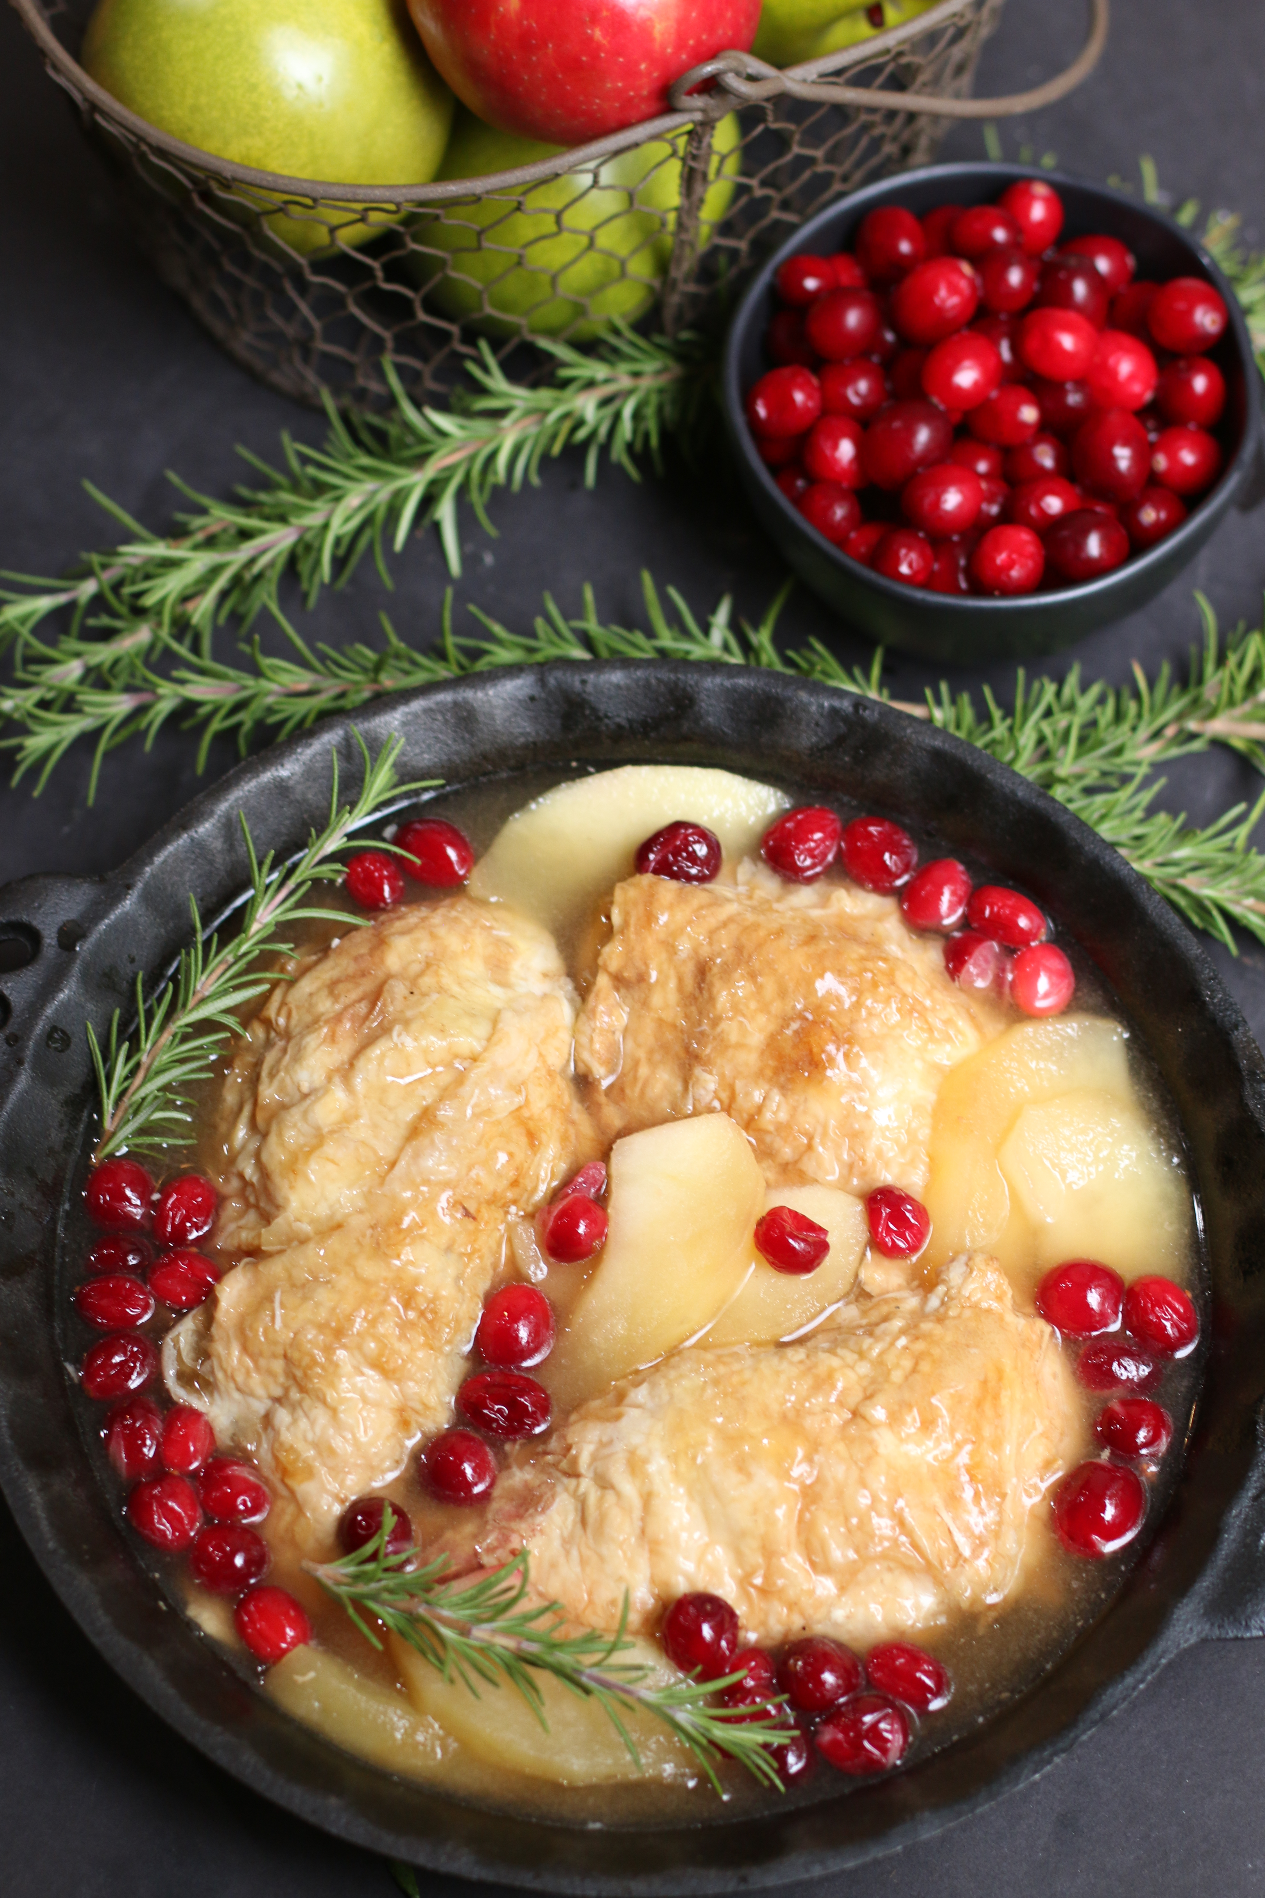

*If you love roasted chicken, this tender Apple Cranberry Chicken Skillet is the perfect autumn dinner. Fresh apple cider, chicken broth, cranberries and apple slices, savory country mustard and caramelized brown sugar create a perfectly sweet and savory sauce. One skillet and so many layers of flavor create a fabulous and easy weeknight dinner!*

**INGREDIENTS:**

2 pounds chicken thighs (skin-on bone-in) or chicken breasts (boneless with skin on)

Salt and Pepper

3 tablespoon olive oil

1 teaspoon fresh rosemary (removed from stem & crushed) or dried rosemary

1 garlic clove (minced)

½ cup apple cider (use REAL apple cider – not apple juice)

½ cup chicken broth or stock

¼ cup light brown sugar

2 tablespoons country mustard

2 apples (peeled, cored and sliced into ¼-inch thick slices)

1-1/2 cups fresh cranberries

Garnish with additional fresh rosemary sprigs

**HOW I MAKE THIS**:

1. Preheat oven to 400 degrees.
2. Lightly salt and pepper the chicken thighs or breasts.
3. Combine 1 tablespoon olive oil, rosemary and the minced garlic in a small bowl. Mix together and brush on both sides of the chicken.
4. On the stove top heat a large cast iron skillet (10 inch) or a Dutch oven over medium-high heat. Add the remaining 2 tablespoons of olive oil.
5. When the oil is hot, place chicken skin side down in the oil. Cook for 5 minutes – skin will be golden brown. Flip over, carefully releasing the skin from the pan (do not allow the skin to stick and tear off, as this helps to keep the chicken moist while cooking).
6. Cook an additional 5 minutes. Remove the chicken from the pan.
7. While the chicken is cooking, combine the brown sugar and mustard in a small bowl. Add the cranberries and apple slices; stir or toss until fruit is evenly coated.
8. Reduce the heat to medium. Slowly pour the chicken stock and apple cider into the pan and use a heat proof spatula to deglaze the pan removing any stuck bits of food in the pan.
9. Add chicken back to the pan skin side up.
10. Spoon the cranberry & apple mixture into the pan evenly around the chicken.
11. Bake in the oven for 20-25 minutes until the chicken reaches 165 degrees (internal temperature) and the apple slices are tender.
12. Remove from oven and allow to rest for five minutes – this will lock juices into the chicken to keep it moist and the sauce will thicken slightly.
13. Serve hot with fruit and sauce spooned evenly over top of chicken.
14. Store leftovers in a sealed container in the refrigerator for up to 3 days. Reheat in microwave.

**SERVINGS**: 4 servings

**RECIPE SECRETS**:

* **CHICKEN**: You can use either chicken thighs or breasts – whichever you prefer. If using chicken thighs, go for bone-in and skin-on. For chicken breasts, boneless is fine, but you’ll want the skin-on for this recipe.
* **TIME CRUNCH**? Pick up a fully-cooked rotisserie chicken and quarter it (leave skin and bones intact). Pre-heat oven to 400 degrees, and start with step 7.
* **CHICKEN BROTH**: You can use chicken broth or chicken stock in this recipe.
* **APPLES**: Honeycrisp have the perfect texture and flavor for this recipe – they won’t get “mushy” or melt down into applesauce.
* **MORE APPLE FLAVOR**? If you really love apple flavor, you can add a couple tablespoons of Apple Syrup or applesauce to the sauce.
* **CRANBERRIES**: Fresh are best, but in a pinch you can substitute frozen cranberries that have been thawed.
* **BROWN SUGAR**: You can use either light brown sugar or dark brown sugar in this recipe – both give a hint of caramelized sweetness to the sauce.
* **COUNTRY MUSTARD**: is a grainy mustard that has a rustic texture, whole mustard seeds and a delicious and rich flavor.
* **COOK CHICKEN THOROUGHLY**: Always cook chicken to an internal temperature of 165 degrees to be food-safe.

*Originally posted September 2014; revised and reposted October 2020.*

*©* ***SnowflakesandCoffeecakes****. All images, attachments & content are copyright protected. All rights reserved. Please do not use my images without prior permission. If you want to republish this recipe, please re-write the recipe in your own words, or link back to* [*www.snowflakesandcoffeecakes.com*](http://www.snowflakesandcoffeecakes.com) *for the recipe.*