brown sugar & CARAMEL english toffee COOKIES
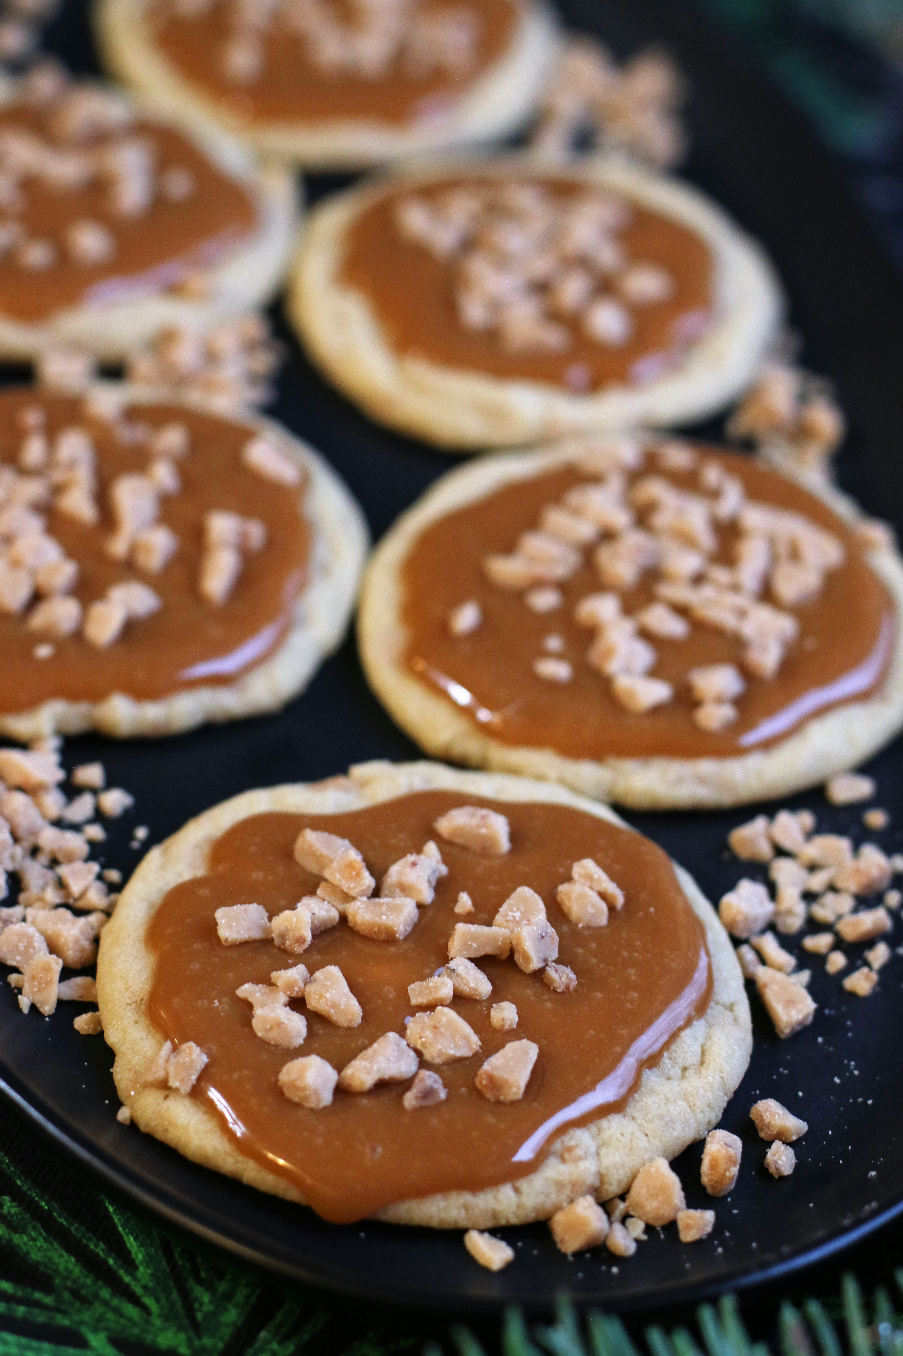

These decadent cookies taste even more wonderful than they look! Chewy, brown-sugar cookies bursting with toffee bits, made fresh from scratch. These are good enough to eat alone – but truly decadent with soft caramel drizzled on top and sprinkled with more English Toffee bits or toasted pecan pieces.
INGREDIENTS:
ENGLISH TOFFEE COOKIES:
2 cups (283g) all-purpose flour
1 Tablespoon cornstarch
½ teaspoon baking soda
½ teaspoon salt
1 cup unsalted butter (softened)
1 cup (210g) packed light brown sugar
1 large egg (room temperature)
1 teaspoon pure vanilla extract
1-1/3 cups English Toffee Bits (Heath Bits o’ Brickle)

CARAMEL FILLING:
1 bag (11 oz.) Soft Kraft Caramels or Werthers Original Chewy Caramels
1/3 cup half & half (plus an additional tablespoon if needed)

GARNISH:
English Toffee Bits or Toasted Pecan pieces

HOW I MAKE THESE:
- Preheat oven to 350 degrees. Line baking sheets with parchment paper or silicone baking mats.
- Prepare Cookies: In a medium mixing bowl, whisk together the flour, cornstarch, baking soda and salt; set aside.
- In the bowl of an electric stand mixer fitted with the paddle attachment, cream together the butter and brown sugar until well blended. Add in the egg, then blend in vanilla extract. Add half of the flour mixture, and mix on low speed just until combined; add remaining flour mixture and mix until just combined. Stir in English Toffee Bits. You do not need to chill this cookie dough before baking!
- Scoop dough out with a medium cookie scoop (1-1/2 tablespoons) and shape into balls. Space cookies 2 inches apart. Bake one sheet at a time for about 10-11 minutes - edges should be set (cookies will appear puffy and slightly under-baked).
- Remove from oven and immediately press the bottom of a glass lightly into each cookie, creating a flat cavity with a ½-inch border around the edge of each cookie (similar to a “Swig” style cookie.). You will need to size your glass so that there is a ½-inch border of the cookie that remains. Cool cookies completely before proceeding to next step.
- Prepare Caramel Filling: Unwrap caramels. Place caramels and half & half in a small microwave-safe bowl and heat in 30 second increments, stirring after each 30 seconds, until caramels are melted; stir well to combine. If needed, add an additional tablespoon of half & half to reach a creamy consistency. Immediately spoon about 1 tablespoon of caramel sauce into the center of each cookie; sprinkle with additional English Toffee bits or chopped pecans.
- Cool until caramel is set.
- Store the cookies in an airtight container at room temperature for up to 3 days.
YIELD: 30 cookies
NOTE: These make LARGE cookies; you can also use a small cookie scoop (1 tablespoon) and adjust the baking time to 8-9 minutes.
You can also make these as Brown Sugar Pecan Cookies by simply replacing the English Toffee Bits with chopped pecans. VERY GOOD!

© SnowflakesandCoffeecakes. All images, attachments & content are copyright protected unless otherwise indicated. All rights reserved. Please do not use my images without prior permission. If you want to republish this recipe, please re-write the recipe in your own words, or link back to www.snowflakesandcoffeecakes.com for the recipe.

