buttermilk corn muffins
WITH HONEY BUTTER GLAZE
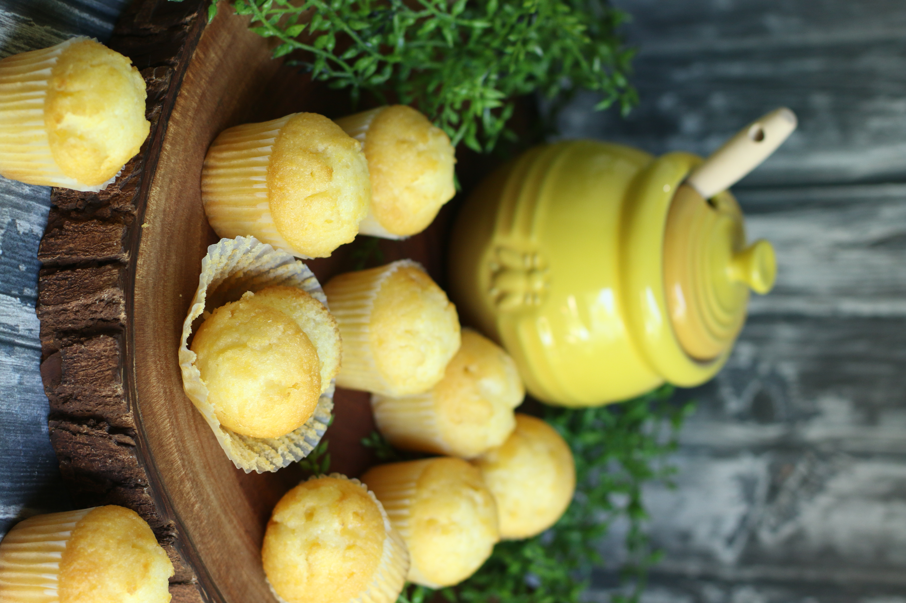

Sweet and savory corn muffins are tender and rich, and loaded with texture. Glazed with homemade honey butter warm from the oven, the topping is so wonderful that you will want to devour muffin top after muffin top! Perfect with homemade chili or served with warm maple syrup as a breakfast treat – you are going to LOVE these!

INGREDIENTS:
BUTTERMILK CORN MUFFINS
½ cup unsalted butter (melted and cooled slightly)
1 large egg (room temperature)
1 cup buttermilk (room temperature)
1 cup (120g) yellow cornmeal
1 cup (125g) all-purpose flour
1 teaspoons baking powder
1/2 teaspoon baking soda
1/2 teaspoon salt
1/3 cup (67g) packed light or dark brown sugar
3 tablespoons honey or pure maple syrup (not pancake syrup)

HONEY BUTTER GLAZE:
1 cup unsalted butter, softened to room temperature
1/3 cup honey
3 tablespoons confectioners’ sugar
½ teaspoon sea salt

HOW I MAKE THESE:
- Remove egg and buttermilk from refrigerator and bring to room temperature.
- Melt the butter and allow to cool down for 10 minutes.
- Preheat oven to 400 degrees; line muffin tins with cupcake liners and spray the bottom of each liner lightly with non-stick cooking spray.
- PREPARE MUFFINS: In a medium bowl, whisk together the cornmeal, flour, baking powder, baking soda and salt; set aside.
- In a large bowl, whisk together the cooled melted butter, brown sugar, and honey/maple syrup until completely smooth and thick. Whisk in the egg just until blended. Finally, whisk in the buttermilk.
- Using a spatula, slowly fold in half of the flour mixture until just combined; add the remaining flour mixture and again stir just until combined – the batter will be very thick. DO NOT OVERMIX!
- Spoon the batter evenly into liners, filling them all the way to the top.
- Bake for 5 minutes at 400 degrees, then, keeping the muffins in the oven, reduce the oven temp to 350 degrees – do not open the oven. Bake for an additional 12-16 minutes or until the tops are set and golden, and a toothpick inserted into the center comes out clean. The total time these muffins take in the oven is about 17-22 minutes, give or take. (NOTE: For mini muffins, bake 11-13 minutes at 350 degrees.)
- PREPARE HOMEMADE HONEY GLAZE: In a large bowl using a paddle attachment or hand-held mixer, beat the butter for 2 minutes on medium speed until completely smooth and creamy. Beat in the honey, powdered sugar and sea salt until completely smooth, scraping down the sides of your bowl as necessary.
- Remove muffins from oven and using a teaspoon, immediately top each muffin with a teaspoon or two of Honey Butter on top of each muffin.
- Allow muffins to cool for 5 minutes in the muffin pan, then transfer to a wire rack to continue cooling.
- Serve the muffins warm or at room temp with Homemade Honey Butter on the side. SO GOOD!
- Muffins are best served the day that you bake them, but you can keep them fresh for an additional day by storing in a covered container. For longer storage, freeze muffins for up to 30 days. Allow to thaw overnight in the refrigerator, then bring to room temperature or warm up in the microwave if desired.

YIELD: 12 regular muffins or 24 mini-muffins
RECIPE NOTES*:
- The initial high baking temperature creates a hot burst of air that will spring up the top of your muffins quickly, then reducing the oven temp to 350 degrees will allow your muffins to bake for the remainder of the time, which helps the muffins rise nice and tall, with perfect dome tops!
- You can substitute pure maple syrup for the honey for a delicious Maple Butter Glaze!

Originally posted November 2010, revised and reposted June 2019.
© SnowflakesandCoffeecakes. All images, attachments & content are copyright protected. All rights reserved. Please do not use my images without prior permission. If you want to republish this recipe, please re-write the recipe in your own words, or link back to www.snowflakesandcoffeecakes.com for the recipe.

