CARAMELQUED BACON
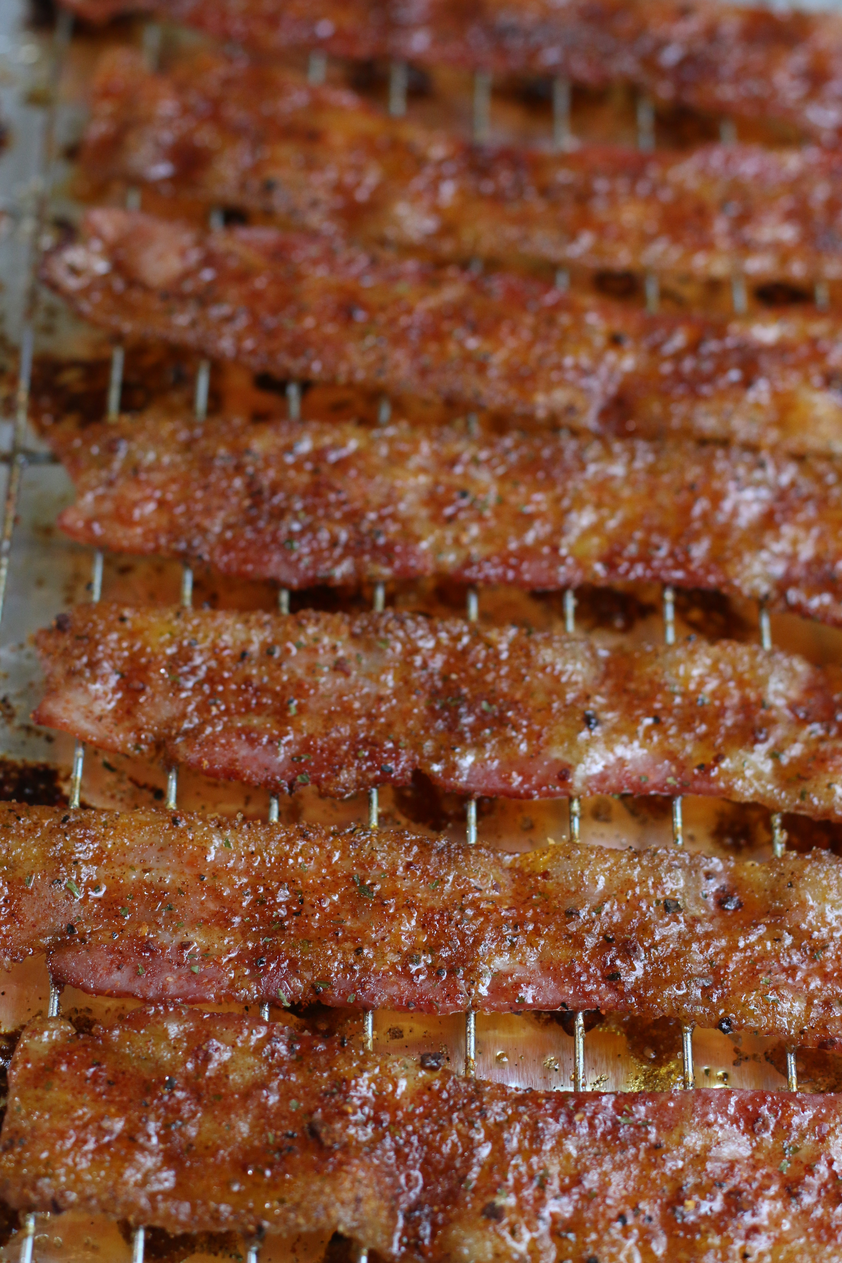

You might as well go ahead and just do the entire package of bacon – this stuff is seriously addictive!
This recipe is a WINNER and family favorite!

INGREDIENTS:
12 oz. hickory smoked bacon
¼ cup barbeque seasoning
¼ cup dark brown sugar

HOW I MAKE THIS:
- Preheat oven to 400 degrees. Line a baking pan with foil and place a baking rack into pan.
- In a pie plate or other baking dish the length of your bacon, mix together the barbeque seasoning and brown sugar with a fork until well blended.
- Take one piece of bacon at a time and dredge into the barbeque brown sugar mixture, pressing down along the entire length of bacon with your fingers to coat evenly on both sides.
- Lay the bacon slices evenly along the baking rack; sprinkle any remaining barbeque brown sugar mixture evenly over the top.
- Bake for 10 to 12 minutes – remove from oven as soon as you see the bacon starting to caramelized and crisp up.
- Transfer each bacon slice immediately to a paper towel to drain any excess grease. (If you keep it on the baking rack too long it will stick like crazy.) After excess grease is drained, move to plate or storage container.
- Now the fun begins! Serve with eggs as a side, in sandwiches, or chop up and sprinkle over salads or baked potatoes. You’ll never go back to plain old bacon again!

YIELD: 12 bacon slices
© SnowflakesandCoffeecakes. All images, attachments & content are copyright protected unless otherwise indicated. All rights reserved. Please do not use my images without prior permission. If you want to republish this recipe, please re-write the recipe in your own words, or link back to www.snowflakesandcoffeecakes.com.

