cranberry apple coleslaw

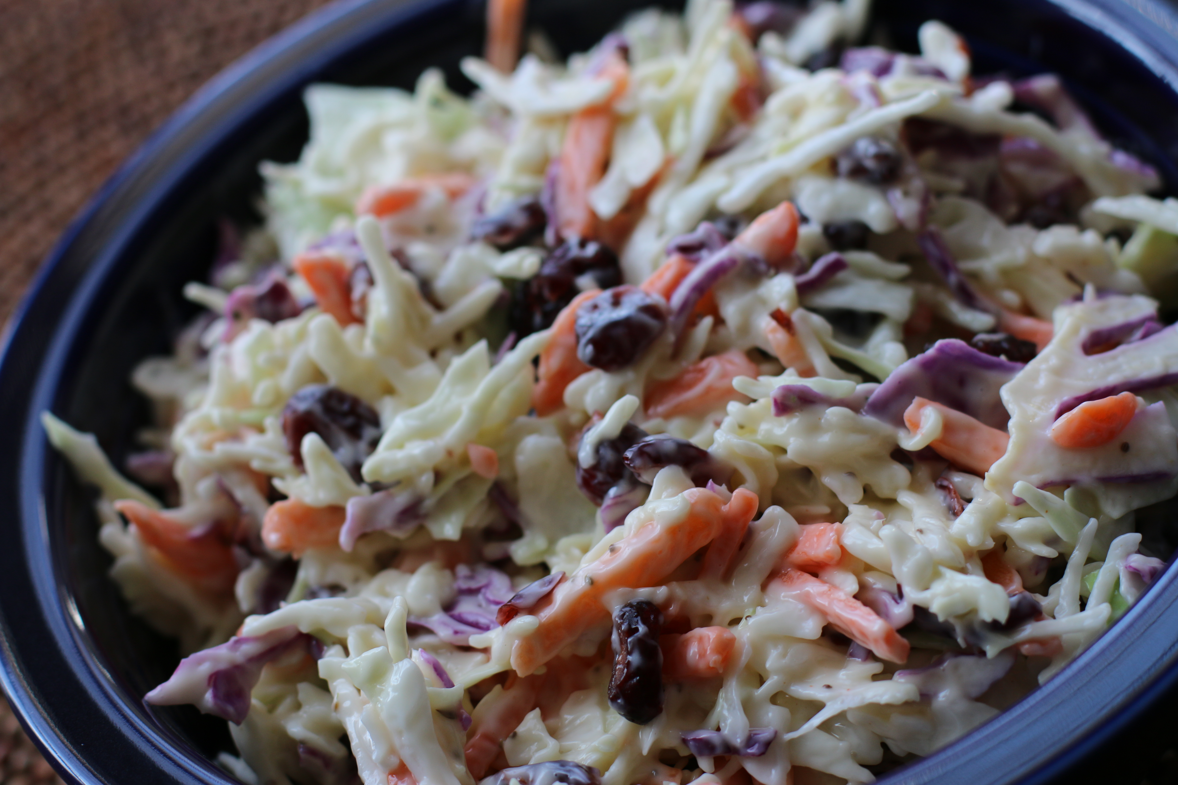

This twist on traditional coleslaw is perfectly creamy and sweet, with the wonderful flavor of tart and sweet apples and dried cranberries. So good as a side, or topped on pulled barbeque meat in a delicious sandwich!

INGREDIENTS:
8 cups shredded cabbage & carrots or broccoli slaw mix
1/2 cup dried cranberries
2 granny smith apples (cored & chopped)
1 cup Miracle Whip
1/3 cup sugar
1/8 cup white vinegar
1 tablespoon yellow mustard
1 tsp. celery salt

HOW I MAKE THIS:
In a large bowl combine Miracle Whip (or mayonnaise), sugar, vinegar, mustard and celery salt, whisking together until well blended. Add remaining ingredients and mix until well coated. Chill in fridge for approximately one hour.
Yield: 8 to 10 servings
Copyright SnowflakesandCoffeecakes. All images and content are copyright protected. Please do not use my images without prior permission. If you want to republish this recipe, please re-write the recipe in your own words, or link back to www.snowflakesandcoffeecakes.com. All rights reserved.

