crumbl CHOCOLATE CAKE COOKIE
(COPYCAT RECIPE)
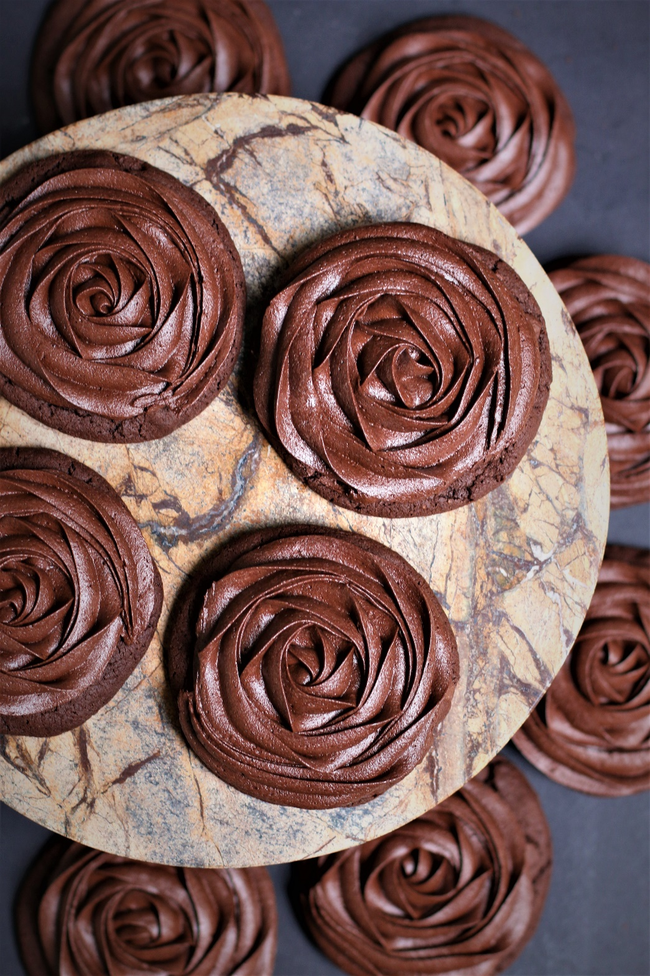

My family calls my copycat recipe for Crumbl Chocolate Cake Cookies “Better Than Crumbl Chocolate Cake Cookies” for good reason! These bakery quality cookies are a chocolate trifecta – a thick and chewy chocolate cookie base is filled with rich cocoa flavor and studded with chocolate chips, and topped with a thick swirl of silky Chocolate Fudge Frosting. So fast and easy to make, with a no-chill dough, it’s easy to see why these are always a favorite for special occasions and everyday treats!
INGREDIENTS:
CHOCOLATE COOKIE BASE:
1-1/2 cups (3 sticks) unsalted butter (softened)
3 large eggs (room temperature)
3-3/4 cups (450g) all-purpose flour
1 cup (100g) Dutch processed cocoa powder
2 tablespoons (15g) cornstarch
1 tablespoon (5g) milk powder
2 teaspoons baking soda
1 teaspoon salt
1-1/2 cups (319g) brown sugar (light or dark)
1/2 cup (100g) granulated sugar
1 teaspoon espresso powder
2 tablespoons corn syrup
1 tablespoon pure vanilla extract
1-1/2 cups semi sweet chocolate chips

CHOCOLATE FUDGE FROSTING:
¾ cup unsalted butter (softened)
4 ounces cream cheese (softened)
1 cup (100g) Dutch processed cocoa powder
4 cups (480g) powdered sugar
1 tablespoon pure vanilla extract
¼ teaspoon salt
6-8 tablespoons heavy cream or half & half

HOW I MAKE THESE:
- Set eggs, butter and cream cheese out to come to room temperature (this helps them incorporate into the cookie dough better).
- Preheat oven to 350 degrees. Line baking sheets with parchment paper; set aside.
- PREPARE COOKIES: In a medium bowl, whisk together the flour, cocoa powder, cornstarch, milk powder, baking powder and salt until well combined; set aside.
- In a large bowl using a hand-held mixer or stand mixer fitted with a paddle attachment, beat the butter, both sugars and espresso powder on medium speed until completely creamy and fluffy (about 3-4 minutes).
- Scrape down the sides and add in the eggs one at a time, beating well between until each is fully mixed in.
- Add corn syrup and vanilla extract; beat until well blended..
- Scrape down the sides and add in the flour mixture, ½ at a time, mixing just until blended; add remaining flour mixture and again mix just until blended.
- Fold in the chocolate chips and stir until evenly mixed. This cookie dough will be really soft and creamy!
- Using a large cookie scoop (3 Tablespoon size), scoop out cookie dough and roll into a ball with your hands. Repeat with remaining dough.
- Place six cookie dough balls on each baking sheet, leaving room between each cookie as the cookies will spread when they bake.
- Flatten the cookie dough balls by pressing gently with your hand to about ¾-inch thickness.
- Bake for 12-14 minutes or until the centers of the cookies have puffed up and are no longer glossy. Every oven is a little bit different, so watch your first batch when baking and time accordingly. DO NOT OVERBAKE, as these will lose their softness.
- Remove from oven and allow cookies to cool on the baking sheets.
- PREPARE CHOCOLATE FUDGE FROSTING: In the bowl of a stand mixer fitted with a paddle attachment, add softened butter and cream cheese, beating until light and fluffy.
- Add cocoa powder and salt and mix until well combined, scraping down sides of bowl as necessary.
- Add powdered sugar and slowly mix until well blended. Add vanilla extract and ½ cup half & half or heavy cream and beat on medium until light, fluffy and well combined, scraping down the sides of the bowl as necessary.
- Add additional half & half or heavy cream, 1 tablespoon at a time, until frosting is piping consistency. If your frosting is too thin, add a little bit of powdered sugar and beat until light and fluffy.
- FROST & DECORATE: Spoon frosting into a large piping bag fitted with a large closed star tip (2D Wilton or Ateco tip).
- Once cookies have reached room temperature, pipe the frosting onto cookies, starting in the center of the cooking and piping in a circular motion until the cookie is covered evenly.
- These cookies are best served at room temperature, or directly from the refrigerator if you prefer cool cookies. You can also warm these up if you prefer warm cookies, but note that the Chocolate Fudge Frosting may melt slightly and loose it’s detail.
- Once the cookies have completely cooled, chill in the fridge until ready to serve. Allow decorated cookies to set completely before storing – keep parchment paper between each layer or place cookies in individual self-sealing bags for easy freezing and serving.
YIELD: Makes 30 (four-inch) cookies
RECIPE NOTES:
WEIGH INGREDIENTS CAREFULLY FOR BEST RESULTS: If I can only share one baking secret with you, always use a DIGITAL KITCHEN SCALE. You can use measuring cups and spoons for most recipes, but using a digital scale makes for the more consistent and efficient baking. Take this from someone that bakes A LOT!
TO KEEP THESE COOKIES SOFT: These cookies will stay soft and fresh in an air-tight container for 3 days at room temperature, or refrigerated for up to 7 days.
MAKE AHEAD TIP: Baked and frosted cookies freeze well for up to 1 months. You can also bake the cookies and freeze UNFROSTED for up to 2 months – simply defrost and then frost before you plan on serving.
BEFORE FREEZING: With frosted cookies, it’s important to freeze the cookie prior to placing them into a container so that the frosting remains intact. Place all frosted cookies on a parchment paper lined baking sheet and pop it in the freezer. Once the icing is set and hard (usually an hour) or the cookies are frozen solid, the cookies can be frozen in containers with parchment paper between layers.
HOW TO THAW FROSTED COOKIES: For frosted cookies or “served chilled” cookies, thaw them in the fridge and NOT at room temp. For chilled cookies, you need to maintain refrigeration throughout the thawing process up until the time you eat the cookie for food safety. To keep your cookies from getting soggy and frosting from losing its shape and texture, remove from the freezer and place the unopened container in the refrigerator overnight to thaw. Cookies that are not frosted can thaw overnight UNOPENED on your kitchen countertop.
FOR PARTIES: I package cookies individually in self-sealing clear cellophane cello bags (Pack It Chic are my favorite brand). Make sure cookies are completely set after decorating before packaging. To make ahead, place individually wrapped and sealed cookies in a larger airtight container and refrigerate or freeze. Thaw frozen cookies unopened in the refrigerator - you are trying to minimize moisture during defrosting, which can cause your frosting to soften too much and loose detail.
Original recipe created by Snowflakes & Coffeecakes; published June 2022.
© SnowflakesandCoffeecakes. All images, attachments & content are copyright protected. All rights reserved. Please do not use my images without prior permission. If you want to republish this recipe, please re-write the recipe in your own words, or link back to www.snowflakesandcoffeecakes.com for the recipe.

Tried it and loved it? Snap a picture and share it with me on Instagram @SnowflakesandCoffeecakes and by using the hashtag #SnowflakesandCoffeecakes.

