CHOCOLATE DIRT CAKE COOKIES (crumbl copycat)
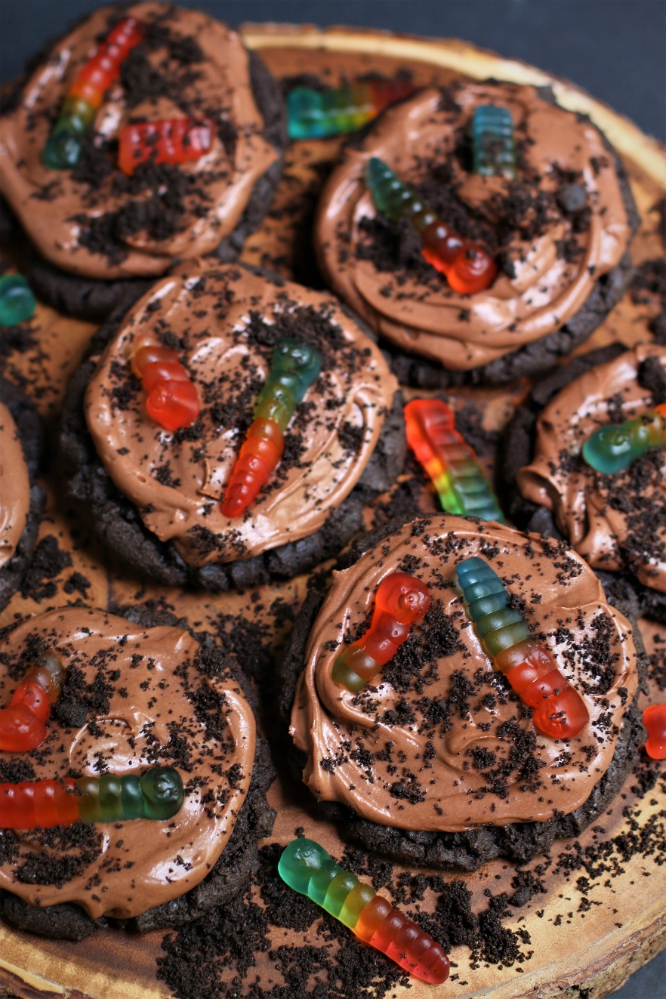

Craving a cookie that combines childhood nostalgia with irresistible chocolatey goodness? Look no further! Chocolate Dirt Cake Cookies with Gummy Worms are the ultimate treat to satisfy your sweet tooth and bring back memories of carefree days. This delicious twist on a classic recipe is a fun and gooey delight that will leave you and your little ones wanting more! These delicious Crumbl-inspired Chocolate Dirt Cake Cookies may be the BEST chocolate cookie of your life! A soft and chewy chocolate cookie base is swirled with Chocolate Pudding Frosting. For the full “dirt cake” effect, the tops are sprinkled with more Oreo crumbs and loaded with soft and colorful gummy worms! So fast and easy to make, it’s easy to see why these irresistible cookies are always a favorite of my little ones – and big ones too! Be adventurous and substitute gummy “centipedes” or other gummy bugs for a fun variety! Take it from this cookie lover - better than Crumbl? Without a doubt!
INGREDIENTS:
CHOCOLATE OREO COOKIE BASE:
2 large eggs (room temperature)
1-½ cups (3 sticks) unsalted butter (softened)
3 cups (375g) all -purpose flour
2-½ cups (340g) Oreo crumbs (plus 1 cup (136g) for rolling)
1 cup (109g) dark cocoa powder - sifted (special dark, Dutch or black)
1 Tablespoon cornstarch
1 Tablespoon milk powder
1-1/2 teaspoon baking powder
1 teaspoon baking soda
1 teaspoon salt
1-½ cups (345g) light or dark brown sugar
1 cup (200g) granulated sugar
1 Tablespoon pure vanilla extract
1 Tablespoon light corn syrup

CHOCOLATE PUDDING FROSTING:
1 can (14 oz.) sweetened condensed milk
1 pkg (3.9 oz.) instant chocolate pudding mix (NOT cook & serve)
1/3 cup (36g) Dutch process cocoa powder (sifted)
2 cups heavy cream (icy cold)
1 teaspoon pure vanilla extract

TOPPINGS:
Oreo crumbs (leftover from rolling cookie dough balls)
30 rainbow gummy worms

HOW I MAKE THESE:
- Set egg and butter out to come to room temperature (this helps them incorporate into the cookie dough better).
- Line baking sheet with parchment paper; set aside.
- PREPARE OREO COOKIE CRUMBS: In the bowl of a food processor, process Oreo cookies until they are pulverized and you have fine crumbs.
- PREPARE CHOCOLATE COOKIES: In a medium bowl, whisk together the flour, cookie crumbs, cornstarch, milk powder, baking soda, baking powder and salt until well combined; set aside.
- In a large bowl using a hand-held mixer or stand mixer fitted with a paddle attachment, beat the butter and both sugars on medium speed until completely creamy and fluffy (about 3-4 minutes).
- Scrape down the sides and add in the eggs one at a time, beating well until fully mixed in.
- Add corn syrup and vanilla extract; beat until well blended.
- Scrape down the sides and add in the flour mixture, ½ at a time, mixing just until blended; add remaining flour mixture and again mix just until blended. This cookie dough will be soft and creamy!
- Using a large cookie scoop (3 Tablespoon size), scoop out cookie dough and roll into a ball with your hands, roll each cookie dough ball in cookie crumbs and place on a baking sheet that has been lined with parchment paper. Repeat with remaining dough, cover and refrigerate for a minimum of 2 hours (or overnight). (You should be able to get all 30 cookie dough balls on one pan.)
- BAKE COOKIES: Preheat oven to 350 degrees. Line baking sheets with parchment paper; set aside.
- Place six cookie dough balls on each baking sheet, leaving room between each cookie as the cookies will spread slightly when they bake.
- Flatten the cookie dough balls by pressing gently with your hand to about ¾-inch thickness.
- Bake for 12 minutes or until the top and edges are just set and no longer glossy. Every oven is a little bit different, so watch your first batch when baking and time accordingly. DO NOT OVERBAKE, as these will lose their softness.
- Remove from oven and allow cookies to cool on the baking sheets for 10 minutes before transferring to a wire rack to cool completely.
- PREPARE CHOCOLATE PUDDING FROSTING: In the bowl of a stand mixer fitted with a paddle attachment, combine all ingredients, beating until light and fluffy and starting to thicken, scraping down the sides of the bowl as necessary.
- The Chocolate Pudding Frosting should be the perfect consistency for spreading, but if needed, add half & half or heavy cream, 1 tablespoon at a time, until frosting is piping consistency. If your frosting is too thin, add a little bit of powdered sugar and beat until light and fluffy.
- ASSEMBLE COOKIES: Spoon Chocolate Pudding Frosting into a large piping bag fitted with a large round tip (or you can simply cut the end off the piping bag so that you have a 1/2-inch opening. If you don’t have a piping bag, simply swirl frosting on top with a spoon.
- Once cookies have reached room temperature, pipe the frosting onto cookies, starting in the center of the cooking and piping in a circular motion until the cookie is covered evenly.
- Top with a sprinkle of Oreo cookie crumbs or chunks on the top of each cookie. Place a colorful rainbow gummy worm (or other gummy creature) on top.
- Assembled cookies should be covered and stored in the fridge until ready to serve.
- These cookies are best served slightly chilled. Remove from the fridge 10-15 minutes before serving so that the Chocolate Pudding Frosting and gummy worms have a few minutes to soften to the perfect texture. You can also serve these directly from the refrigerator if you prefer chilled cookies.
- Store cookies in an airtight container in the refrigerator for 3-4 days – if they last that long!
YIELD: Makes 30 (three-inch) cookies
RECIPE NOTES:
WEIGH INGREDIENTS CAREFULLY FOR BEST RESULTS: If I can only share one baking secret with you, always use a DIGITAL KITCHEN SCALE. You can use measuring cups and spoons for most recipes, but using a digital scale makes for the more consistent and efficient baking. Take this from someone that bakes A LOT!
OREO SECRETS: You are going to need regular Oreo cookies (not double-stuf) for this recipe, and you’ll use the entire Oreo cookies (cookies AND filling). For reference, there are 11 regular Oreo cookie crumbs in a cup (136g per cup). I use my food processor to quickly and easily crush the cookies, but you can also place them in a gallon Ziploc bag and smash them with a rolling pin.
INSTANT CHOCOLATE PUDDING: Make sure to use the dry packet of INSTANT chocolate pudding for the right texture and thickness. Cook & Serve pudding mix does NOT work for this Chocolate Pudding Frosting!
HEAVY CREAM: Is sometimes called “Heavy Whipping Cream”. For best results, make sure it is icy cold – it will whip up better in the Chocolate Pudding Frosting and give you thick and fluffy creaminess!
COCOA POWDER: Make sure to add cocoa powder to the Chocolate Pudding Frosting for a richer chocolate flavor.
GUMMY WORMS: This wouldn’t be a traditional dirt dessert recipe without the gummy worms! Use colorful rainbow worms that are nice and soft for best results! Adding gummy worms (or gummy centipedes or other gummy bugs) to the top make these cookies look just like dirt cake with worms! Squishy, delicious and fun!
DON’T OVERBAKE: For soft and chewy cookies, remove the cookies from the oven when the edges are set but the centers look slightly underdone. Don’t worry! They will continue to bake and set-up as they cool on the cookie sheets – giving you a perfectly soft and chewy texture!
TO KEEP THESE COOKIES FRESH: Frosted cookies will stay soft, chewy and fresh for up to 3 days in an air-tight container kept in the refrigerator. Fully decorated cookies (with Chocolate Pudding Frosting) should be refrigerated until ready to serve.
MAKE AHEAD TIP: You can bake these cookies and freeze UNFROSTED for up to 2 months – simply defrost and then top with Chocolate Pudding Frosting and add Oreo cookie crumbs and gummy worms before you plan on serving. The Chocolate Pudding Frosting can be made ahead of time and refrigerated in airtight containers for up to 2 days
CAN I MAKE GLUTEN-FREE CHOCOLATE DIRT CAKE COOKIES? You can easily make this recipe gluten-free by substituting your favorite 1:1 gluten free flour for the all-purpose flour - I use and recommend King Arthur, Measure for Measure Flour and Bob's Red Mill Gluten Free 1-to-1 Baking Flour. You will also need to replace the regular Oreo cookies with gluten-free Oreos). Traditional Oreos do contain wheat flour, but Gluten-Free Oreos use gluten free flour. Gluten-Free Oreos are available in original and double stuf.

Original recipe created by Snowflakes & Coffeecakes; published July 2023.
© SnowflakesandCoffeecakes. All images, attachments & content are copyright protected. All rights reserved. Please do not use my images without prior permission. If you want to republish this recipe, please re-write the recipe in your own words, or link back to www.snowflakesandcoffeecakes.com for the recipe.

Tried it and loved it? Snap a picture and share it with me on Instagram @SnowflakesandCoffeecakes and by using the hashtag #SnowflakesandCoffeecakes.

