crumbl CONFETTI CAKE COOKIES
(COPYCAT RECIPE)
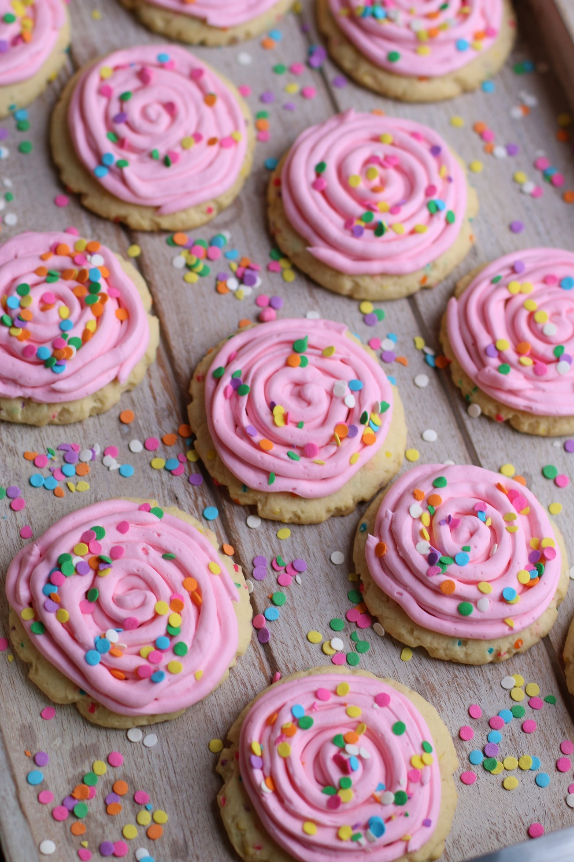

What was the first Crumbl cookie you fell in love with? These Crumbl Confetti Cake Cookies with Confetti Cream Cheese Frosting are irresistible! This copycat recipe is so fast and easy to make, with a no-chill dough - it’s easy to see why these always disappear as fast as I can bake them! These tender cake batter flavored sugar cookies are super soft, chewy and buttery, and stuffed with confetti sprinkles, topped with perfect swirls of pink cake batter cream cheese frosting and topped with large confetti sprinkles, and the same GIANT size to share or tackle on your own! I’m famous for my decorated sugar cookies, but sometimes you just want a cookie that is fast, yummy, and warm from the oven!
INGREDIENTS:
CONFETTI CAKE COOKIES:
1-1/2 cups salted butter
1-1/2 cups (300g) granulated sugar
3 large eggs (room temperature)
1 Tablespoon pure vanilla extract
2 teaspoons cake batter flavor or emulsion (Amoretti or LorAnn Oils /Super Strength Flavor)
4-1/4 cups (531g) all purpose flour
¼ cup (30g) cornstarch
3 teaspoons baking powder
¼ cup pastel quins or confetti sprinkles

CAKE BATTER CREAM CHEESE FROSTING:
8 ounces cream cheese (room temperature)
¼ cup butter (softened)
4 cups (480g) powdered sugar
1-1/2 teaspoon cake batter flavor or emulsion
2-4 tablespoons milk or half & half
AmeriColor Soft Gel Food Coloring (strongly recommended – electric pink is the perfect color)
½ cup pastel quins or confetti sprinkles

HOW I MAKE THESE:
- Set eggs out to come to room temperature (this helps them incorporate into the cookie dough better).
- Preheat oven to 350 degrees. Line four baking sheets with parchment paper; set aside.
- PREPARE COOKIES: In a medium bowl, whisk together the flour, cornstarch and baking powder; set aside.
- In a large bowl using a hand-held mixer or stand mixer fitted with a paddle attachment, beat the butter and sugar on medium speed until completely creamy and fluffy (about 3 minutes).
- Scrape down the sides and add in the eggs one at a time, beating well between each is fully mixed in.
- Add vanilla extract and cake batter extract; beat until mixed.
- Scrape down the sides and add in the flour mixture, ½ at a time, mixing just until blended; add remaining flour mixture and again mix just until blended.
- Stir in pastel quins or confetti just until evenly distributed throughout the dough. This cookie dough will be really soft and creamy!
- Using a large cookie scoop (3 Tablespoon size), scoop out cookie dough and roll into a ball with your hands. Repeat with remaining dough.
- Place six cookie dough balls on each baking sheet, leaving room between each cookie as the cookies will spread when they bake.
- Flatten the cookie dough by gently pressing down with your hand so that it is in the shape of a hockey puck; repeat with remaining dough.
- Bake for 13-14 minutes or until the centers of the cookies have puffed up and are no longer glossy. Every oven is a little bit different, so watch your first batch when baking and time accordingly. DO NOT OVERBAKE, as these will lose their softness.
- Remove from oven and allow cookies to cool on the baking sheets.
- PREPARE CAKE BATTER CREAM CHEESE FROSTING: In the bowl of a stand mixer fitted with a paddle attachment, add softened butter and cream cheese on medium high speed until smooth and fluffy.
- Add vanilla and cake batter flavoring and beat until well blended.
- Add powdered sugar one cup at a time, mixing each time until completely blended.
- Beat on medium speed until light and fluffy; add milk or half & half a tablespoon at a time until the frosting is spreading consistency – it should hold a soft tip. If your frosting is too thin, add a little bit of powdered sugar and beat until light and fluff.
- Add gel food coloring, if desired, and continue beating until well blended, scraping down the sides of the bowl as necessary.
- FROST & DECORATE: Place the frosting in a large piping bag fitted with a large round tip. (If you don’t have a piping bag available, you can also place the frosting in a gallon sized zip top bag and cut the corner to use to pipe the frosting onto the cooled cookies. Starting in the center of each cookie, pipe a swirl and continue rotating the cookie until the top is evenly frosted in a circular pattern.
- Sprinkle the top of each cookie with additional pastel quins or confetti sprinkles.
- Once the cookies have completely cooled, chill in the fridge until ready to serve. Allow decorated cookies to set and dry completely before storing – keep parchment paper between each layer or place cookies in individual self-sealing bags for easy freezing and serving.
- These cookies should be served chilled.
YIELD: Makes 24 (four-inch) cookies
NOTES: These cookies will stay fresh in an air-tight container in the refrigerator for up to 1 week.
MAKE AHEAD TIP: Baked and frosted cookies freeze well for up to 1 month. Thaw overnight UNOPENED on your kitchen countertop before decorating.
FOR PARTIES: I package cookies individually in self-sealing clear cellophane cello bags (Pack It Chic are my favorite brand). Make sure cookies are completely dry after decorating before packaging. To make ahead, place individually wrapped and sealed cookies in a larger airtight container and refrigerate or freeze. Thaw frozen cookies in the refrigerator or on your countertop before serving - you are trying to minimize moisture during defrosting, which can cause your frosting to run or bleed.
TO KEEP THESE COOKIES SOFT: These cookies will stay soft and fresh in an air-tight container refrigerated for up to one week.

Original recipe created by Snowflakes & Coffeecakes; published May 2022.
© SnowflakesandCoffeecakes. All images, attachments & content are copyright protected. All rights reserved. Please do not use my images without prior permission. If you want to republish this recipe, please re-write the recipe in your own words, or link back to www.snowflakesandcoffeecakes.com for the recipe.

Tried it and loved it? Snap a picture and share it with me on Instagram @SnowflakesandCoffeecakes and by using the hashtag #SnowflakesandCoffeecakes.

