crumbl galaxy brownie cookies
(COPYCAT RECIPE)
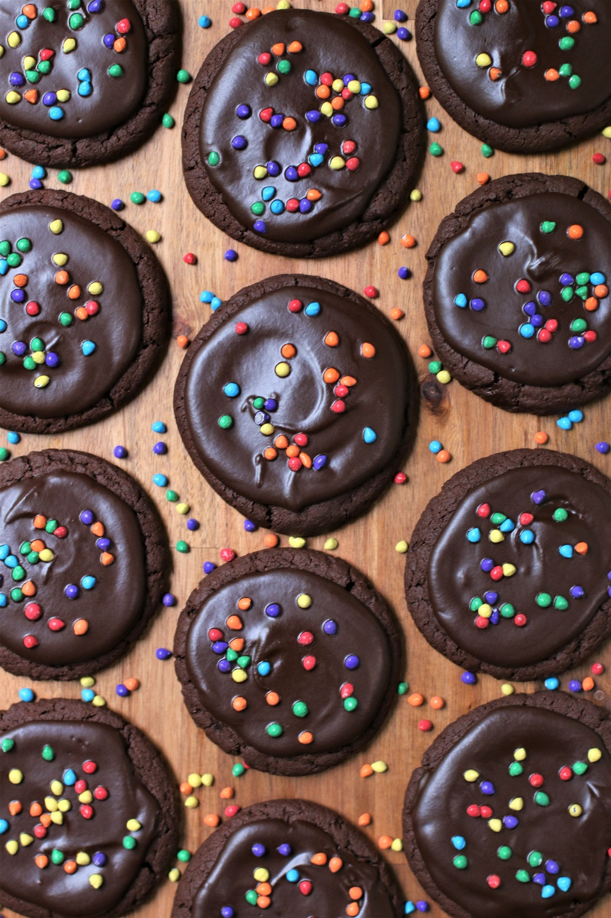

If you love brownies with chewy edges and soft centers fresh from the oven, you are going to love my copycat recipe for Crumbl Galaxy Brownie Cookies! So fast and easy to make with a no-chill dough, it’s easy to see why these are always a favorite at our house. These rich and fudgy brownie cookies are thick and chewy, with perfect shiny and crackled tops, covered with a warm and silky chocolate ganache and topped with intergalactic rainbow candy bits. My little ones call these “Cosmic Brownie Cookies” – because they taste “out-of-this-world-wonderful” and the cookie of your chocolate loving dreams – they are also reminiscent of the Little Debbie Cosmic Brownies from your childhood!
INGREDIENTS:
BROWNIE COOKIE BASE:
1 cup (2 sticks or 226g) unsalted butter (softened to room temperature)
2 large eggs (room temperature)
2-1/2 cups (300g) all-purpose flour
1 cup (100g) Dutch-process cocoa powder
1 tablespoon milk powder
1 teaspoon baking soda
1/2 teaspoon salt
¾ cup (150g) granulated sugar
1 cup (200g) brown sugar (light or dark)
1 teaspoon espresso powder
1-1/2 tablespoons light corn syrup
3 teaspoons pure vanilla extract

CHOCOLATE GANACHE GLAZE:
1/2 cup heavy cream
2 cups (12 ounces or 340g) Ghirardelli semi-sweet chocolate chips
½ cup rainbow candy chips

HOW I MAKE THESE:
- Set butter and eggs out to come to room temperature (this helps them incorporate into the cookie dough better).
- Preheat oven to 350 degrees. Line three baking sheets with parchment paper; set aside.
- PREPARE COOKIES: In a medium bowl, whisk together the flour, cocoa powder, milk powder, baking soda and salt until well combined; set aside.
- Using a stand mixer fitted with a paddle attachment, beat the butter, granulated sugar, brown sugar and espresso powder for 3 minutes on medium speed until light and fluffy.
- Add the eggs, one at a time, and beat just until blended, scraping down the sides as needed.
- Add vanilla extract and light corn syrup and beat just until blended.
- Scrape down the sides and add in the flour mixture, ½ at a time, mixing just until blended; add remaining flour mixture and again mix just until blended. DO NOT OVERMIX! This cookie dough will be really soft and creamy!
- Using a large cookie scoop (3 Tablespoon size), scoop out cookie dough and roll into a ball with your hands. Repeat with remaining dough.
- Place six cookie dough balls on each baking sheet, leaving room between each cookie as the cookies will spread slightly when they bake.
- Using the palm of your hand, gently press down on each ball just slightly until it creates a very thick disk.
- Bake for 10-12 minutes or until the edges are set and centers of the cookies have puffed up and are no longer glossy. Every oven is a little bit different, so watch your first batch when baking and time accordingly. DO NOT OVERBAKE, as these will lose their softness.
- Remove from oven and allow cookies to cool on the baking sheets for 5 minutes.
- NOTE: I like to load these cookies up with LOTS of fudgy frosting, so I use a glass and make an indentation in the center of each cookie immediately after taking them out of the oven. Continue to cool on baking sheet for 5 minutes.
- PREPARE CHOCOLATE GANACHE: While cookies are cooling, place the chocolate chips in a medium bowl; set aside.
- In a small microwave safe bowl, heat the heavy cream on high for 1-1.5 minutes or until it is just starting to boil.
- Pour the hot heavy cream over the chocolate chips and let sit undisturbed for 3 to 5 minutes.
- After sitting for 3 to 5 minutes, gently whisk the chocolate and cream until smooth.
- FROST & DECORATE: Spoon 2 tablespoons of the chocolate ganache over each cookie, giving the top a gentle swirl with the back of your spoon for a nice, smooth finished look.
- Immediately sprinkle with the candy coated chips.
- Once the cookies have completely cooled, chill in the fridge until ready to serve. Allow decorated cookies to set and dry completely before storing – keep parchment paper between each layer or place cookies in individual self-sealing bags for easy freezing and serving.
- These cookies are best served warm, they are still great at room temperature or even chilled.
YIELD: Makes 18 (four-inch) cookies
RECIPE NOTES:
TO KEEP THESE BROWNIE COOKIES SOFT: These cookies will stay soft and fresh in an air-tight container in the refrigerator for up to 5 days. These cookies are best the day you make them – but they are still great chilled.
FOR TENDER, CHEWY COOKIES: Don’t over mix the cookie dough to prevent the dough from getting tough. Don’t overbake your cookies either! Remember, cookies will continue to bake for a few minutes while resting on the baking sheets after you take them out of the oven.
CHECK YOUR OVEN TEMP: Be sure your oven is at the right temperature – using an oven thermometer is helpful to make sure your oven isn’t running hotter or cooler than it should be. Every oven is a little bit different, so watch your first batch when baking and time accordingly.
CHOCOLATE GANACHE: Make sure to remove your heavy cream from the microwave (or stovetop) before it is at a full boil. Make sure to cover the chocolate with the hot cream and let it sit undisturbed for 5 minutes. Mixing prematurely can cause the ganache to be grainy-looking. Freezing chocolate ganache may also cause it to “bloom” with cloudy or white patches.
MAKE AHEAD TIP: Store the cookies in an airtight container in the fridge due to the heavy cream in the ganache. If you want to freeze the baked cookies, I would bake and freeze the cookies without the ganache. The ganache won’t hold up very well in the freezer due to the heavy cream in it. For best results, individually wrap the cookies then store in the airtight container for up to 2 months. Thaw cookies completely and then frost with Chocolate Ganache and add sprinkles.
FOR PARTIES: I package cookies individually in self-sealing clear cellophane cello bags (Pack It Chic are my favorite brand). Make sure cookies are completely dry after decorating before packaging. To make ahead, place individually wrapped and sealed cookies in a larger airtight container and refrigerate until ready to serve.

INGREDIENT NOTES:
- Dutch-Processed Cocoa: Dutch-processed cocoa powder has a richer chocolate flavor and darker color than natural cocoa powder. It also produces a fudgier baked good than natural cocoa powder, since it isn’t acidic at all. This is how we get rich chocolate flavor and perfect brownie-like texture for gourmet brownies and brownie cookies.
- Can I substitute regular cocoa powder? I would recommend using the cocoa powder listed, since the ingredients and proportions in this recipe are tailored to Dutch-processed cocoa powder.
- Baking Soda rather than Baking Powder? Typically you use baking powder when baking with Dutch-processed cocoa, which is acidic and won’t react with baking soda. Using baking soda in this recipe makes the cookies chewier and more “brownie-like”, whereas baking powder would cause the cookies to be more puffed up and “cake-like”. This recipe is an exception to the standard rule!
- Brown Sugar: You know a cookie will be moist when there is more brown sugar than the granulated sugar! For deeper flavor, I recommend dark brown sugar, but you can use either light or dark brown sugar in this recipe.
- Espresso Powder: A touch of espresso powder greatly enhances and intensifies the chocolate flavor in brownies, cakes and cookies, without adding any mocha flavor.
- Cornstarch: Using cornstarch in the cookie dough makes the cookies tender and chewy.
- Milk Powder: Adding just a tablespoon of nonfat milk powder to your flour, baking powder, baking soda and salt, before you combine them with softened butter, sugar and eggs, adds depth to baked goods. If you are using cocoa powder or chocolate chips in your recipe, it intensifies the flavor of chocolate – making regular chocolate taste more luxurious and vanilla flavor more magical. It is the secret ingredient in these brownie cookies!
- Corn Syrup: Adding even a little bit of corn syrup to cookies will make them stay softer longer!
- Baking Soda: The baking soda will give us some rise to the cookies, but since we are using Dutch-processed cocoa powder, the cookies won’t puff up like cake — which is a good thing!
- Rainbow Candy Chips: Iconic for both Crumbl Galaxy Brownie Cookies and Little Debbie Cosmic Brownies. You can find these on Amazon, or your local baking supply or craft stores. If you can’t find these colorful little chips, you can also use mini M&M’s or colorful sprinkles.

Original recipe created by Snowflakes & Coffeecakes; published May 2022.
© SnowflakesandCoffeecakes. All images, attachments & content are copyright protected. All rights reserved. Please do not use my images without prior permission. If you want to republish this recipe, please re-write the recipe in your own words, or link back to www.snowflakesandcoffeecakes.com for the recipe.

Tried it and loved it? Snap a picture and share it with me on Instagram @SnowflakesandCoffeecakes and by using the hashtag #SnowflakesandCoffeecakes.

