easy ITALIAN STUFFED SHELLS
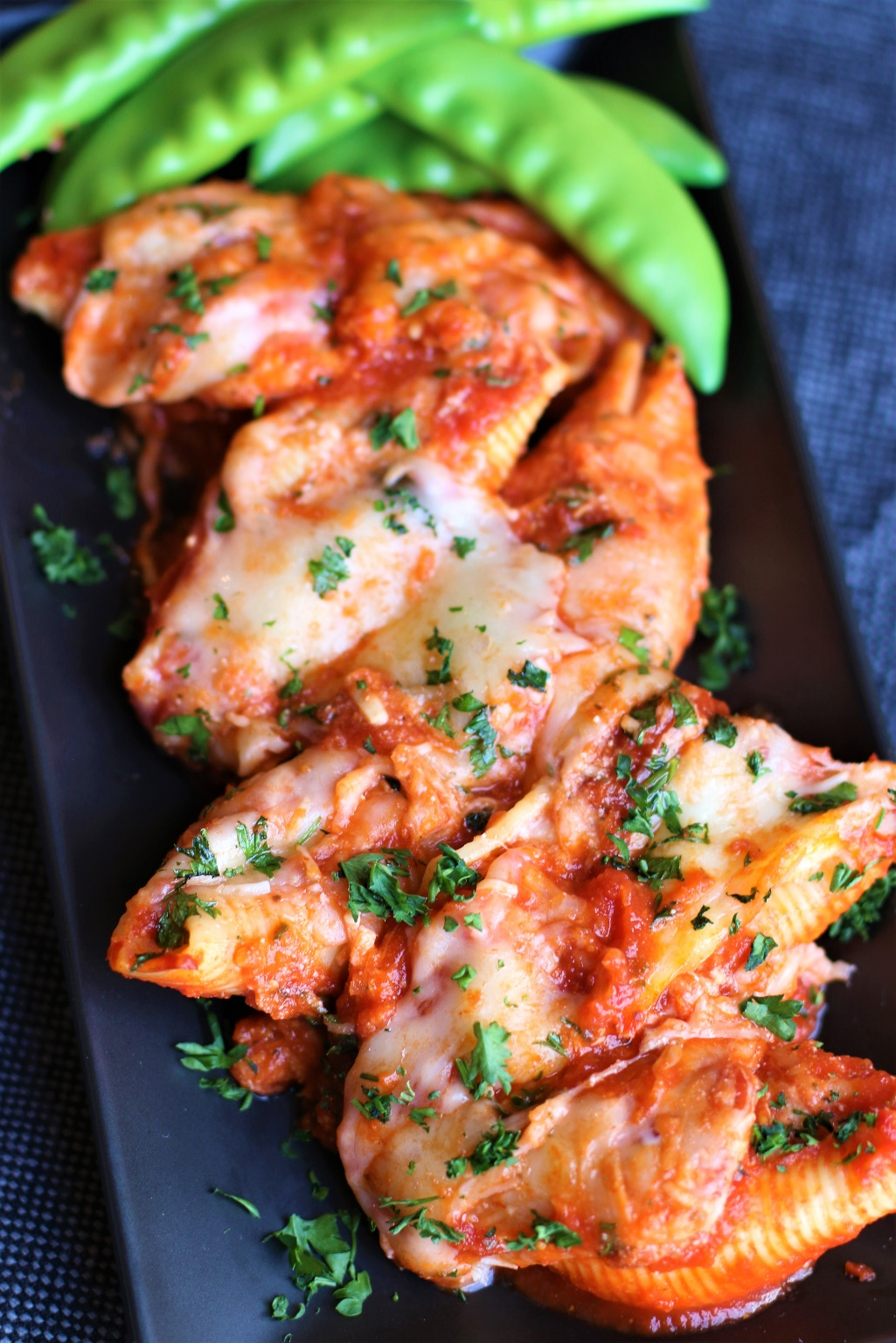

Looking for a quick and delicious dinner? Easy Italian Stuffed Shells are a classic comfort food that no one can resist and will transport you to the heart of Italy! Perfect for those busy nights when you don’t have a lot of time to make dinner, but delicious enough for company! Delectable pasta shells are filled with a delightful combination of creamy cheeses, savory sweet Italian sausage and aromatic herbs, and smothered with marinara sauce and bubbling cheese, creating a home-cooked dinner that is loaded with Italian flavor. Serve these flavorful Italian Stuffed Shells alongside a simple salad and cheesy garlic bread for a cozy dinner that’s perfect anytime of the year!
INGREDIENTS:
1 12 oz. box jumbo pasta shells
2 24 oz. jars marinara sauce (Rao’s or other quality sauce recommended)
1 pound sweet Italian sausage (casings removed)
½ medium yellow onion (chopped)
3 garlic cloves (minced)

HERB RICOTTA CHEESE FILLING:
1 large egg
1 1/2 cups whole milk ricotta cheese, strained
1/2 cup sour cream
2 ½ cups freshly shredded mozzarella
1/3 cup freshly grated Parmesan cheese
2 tablespoons chopped fresh basil (or 1 ½ teaspoon dried)
2 tablespoons chopped fresh parsley (or 1 ½ teaspoon dried)
½ teaspoon oregano
½ teaspoon garlic powder
½ teaspoon pepper
¼ teaspoon nutmeg
¼ teaspoon salt

CHEESE TOPPING:
2 cups freshly shredded mozzarella
½ cup freshly grated Parmesan cheese
Fresh parsley (chopped)

HOW I MAKE THIS:
- Preheat oven to 350 degrees. Spray 9x13 baking dish with non-stick spray.
- PREPARE SHELLS: Boil pasta shells in salted water for 1 minute less than al dente, don’t overcook! Immediately rinse with cold water until shells are completely cool; drain and set aside.
- PREPARE MEAT: In a large skillet, brown sausage and onion until golden brown. Add garlic and cook for one minute. Drain the sausage mixture of any liquid or grease that may have accumulated.
- Remove 1-1/2 cups sausage mixture and add to prepared baking dish, along with half of the marinara sauce. Stir until evenly blended, then smooth into an even layer.
- PREPARE CHEESE FILLING: In a large bowl, whisk the egg; add all remaining filling ingredients and stir until well blended. Add remaining sausage mixture and stir until evenly combined.
- FILL PASTA SHELLS: Fill each shell with the filling and line on top of the sauce in the baking dish. The easiest way to do this is add the filling to a large piping bag or gallon-sized Ziplock bag, snip the corner (about 3/4-inch cut). Holding a shell in your hand, pipe the filling into each shell. Arrange the shells in a single layer of rows, as tightly as possible (7 rows of 4 works best for me).
- Pour remaining marinara sauce over shells, making sure they are covered. Top the marinara with shredded mozzarella and Parmesan cheese.
- Cover with foil and bake at 350 degrees for 20 minutes. Remove the foil and bake an additional 10 minutes or until the cheese is completely melted and the sauce is bubbling.
- Sprinkle with fresh parsley and serve warm!
YIELD: 28 shells (about 8 servings)
RECIPE NOTES:
Do I have to use Italian Sausage? Sweet Italian sausage is one of the easiest ways to get perfect flavor in Italian recipes without added effort. If you prefer, you can substitute regular ground beef or ground turkey, or leave the meat out altogether for meat-free stuffed shells – see Recipe Variations. This recipe is so easy to customize!

Strain ricotta: Ricotta can be very wet, which in turn can make your stuffed shells watery. To prevent this, start by straining your ricotta cheese. Place a fine mesh strainer over a bowl. Line the strainer with paper towels, a large coffee filter or cheesecloth. Spoon the ricotta into the lined strainer and firmly press out excess moisture with the back of a silicone spatula.
Allow for shells breaking: A 12-ounce jumbo pasta shell box comes with about 33-35 shells, but you’ll only need 28 to fill a 9x13 baking dish. I recommend cooking the entire box so that you'll have extra in case your shells break or tear while cooking or filling - and they always do!
Cook pasta in salted water: Always add salt to your pasta water – which enhances the subtle pasta flavor – you can taste the difference! Use 1 tablespoon salt for 6 quarts of water.
Don’t overcook pasta shells: Cook your shells about 2 or 3 minutes less than the box recommends. The shells should be al dente– meaning they should still be a little firm/ have a “bite” because they will continue to cook in the oven when sauced up. Also, if the shells are cooked completely or over-cooked, they will be flimsy, hard to stuff and easily break when filling.
Stop shells from cooking: Strain and rinse jumbo shells with icy cold water until they are completely chilled to prevent them from continuing to cook and becoming flimsy or tearing apart when stuffing.
Easily stuff cooked shells: To easily stuff shells, fill a pastry bag or freezer bag with cheese filling and cut off a large tip/corner and gently squeeze the filling into the shells. You can also use a cookie scoop or spoon, being careful not to tear the edges.
Shred block cheese: As with most dishes, always shred your own block cheese for best results. Bagged cheese may be easier, but pre-shredded or grated cheeses are coated in anti-clumping chemicals that prevent it from clumping together in the bag and prevent it from melting into creamy silky cheesiness! It’s worth the time to shred fresh – and only takes minutes!
MAKE AHEAD DIRECTIONS: To make ahead of time, layer the ingredients in a casserole dish, cover and refrigerate (without baking). Add an extra 10 minutes to the baking time.
STORING STUFFED SHELLS: Place leftover stuffed shells in an airtight container and refrigerate for up to 4 days. Reheat either in the oven or in the microwave until warm.
REHEATING STUFFED SHELLS: Place individual servings in a microwave safe container. To minimize splattering and to ensure that the stuffed shells taste fresh and moist after reheating, sprinkle a little water on top and cover with a damp paper towel before microwaving. Reheat in the microwave for 3-4 minutes on 50% power – add additional minutes at 50% power as necessary until heated through.

RECIPE VARIATIONS:
- Spinach and Ricotta Stuffed Shells: Omit the sausage and use one 10 oz. package frozen, thawed, well drained spinach to the filling. You can also sauté 4 cups fresh spinach in some butter or olive oil until wilted. Drain well and add to cheese mixture. Stuff shells and bake in marinara sauce.
- Chicken Alfredo Stuffed Shells: Cook and shred chicken breasts or use rotisserie chicken. Add to cheese mixture, stuff the shells and bake in Alfredo or béchamel sauce. Top with Parmesan cheese before baking.
- Three Cheese Stuffed Shells: Mix ricotta, mozzarella, and grated Parmesan cheese together. Add garlic, chopped fresh herbs (such as basil or parsley). Stuff shells and bake in marinara sauce.
- Sausage and Spinach Stuffed Shells: Cook and crumble Italian sausage. Sauté it with chopped onion and garlic until browned. Add fresh spinach and cook until wilted. Drain well and add to cheese mixture. Stuff shells and bake in marinara sauce.
- Vegetarian Stuffed Shells: Sauté a mix of finely chopped vegetables (such as broccoli, zucchini, bell peppers, carrots, mushrooms) with garlic until tender. Drain well and mix with ricotta cheese, grated mozzarella, chopped fresh herbs (such as basil or parsley). Good with marinara sauce, creamy Alfredo or béchamel sauce.
- Mushroom and Goat Cheese Stuffed Shells: Sauté chopped mushrooms with garlic until tender. Drain well and mix with goat cheese, grated mozzarella, chopped fresh herbs (such as parsley or basil), and salt. Stuff shells and bake in marinara sauce.
- Mexican Stuffed Shells: Mix cooked ground beef or turkey with black beans, corn, chopped bell peppers, diced tomatoes, and taco seasoning. Stuff the shells and bake them in tomato sauce or enchilada sauce. Top with shredded cheese before baking.
- Seafood Stuffed Shells: Mix cooked and chopped shrimp, crab meat, or a combination of both with cream cheese, grated Parmesan, chopped fresh herbs (such as dill or parsley), garlic powder. Stuff shells and bake them in creamy Alfredo or béchamel sauce.
- Buffalo Chicken Stuffed Shells: Cook and shred chicken breasts. Mix them with cream cheese, hot sauce, crumbled blue cheese, garlic powder, and salt. Stuff the shells and bake them in creamy béchamel sauce with buffalo sauce stirred in. Top with more blue cheese before baking.
- Caprese Stuffed Shells: Mix diced fresh tomatoes, mozzarella cheese, chopped fresh basil, minced garlic, olive oil, and salt. Stuff the shells and bake in marinara sauce. Drizzle with balsamic glaze before serving.

Original recipe created by Snowflakes & Coffeecakes June 2014; revised and reposted August 2023.
© SnowflakesandCoffeecakes. All images, attachments & content are copyright protected. All rights reserved. Please do not use my images without prior permission. If you want to republish this recipe, please re-write the recipe in your own words, or link back to www.snowflakesandcoffeecakes.com for the recipe.

Tried it and loved it? Snap a picture and share it with me on Instagram @SnowflakesandCoffeecakes and by using the hashtag #SnowflakesandCoffeecakes.

