green beans almondine
with caramelized almonds
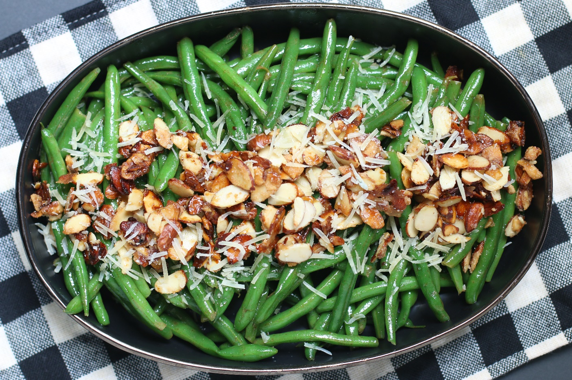

Traditional green beans almondine are a classic French side dish, but today we’re upgrading this simple recipe to an incredibly delicious and flirty Green Beans Almondine with Caramelized Almonds! Picture this – fresh steamed tender green beans, lightly seasoned with garlic and herbs, tossed in a buttery sauce, then sprinkled with Parmesan cheese and topped with sweet and crunchy Caramelized Almonds that add a touch of indulgence to this simple dish. Trust me, this recipe will leave your taste buds (and maybe even your heart) fluttering! This is one of my favorite ways to serve green beans – so simple to make and absolutely delicious! It’s perfect with fresh green beans from our garden or the farmers market, and a family favorite for holiday dinners. Add some crisp bacon crumbles, and it makes for a light and easy summer dinner all by itself!
INGREDIENTS:
GREEN BEANS:
1 pound fresh green beans (preferably haricot verts), trimmed
1 teaspoon salt
¼ cup unsalted butter (or Land O Lakes Cinnamon Sugar Butter)
¼ cup shallots (finely sliced) or sweet onions (minced)
1 clove garlic (finely minced)
1 Tablespoon fresh lemon juice
½ cup grated Parmesan cheese

CARAMELIZED ALMONDS:
3 Tablespoons unsalted butter (or Land O Lakes Cinnamon Sugar Butter)
1 cup sliced almonds
6 Tablespoons granulated sugar

HOW I MAKE THIS:
- PREPARE CARAMELIZED ALMONDS: Line a baking sheet with parchment paper and set aside.
- Melt butter in a 10-inch skillet until bubbling; add almonds and 4 tablespoons of sugar. Cook over medium heat, stirring constantly for about 4-5 minutes, or until the sugar melts and nuts are golden brown. WATCH CAREFULLY TO PREVENT BURNING!
- Remove from heat; sprinkle with remaining 2 Tablespoons sugar.
- Quickly spread on prepared pan; cool completely. Break clusters of caramelized nuts into pieces. Set aside if serving immediately, or store in airtight container if preparing ahead of time.
- PREPARE GREEN BEANS: Fill a large skillet with 1/2-1 inch of water and bring to a boil over high heat. Add the green beans and salt and cover with a lid. Simmer for 3 minutes or until beans are bright green and crisp-tender. Place green beans in a strainer to drain; set aside.
- In the same skillet, melt the butter over medium heat. Add the onions or shallots and salt, and sauté for 2 minutes. Add the garlic and drained green beans and sauté for 2 to 4 more minutes, until the green beans are tender and warmed through.
- Remove the pan from the heat, sprinkle with fresh lemon juice and toss to evenly coat.
- Using tongs, layer half the green beans in a row over a serving platter. Top with half the parmesan cheese, then half of the Caramelized Almonds.
- Repeat layering with green beans, parmesan and Caramelized Almonds.
- Serve warm.
- Store leftovers in a covered container in the refrigerator for up to 3 days. Reheat in a skillet over medium heat for 3-5 minutes.
YIELD: 6 servings, 1 cup of Caramelized Almonds
RECIPE NOTES:
- BROWN BUTTER: If you have the time, I recommend taking an extra step and using brown butter in this recipe. With its golden brown color and rich nutty flavor, it gives Green Beans Almondine a unique taste. You can use brown butter for both toasting the almonds and coating the green beans.
- HOW DO I BROWN BUTTER? To brown butter, melt the butter over medium-low heat in a small heavy saucepan. Once all melted, the butter will start to simmer and foam. This should take 3-4 minutes. Eventually the butter will stop foaming. Keep a close eye on it and watch for golden specks to form at the bottom of the pan. Smell the butter for nutty aromas. This should take about 4-5 minutes. Be careful, as it’s easy to go from brown-butter to burnt-butter. If you think you’ve over-cooked or burned the butter, do not overthink it. Dump it and start again. For this recipe, it is best for the brown butter to not be fully brown yet (light gold color is best) before adding to the almonds or green beans.
- CINNAMON SUGAR BUTTER? For a taste that is absolutely out-of-this-world wonderful, I many times use Land O’Lakes Cinnamon Sugar Butter in place of brown butter or unsalted butter for both the green bean sauce and for caramelizing the almond slices. The hint of cinnamon is incredibly wonderful – but be careful of snitchers munching on the caramelized almonds – they won’t be able to stop!
- WHAT KIND OF ALMONDS CAN I USE? You can use sliced almonds that are either blanched or unblanched (with skin on). The almonds will be lightly toasted in brown butter to develop further nutty flavors with a delicious crunch. As another option, you can use slivered almonds (same quantities).
- WHAT IS DIFFERENCE BETWEEN GREEN BEANS AND HARICOT VERT? French green beans (also called Haricots Verts) are slightly longer, straighter and skinnier than regular green beans and may be a little bit more expensive. They are harvested earlier than regular green beans, so they are usually more tender and flavorful. Either works well for this recipe, along with string beans or even wax beans. When picking out the beans, look for a vibrant color, little to no blemishes, and a strong “snap” to ensure freshness.
- SHOULD I BLANCH THE GREEN BEANS FIRST? To keep fresh green beans nice and crisp and maintain the vibrant green color, you can steam the green beans for 3 minutes and then blanch in ice water and drain well.
- CAN I USE FROZEN GREEN BEANS? Yes, but you’ll have better results (texture and flavor) with fresh green beans. Defrost, rinse with warm water and drain well before sauteing.
- ONIONS OR SHALLOTS? Whichever you prefer! Sweet onions are wonderful, but shallots are a beloved ingredient in French cooking, and they shine in this dish. They have a delicate sweet flavor that pairs perfectly with the nutty brown butter and almonds. When picking out shallots, look for ones that are non-sprouted and that feel dry, firm and heavy for their size. And for something truly incredible, caramelize the onions or shallots for this recipe!
- MAKE AHEAD DIRECTIONS: Green Beans Almondine can be prepared ahead of time, but I recommend storing the green beans and the Caramelized Almonds separately and assembling right before serving. Undercook the green beans slightly when preparing initially and reheat before using. Reheat in a lightly oiled skillet over medium heat, stirring occasionally until warmed through. You can also reheat the green beans in a preheated 350 degree oven in a baking dish (covered with foil) until warmed through, about 15 minutes. Garnish with Caramelized Almonds right before serving.
- CAN I MAKE THIS RECIPE DAIRY FREE? Yes! Simply use vegan butter or olive oil instead of the butter.
- CARAMELIZED ALMONDS are great for topping fresh salads, yogurt, added to granola, caramel corn or oatmeal cookies, or simply for snacking and munching on! Store in an airtight container for up to 1-2 weeks.
RECIPE VARIATIONS:
- CARAMELIZED ONION: For extra-level incredible, caramelize the onions/shallots for this recipe. You’ll want to start with onions that are sliced ¼ to 1/3-inch thick. Simply caramelize in the large fry pan with a drizzle of olive oil and a sprinkling of sugar prior to adding the garlic and green beans. Note that caramelizing onions takes some time – allow 15-20 minutes, stirring occasionally until tender and caramelized.
- BACON GREEN BEANS ALMONDINE: These are the best green beans ever, but when you add bacon, they just might be even better! Sprinkle ½ cup of hickory smoked bacon bits in the middle and liberally on top before adding the Caramelized Almonds.
- GARLIC: Not only does this easy green bean recipe taste great with onions, but it’s also pretty amazing with garlic too. Just add in some minced garlic (regular or fire roasted) when you are sauteing the green beans – you don’t want to add it sooner or it will burn. If you LOVE garlic, feel free to add an extra clove or two!
- MUSHROOMS: Anyone who loves mushrooms is going to fall in love with the combination of these skillet green beans and mushrooms together. You’d want to saute fresh mushrooms together with the onions if you want to include them.
- CARROTS: Thinly slice (Julianne style) carrots and toss them into the pan. They add extra flavor and color to the dish.
- CRAISINS: For special holiday dinners, sprinkle with craisins (dried cranberries).
- FETA CHEESE: Replace the parmesan cheese with feta cheese for something delicious and different!

Original recipe created by Snowflakes & Coffeecakes June 2010; revised and reposted June 2023.
© SnowflakesandCoffeecakes. All images, attachments & content are copyright protected. All rights reserved. Please do not use my images without prior permission. If you want to republish this recipe, please re-write the recipe in your own words, or link back to www.snowflakesandcoffeecakes.com for the recipe.

Tried it and loved it? Snap a picture and share it with me on Instagram @SnowflakesandCoffeecakes and by using the hashtag #SnowflakesandCoffeecakes.

