lilac sugar
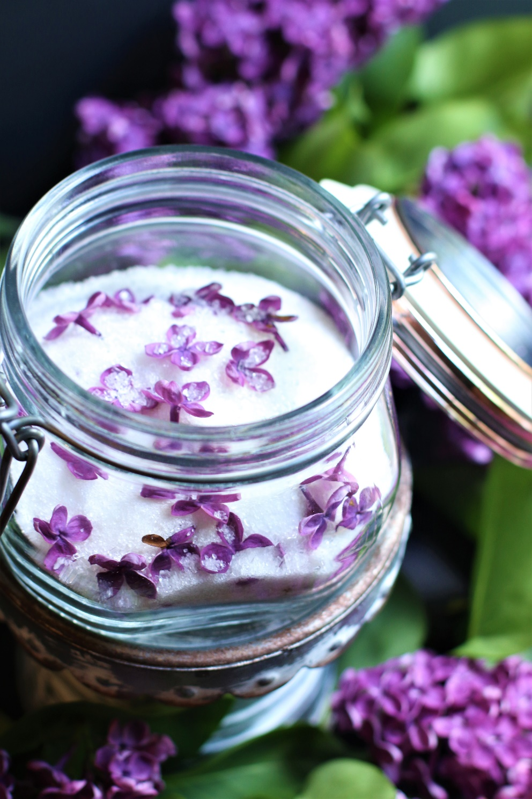

Spring is the season of new beginnings, and what better way to welcome it than with a sweet treat that embodies the essence of the season? Lilac Sugar and Lilac Simple Syrup are delightful ingredients that bring a unique floral flavor to so many things! Lilac Sugar and Lilac Simple Syrup are not only delicious and so easy to make, but the soft purple color adds a pop of color to any dish, and the delicate flavor of lilac adds a touch of old-fashioned sophistication to your springtime entertaining. Lilac Sugar and Lilac Simple Syrup capture the essence of spring in every bite. With its unique flavor and charming appearance, both are the perfect addition to your spring baking and beverage repertoire.
INGREDIENTS:
LILAC SUGAR:
1 cup fresh lilac petals
2 cups granulated or sparkling sugar

LILAC SIMPLE SYRUP:
4 cups lilac florets
2 cups granulated sugar
2 cups water
HOW I MAKE THESE:
- PREPARE LILACS: Choose vibrant lilac blooms that have just opened and that aren't yet turning brown - a few unopened buds are no problem.
- It is important to NOT WASH the lilac flowers or petals.
- Give your lilac blooms a good shake to be sure there isn’t any dirt or small bugs clinging on to any of the blossoms.
- Give the individual flower petals a slight tug, and they should easily slide right off, detaching from the little green stem at its base. Make sure to only save the purple floret as the tiny green stems can make the Lilac Sugar or Lilac Simple Syrup bitter.
- TO PREPARE LILAC SUGAR: In a glass mason jar, simply layer the lilac petals with sugar. Start by placing a couple of tablespoons of sugar in the bottom of a jar. Layer about a heaping tablespoon of lilac blossoms on top of the sugar.
- Repeat the layers, ending with sugar as the top layer.
- Cover and gently shake the closed jar.
- Place in a dark, dry place, remembering to gently shake the jar every day for a week to mix the sugar and prevent lumps (the sugar pulls moisture from the lilac blossoms, and you don't want a solid mass of sugar).
- After the lilac petals are dry (it takes about a week), you can sift the preserved and candied flower petals out of the sugar using a fine-mesh strainer, or leave them in for more color and flavor.
- Store Lilac Sugar in a cool dark place.
- TO PREPARE LILAC SIMPLE SYRUP: In a small heavy saucepan, stir together fresh lilac florets, sugar and water. In a small saucepan, combine the sugar and water over medium heat. Bring to a boil while stirring until all of the sugar has dissolved. Add the lilac florets, stir gently, and cover. Reduce heat and simmer for about 5 minutes. Remove the pan from the heat, keep it covered, and wait.
- As it cools and rests, the lilacs will add their sweet flavor to the syrup. The time it takes to steep will depend on the variety of lilacs and how intense you want the flavor. Since it is a delicate flower, it usually takes 3 to 8 hours to fully infuse flavor and color.
- Pour the syrup into a fine-mesh strainer resting on a large bowl. Allow it to sit for a few minutes and shake it occasionally so more of the syrup filters through the flowers and drips into the bowl.
- After straining, pour the finished lilac syrup into a glass container with a tight-sealing lid. Refrigerate in a well-sealed jar or airtight container for about two weeks. Check for spoilage before using – if it is cloudy at all, don’t use. Lilac simple syrup can be stored longer in an airtight container in the freezer, or for individual servings, you can also pour in ice cube trays and freeze. Frozen Lilac Simply Syrup will be good for up to six months.
YIELD: 2 cups Lilac Sugar (or 2 cups Lilac Simple Syrup)
HOW TO USE LILAC SUGAR:
You can use Lilac Sugar anywhere you’d use granulated sugar or sparkling sugar to add a summery light lilac flavor. For most beverage, baking or dessert recipes, simply replace the granulated sugar with lilac infused sugar, or sprinkle on top for a delicate sugar topping:
- Shortbread Cookies
- Sugar Cookies (especially for tea parties or garden teas)
- Tea Cakes & Petit Fours
- Rosettes
- Springtime cakes, cupcakes, pound cakes or bundt cakes (especially good in vanilla and coconut cakes)
- Blueberry Muffins
- Buttercream Frosting (especially vanilla, vanilla bean and blackberry)
- Pancakes and Crepes
- Vanilla Pudding​
- Sprinkle on Fresh Spring or Summer Berries
- Add a touch of springtime charm by using Lilac Sugar to sweeten your morning tea or coffee
- Perfect for making Lilac Sugar Facial Scrubs!

HOW TO USE LILAC SIMPLE SYRUP:
You can use Lilac Simply Syrup in your favorite beverages to add a summery light lilac flavor:
- Lilac Sparkling Water
- Fresh Lemonade
- Sweet Tea
- Spring and Summer Cocktails
- You can also make Lilac Ice Cubes by adding Lilac Simple Syrup to water (1:1 ratio) and adding a sprig of fresh lilac flowers before freezing. So fun for garden teas and bridal showers!
RECIPE NOTES:
- In early spring, choose vibrant lilac blooms that have just opened and that aren't yet turning brown. A few unopened buds are no problem. You will get the best flavor from sprigs that have just bloomed.
- It is important to NOT WASH the lilac flowers or petals.
- Simply give your lilacs a good shake to be sure there aren’t any small bugs clinging on to any of the blossoms, then carefully remove individual blossoms from the stems.
- Give the individual flower petals a slight tug, and they should slide right off, detaching from the little green stem at its base. Make sure to only save the purple floret as the tiny green stems can make the Lilac Sugar or Lilac Simple Syrup bitter.
- Taste test your Lilac Simple Syrup regularly. After three hours, it will develop a soft flavor; if you let it steep for eight hours, it will be perfect. The syrup should have a floral intensity that will become balanced once it's added to drinks, neither overpowering nor disappearing against the other ingredients.

Original recipe created by Snowflakes & Coffeecakes May 2023.
© SnowflakesandCoffeecakes. All images, attachments & content are copyright protected. All rights reserved. Please do not use my images without prior permission. If you want to republish this recipe, please re-write the recipe in your own words, or link back to www.snowflakesandcoffeecakes.com for the recipe.

Tried it and loved it? Snap a picture and share it with me on Instagram @SnowflakesandCoffeecakes and by using the hashtag #SnowflakesandCoffeecakes.

