pork tenderloin with Sesame ginger glaze

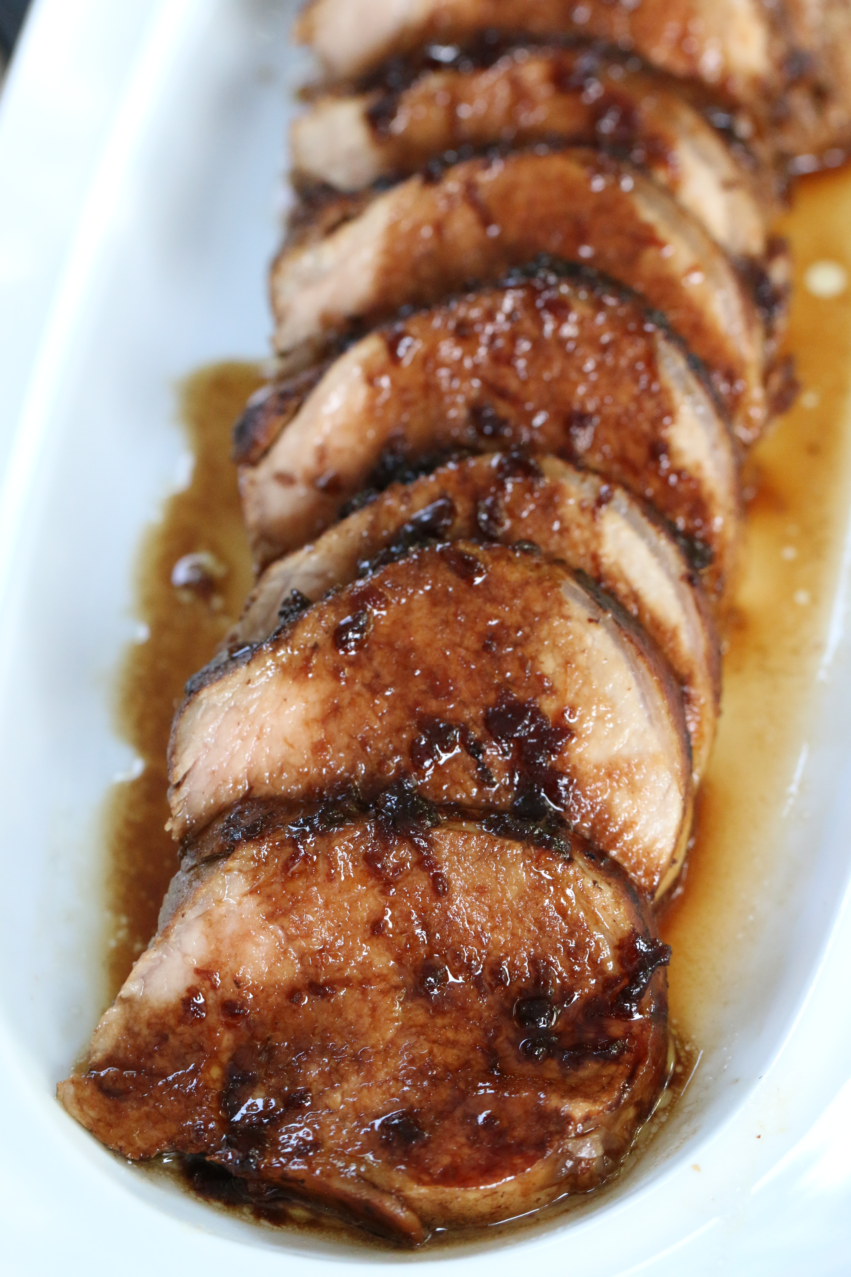
Perfect for a special dinner! Very flavorful and moist – the glaze is divine.
Easy to prepare and impressive to serve!

INGREDIENTS:
2 1/2 lb Pork Tenderloin
1/2 cup balsamic port vinegar
1/2 cup low sodium soy sauce
1/2 cup olive oil
4 tablespoons sesame oil
4 tablespoons grated fresh ginger
2 shallot, peeled and chopped (about 1/2 cup)
salt and pepper
olive oil for searing meat
HOW I MAKE THIS:
- Place the pork tenderloin in a gallon Ziplock bag.
- Whisk all of the ingredients together in a bowl and pour 3/4 cup of the marinade over the pork. Squish the pork around in the bag to make sure has covered all areas of the pork.
- Reserve the remaining marinade to make a reduction after the pork is cooked. Do not put the reserve marinade on the pork. Set aside remaining marinade.
- Marinate the pork for at least 2 and up to 24 hours in refrigerator.
- When ready to cook, remove marinaded meat from refrigerator and let sit at room temperature for an hour.
- Preheat oven to 425, with rack on top third of oven.
- Turn the heat on the stove to medium high heat. Pour two tablespoons of olive oil into a searing pan after the pan is hot.
- Remove the meat from the marinade and season the meat generously with salt and pepper. Let any excess marinade drip off the meat before searing, so you won't get splattered by the hot oil/liquid reaction. Discard marinade.
- Using tongs, carefully turn and sear the meat on all sides for about 2 minutes per side. It is going to spit and sizzle like crazy – so stand back when you are placing this in your searing pan!
- When the meat is browned on all sides, remove from pan with tongs and set on a baking sheet.
- Cook for 18 minutes at 425 degrees. Do not over cook. Remove meat from oven, and immediately wrap meat tightly in plastic wrap; set aside.
- Make the reduction:
Take the remaining reserved marinade (that was not used with meat) and place in the same pan used to sear the meat, do not wipe out pan. Heat over medium high heat until boiling. Simmer for one to two minutes. Add water if too thick (1-2 tablespoons). Remove from heat.
- When ready to serve: Remove the meat from plastic wrap. Place on cutting board and slice into 3/4-1 inch thick medallions. Place the meat on a serving platter and pour the sauce over the meat.
YIELD: Serves 8
VERY IMPORTANT TIPS:
- Buy the right kind of pork. This is Pork Tenderloin. The package is long and skinny. Pork Tenderloin is often confused with Pork Loin. Do not buy Pork Loin roast. It's usually a fat (shaped) roast. It doesn't work well with this cooking method. Check the name of the cut of meat carefully. Remember, the package is long and skinny. You will find nice pork tenderloins at Costco in a two-pack. If you purchase in a two pack, usually one side of the package will weigh about 2 1/2 lbs. or enough for a single recipe above. If you double the recipe, I would 1 1/2 times the sauce. You won't need two times the sauce/marinade.
- Make sure the oven is preheated for at least 10 minutes before cooking the pork. You want the oven to be all the way up to temperature.
- Wrapping the meat: Use plastic wrap. This adds an extra measure of trapping the juice in, and next to the meat. If you are waiting more than about 10 minutes to serve dinner after the pork is cooked, try wrapping in foil over the plastic wrap as well to keep it warm. One more note about wrapping the meat in plastic wrap – this method is used by chefs all over the country – and no, the plastic wrap won’t melt!
- Don't overcook the meat. It will continue to cook after you remove it from the oven and while wrapped in plastic wrap.
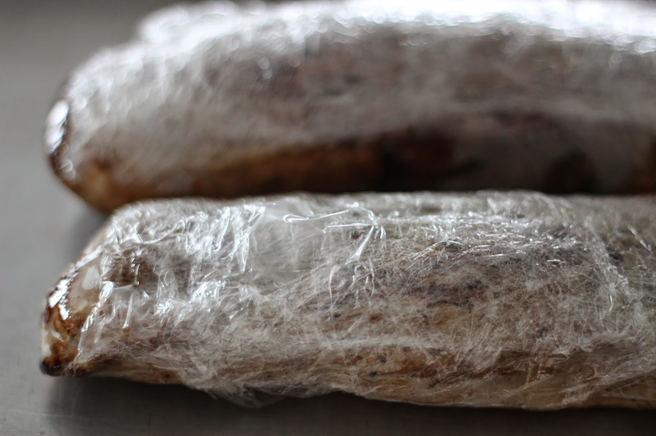
All writing, images, attachments and photography is Copyrighted 2010 by Snowflakes & Coffeecakes Cooking School - www.snowflakesandcoffeecakes.com - unless otherwise indicated. All rights reserved.

