ROSETTES
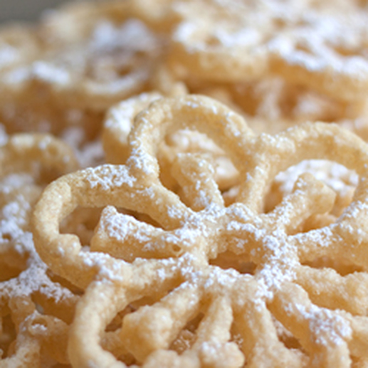

This is another family favorite recipe – a Scandinavian holiday treat that my Mom made every year with her best friend! They would spend a quiet afternoon making these without any kids around and sip on just a bit of brandy…good conversation and good times!

INGREDIENTS:
2 cups flour
2 Tablespoons sugar
1 teaspoon salt
1-1/2 cups whole milk
1 teaspoon vanilla
2 large eggs (room temperature)
2 tablespoons vegetable oil
Additional vegetable oil (for frying)

EQUIPMENT YOU’LL NEED:
Rosette Iron
Electric Skillet

SPRINKLE WITH ANY OF THE FOLLOWING BEFORE SERVING:
Powdered Sugar
Cinnamon Sugar
Granulated Sugar

HOW I MAKE THESE:
- In a mixing bowl, whisk together the flour, sugar and salt. In a separate bowl, mix together the milk, egg, vanilla and oil. Slowly add flour mixture and blend until smooth. DO NOT OVERMIX, or cookies will blister. Cover and chill batter for one hour before cooking.
- Fill electric skillet with 4 inches of good quality cooking oil. Heat electric skillet or deep fryer to 365 degrees. Arrange double layers of paper towels on top of wire baking racks – this will be your draining tray.
- Dip rosette iron in oil to heat it (about 1 minute), remove the iron from the oil, blot lightly on paper towels and then dip in the rosette batter up to ¼ inch from the top of the iron – the batter should not go over the top of the iron design.
- Submerge battered iron immediately into hot oil. After about 30 seconds, lightly shake up and down, and the rosette should slide right off. Fry until golden, 30 to 45 seconds (depending on the shape of the size/shape of the iron you are using) – flipping gently with a pair of tongs to brown the other side.
- When golden brown on both sides, lift rosettes and place hollow side down on a rack covered with paper towels to drain and cool. If the rosettes did not release from the rosette iron when you were frying, gently push the rosette off the iron with a fork.
- Stir batter between each rosette. Reheat iron 1 minute; make next rosette.
- Just before serving, (1) dip upside down in granulated sugar or cinnamon sugar; or (2) sprinkle the tops with sifted powdered sugar. (The rosettes will get soggy and the sugar will “melt off” the rosette if you sprinkle sugar it on before storing.)
- Store in a large airtight container with paper towels between each layer of rosettes - these are REALLY FRAGILE! Rosettes do not keep long – plan on serving them within 2 or 3 days.

NOTES:
- Soggy rosette? It should be fairly crisp as soon as it is slightly cool. Your vegetable oil may be too cool or you are not frying long enough. Also, make sure you drain these hollow side down - the oil needs to drain off the edges.
- Lots of blisters on your rosette? You overbeat your eggs.
- Can’t get the rosette off the iron? Gently remove with a fork. You may have dipped it too deep in the batter.
YIELD: Makes approximately 50 rosettes.
© SnowflakesandCoffeecakes. All images, attachments & content are copyright protected unless otherwise indicated. All rights reserved. Please do not use my images without prior permission. If you want to republish this recipe, please re-write the recipe in your own words, or link back to www.snowflakesandcoffeecakes.com for the recipe.
