easy crockpot lasagna
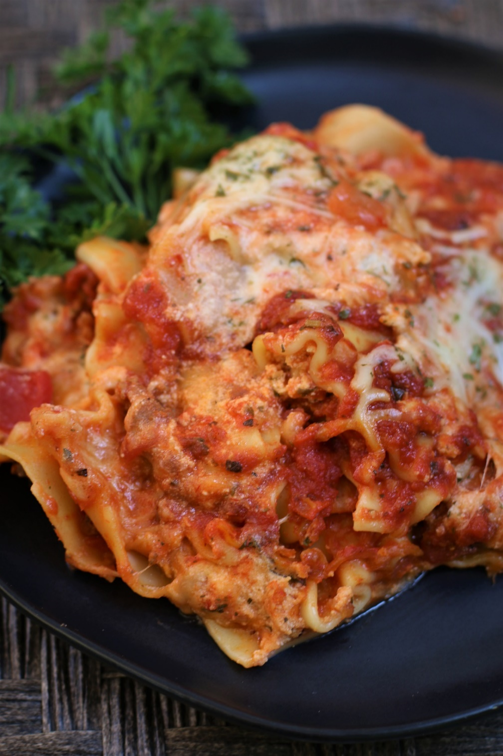

Lasagna is a classic comfort food, and no one can resist this Easy Crockpot Lasagna, which tastes just as wonderful as traditional lasagna, but is so incredibly fast and easy to make! Perfect for those busy nights when you know you won’t have time to make dinner, but delicious enough for company when you don’t want to spend all day in the kitchen! Layers of tender pasta, flavorful meat sauce and a delightfully cheesy texture and flavor make for a home-cooked lasagna that is loaded with Italian flavor. Serve this delicious homemade lasagna alongside a simple salad and cheesy garlic bread for a cozy dinner that’s perfect anytime of the year!
While I’m sure everyone will say their lasagna recipe is the best, not everyone can say their recipe is both easy and beyond delicious! The beauty of this recipe is the noodles, sauce, meat, herbed ricotta filling and flavorful cheeses simmering and cooking together for four hours until they are bursting with flavor! When it comes to developing flavor in Italian cuisine, it is all about the low and slow, and that’s what you get with this easy crockpot lasagna recipe!

INGREDIENTS:
ITALIAN SAUCE:
2 lbs. Italian sausage
4 garlic cloves (minced)
3-24 oz jars marinara sauce (I use Classico Italian Sausage with Peppers & Onions)
1 tablespoon Italian seasoning
salt and pepper to taste

HERB RICOTTA CHEESE FILLING:
15 oz. whole milk ricotta
2 cups (8 ounces) Italian Shredded Cheese Blend (mozzarella, smoked provolone, asiago, parmesan, romano & fontina cheeses)
1/3 cup fresh parsley (chopped)
1 tablespoon Italian seasoning

FOR LASAGNA:
15-18 lasagna noodles* - UNCOOKED
18 oz mozzarella (shredded)(reserve 1 cup)
Fresh parsley (chopped)

HOW I MAKE THIS:
- PREPARE SAUCE: In a large skillet or Dutch oven, brown sausage until brown. Add garlic and cook for one minute. Drain the sausage of any liquid or grease that may have accumulated.
- Add marinara sauce and simmer for about 5 minutes; remove from heat.
- PREPARE CHEESE FILLING: In a medium bowl, mix ricotta, shredded Italian cheese blend, Italian seasoning and chopped parsley, stirring until fluffy and well blended.
- PREPARE SLOW COOKER: Spray the bottom and sides of a large crock pot with nonstick cooking spray.
- ASSEMBLE LASAGNA: Begin layering, starting with the sauce. Pour 2-3 cups of sauce on the bottom of the slow cooker, making sure that the entire bottom is covered with sauce.
- Add a single layer of uncooked lasagna noodles to cover the sauce, breaking the noodles as necessary to make them fit – think of it as a noodle jigsaw puzzle!
- Add a thin layer of Cheese Filling on top of the lasagna noodles – you can use a spoon or your fingers to do this easily without disturbing the layer of noodles.
- Generously sprinkle a layer of shredded mozzarella cheese on top of the Italian Sauce.
- Repeat these layers until all ingredients are used and it fills your crock pot. (Italian Sauce, noodles, cheese filling, shredded mozzarella, etc.), ending with a layer of shredded mozzarella cheese on top. I typically have 3 layers in my rectangular crockpot, 4 layers in an oval crockpot, or 5 layers in a circular crock pot.
- Cover and cook on LOW for 4-5 hours, or until the noodles are soft, being careful not to overcook. Resist the urge to lift the cover to check on progress during this period – you want to keep it covered as constantly as possible to retain heat and moisture for best results – this is really important for the noodles to cook properly!
- After four hours, test for doneness! Remove cover and stick a table knife in the center – if it is tender all the way thru to the bottom, the edges are golden brown, and the top of the lasagna is hot and bubbling, you’ll know you’re getting close!
- Sprinkle with 1 cup of reserved mozzarella cheese. Cover with the lid and keep covered until the cheese is melted.
- Once final layer of cheese is melted, keep covered and allow to sit for 30 minutes before serving.
- Sprinkle with fresh parsley and serve warm!
YIELD: 12-15 servings
RECIPE NOTES:
WHAT IS THE BEST SLOW COOKER FOR THIS RECIPE? Use a large crockpot for best results. It’s easier to make in a 5 or 6-quart rectangular or oval slow cooker than in a circular crockpot. If you use a 3 quart crockpot, you’ll need to cut the recipe in half.
TO KEEP LASAGNA FROM STICKING & BURNING: Be sure to spray the crock pot with non-stick cooking spray prior to adding the ingredients, or line it with a slow cooker liner. This will make it easier to remove when it comes time for serving and makes clean up quicker and easier! In addition to this, we add 2-3 cups of sauce on the bottom of the slow cooker before adding any layers of noodles, which also prevents the lasagna from sticking and burning. This same sauce trick works if you were to use the oven instead of a crockpot to bake this recipe!
HOW MANY LASAGNA NOODLES WILL I NEED? For a rectangular or oval slow cooker, you’ll probably use 18 noodles; for a circular crock pot you’ll probably only use 15 noodles. There are usually 18 noodles in a box of lasagna noodles.
HOW MANY LAYERS IN THIS LASAGNA? I typically have 3 layers in my rectangular crockpot, 4 layers in my oval crockpot, or 5 layers in a circular crock pot.
COOK ON LOW SETTING: For best results, do not cook on the high heat setting! Cooking on a high temp will cause the outside (and sometimes bottom) to cook too quickly, resulting in dry edges and noodles that aren’t tender.
REST BEFORE SERVING: I recommend allowing the lasagna to rest for 30 minutes before serving, as this will allow the lasagna to settle and firm up, and will make cutting and serving much easier.
MAKE AHEAD DIRECTIONS: To make ahead of time, layer the ingredients in the slow cooker the night before and refrigerate. The next day, cook according to instructions. You may need to add an extra 30 minutes of cooking time, or you can remove from the refrigerator and allow to sit at room temperature for one hour before starting to cook.
STORING LASAGNA: Place leftover lasagna in an airtight container and refrigerate for up to 5 days. Reheat either in the oven or in the microwave until warm.
FREEZING LASAGNA: Let lasagna cool completely and then cut into individual servings, placing in freezer-safe airtight containers and mark them with the date. The lasagna will keep in the freezer for up to 3 months.
REHEATING LASAGNA: Place individual servings in a microwave safe container. To minimize splattering and to ensure that the lasagna tastes fresh and moist after reheating, sprinkle a little water on top and cover with a damp paper towel before microwaving. Reheat in the microwave for 3-4 minutes on 50% power – add additional minutes at 50% power as necessary until heated through. If you refrigerated the crockpot with leftover lasagna, you can reheat the entire casserole after sprinkling the top with water, cover with foil and bake in a 350 F oven for about 30 minutes.

Original recipe created by Snowflakes & Coffeecakes June 2014; revised and reposted June 2022.
© SnowflakesandCoffeecakes. All images, attachments & content are copyright protected. All rights reserved. Please do not use my images without prior permission. If you want to republish this recipe, please re-write the recipe in your own words, or link back to www.snowflakesandcoffeecakes.com for the recipe.

Tried it and loved it? Snap a picture and share it with me on Instagram @SnowflakesandCoffeecakes and by using the hashtag #SnowflakesandCoffeecakes.

RECIPE FAQ’S:

HOW LONG DOES IT TAKE TO MAKE EASY CROCKPOT LASAGNA?
This easy lasagna recipe takes about 30 minutes to assemble, and 4 to 5 hours to cook in the crockpot (on the low setting). You want the cheese on top to be nice and bubbly, and the noodles to be fork tender. I recommend keeping an eye on it at about the 4 hour mark, so that it doesn’t overcook and dry out. Let it rest for 30 minutes before serving, and a dinner that everyone will love is ready!
DO I HAVE TO PRECOOK THE NOODLES?
No! One of the best things about this recipe is that there is no need to pre-cook the lasagna noodles, which is such a time saver! Regular lasagna noodles soften up perfectly as the lasagna cooks and will be perfectly tender when you are ready to serve. Because you’ll be using dry noodles to assemble this lasagna, you’ll want to make sure that all of the noodles are covered with sauce so that they absorb moisture, cook fully and become tender. I don’t recommend using “oven-ready” noodles or gluten free noodles for this recipe, as they can become mushy.
HOW DO I KEEP THE BOTTOM OF MY LASAGNA FROM BURNING?
Be sure to spray the crock pot with non-stick cooking spray prior to adding the ingredients, or line your crockpot with a slow cooker liner. This will make it easier to remove when it comes time for serving and makes clean up quicker and easier! In addition to this, we add 2-3 cups of sauce on the bottom of the slow cooker before adding any layers of noodles, which also helps prevent the lasagna from sticking and burning.
WHAT IS THE BEST SAUCE TO USE FOR CROCKPOT LASAGNA?
You can use whatever type of marinara sauce you’d like! Pick your favorite or use what you have in your pantry. I use Classico Italian Sausage with Peppers & Onions, but you can change the flavor of the lasagna by using a simple marinara sauce, four-cheese sauce, or even try Alfredo Sauce for something different!
DO I HAVE TO USE ITALIAN SAUSAGE?
Sweet Italian sausage is one of the easiest ways to get perfect flavor in Italian recipes without added effort. If you prefer, you can substitute regular ground beef or ground turkey, or leave the meat out altogether for a meat-free lasagna. This recipe is so easy to customize!
CAN I MAKE THIS AHEAD OF TIME?
To make ahead of time, layer the ingredients in the slow cooker the night before and refrigerate. The next day, cook according to instructions. You may need to add an extra 30 minutes of cooking time, or you can remove from the refrigerator and allow to sit at room temperature for one hour before starting to cook.

