crumbl peach sugar cookies
WITH TROLLI PEACHIE O’S
(COPYCAT RECIPE)
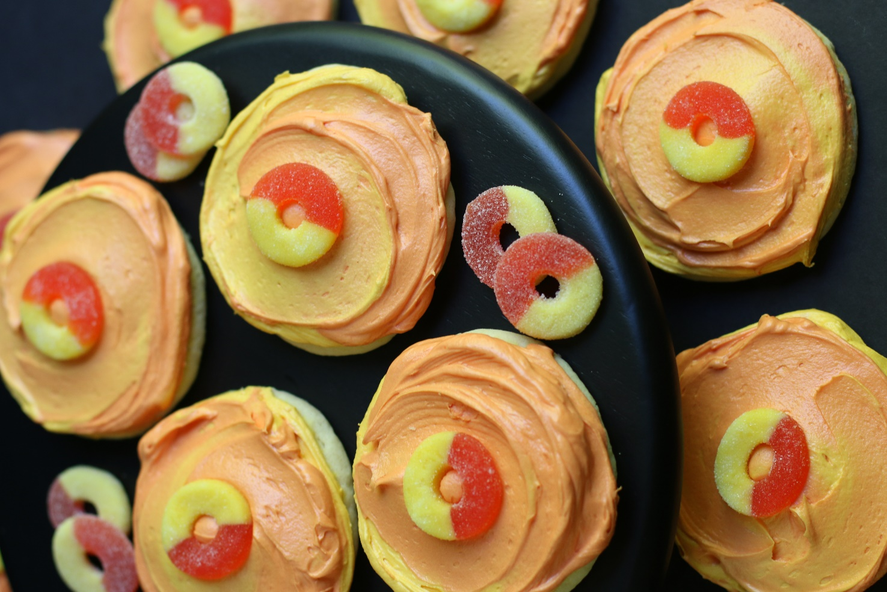

No need to wait for the Peach Truck! If you love fresh summer peaches, you are going to love this copycat recipe for Crumbl Peach Sugar Cookies! Thick and tender peach sugar cookies swirled with sweet and juicy Peach Buttercream Frosting, and topped with Trolli Peachie O’s gummy candy are truly a treat! Not only do these smell like a soft and fuzzy ripe peach, these cookies are exploding with fresh peach flavor – truly extraordinary cookies! As my family always says, “These are better than Crumbl!”
INGREDIENTS:
PEACH SUGAR COOKIE BASE:
1 cup unsalted butter (softened)
2 large eggs (room temperature)
1 cup (200g) granulated sugar
1 tablespoon pure vanilla extract
2-3/4 cups (330g) all-purpose flour
1/4 cup (35g) freeze-dried peach powder*
2 tablespoons cornstarch
1 tablespoon milk powder
2 teaspoons baking powder
½ teaspoon salt

PEACH BUTTERCREAM FROSTING:
1/2 cup salted butter softened
3 cups (360g) powdered sugar
1/4 cup (35g) freeze-dried peach powder*
1/4 teaspoon pure almond extract
2-4 tablespoons milk or half & half
AmeriColor Soft Gel Food Coloring – Peach & Electric Pink

GARNISH:
Trolli Peachie O’s gummy candy

HOW I MAKE THESE:
- Set eggs and butter out to come to room temperature (this helps them incorporate into the cookie dough better).
- Pulverize the freeze dried peaches in a blender or small bag until they become a powder; set aside.
- Preheat oven to 350 degrees. Line three baking sheets with parchment paper; set aside.
- PREPARE COOKIES: In a medium bowl, whisk together the flour, peach powder, cornstarch, milk powder, baking powder and salt; set aside.
- In a large bowl using a hand-held mixer or stand mixer fitted with a paddle attachment, beat the butter and sugar on medium speed until completely creamy and fluffy (about 3 minutes).
- Scrape down the sides and add in the eggs one at a time, beating well between each is fully mixed in.
- Add vanilla extract and beat until mixed.
- Scrape down the sides and add in the flour mixture, ½ at a time, mixing just until blended; add remaining flour mixture and again mix just until blended. This cookie dough will be really soft and creamy!
- Using a large cookie scoop (3 Tablespoon size), scoop out cookie dough and roll into a ball with your hands. Repeat with remaining dough.
- Place six cookie dough balls on each baking sheet, leaving room between each cookie as the cookies will spread when they bake.
- Bake for 9-11 minutes or until the centers of the cookies have puffed up and are no longer glossy. Every oven is a little bit different, so watch your first batch when baking and time accordingly. DO NOT OVERBAKE, as these will lose their softness.
- Remove from oven and allow cookies to cool on the baking sheets.
- PREPARE PEACH BUTTERCREAM FROSTING: In the bowl of a stand mixer fitted with a paddle attachment, add softened butter, peach powder, powdered sugar, almond extract and 2 tablespoons of milk or half & half.
- Beat on low speed until all ingredients are combined, then increase speed to medium-high and beat until light and fluffy (about 5 minutes); add additional milk or half & half as necessary until you the frosting is spreading consistency. If your frosting is too thin, add a little bit of powdered sugar and beat until light and fluffy.
- Add gel food coloring, if desired, and continue beating until well blended, scraping down the sides of the bowl as necessary.
- FROST & DECORATE: Spread the frosting on the cookies while they are completely cool. Place a Trolli Peachie O gummy candy in the middle of each cookie.
- OPTIONAL: If desired, use a fine mesh sieve to garnish the top of cookies with the peach powder, rather than using gummy peaches.
- Once the cookies are frosted and decorated, chill in the fridge until ready to serve. Allow decorated cookies to set and dry completely before storing – keep parchment paper between each layer or place cookies in individual self-sealing bags for easy freezing and serving.
- These cookies are best served chilled.
YIELD: Makes 18 (four-inch) cookies
RECIPE NOTES:
FREEZE DRIED PEACHES: A 1.25-ounce (37g) bag will yield about 1/4 cup when ground. I recommend grinding them in a high speed blender or food processor for best results.
NO FREEZE DRIED PEACHES? You can substitute 2 tablespoons of Natural Peach Emulsion in the cookies and 2 teaspoons of Natural Peach Emulsion in the Peach Buttercream. I recommend Amoretti Artisan Peach Natural Flavors.
WEIGH INGREDIENTS CAREFULLY FOR BEST RESULTS: If I can only share one baking secret with you, always use a DIGITAL KITCHEN SCALE. You can use measuring cups and spoons for most recipes, but using a digital scale makes for the more consistent and efficient baking. Take this from someone that bakes A LOT!
TO KEEP THESE COOKIES SOFT: These cookies will stay soft and fresh in an air-tight container refrigerated for up to 5 days. These cookies are best the day you make them – the cookies may soften up after a day or two.
MAKE AHEAD TIP: Baked and frosted cookies freeze well for up to 1 month. You can also bake the cookies and freeze UNFROSTED for up to 2 months – simply defrost and then frost before you plan on serving.
BEFORE FREEZING: With frosted cookies, it’s important to freeze the cookie prior to placing them into a container so that the frosting remains intact. Place all frosted cookies on a parchment paper lined baking sheet and pop it in the freezer. Once the icing is set and hard (usually an hour) or the cookies are frozen solid, the cookies can be frozen in containers with parchment paper between layers.
HOW TO THAW FROSTED COOKIES: For frosted cookies or “served chilled” cookies, thaw them in the fridge and NOT at room temp. For chilled cookies, you need to maintain refrigeration throughout the thawing process up until the time you eat the cookie for food safety. To keep your cookies from getting soggy and frosting from losing its shape and texture, remove from the freezer and place the unopened container in the refrigerator overnight to thaw. Cookies that are not frosted can thaw overnight UNOPENED on your kitchen countertop.
FOR PARTIES: I package cookies individually in self-sealing clear cellophane cello bags (Pack It Chic are my favorite brand). Make sure cookies are completely set after decorating before packaging. To make ahead, place individually wrapped and sealed cookies in a larger airtight container and refrigerate or freeze. Thaw frozen cookies unopened in the refrigerator - you are trying to minimize moisture during defrosting, which can cause your frosting to soften too much and loose detail.

Original recipe created by Snowflakes & Coffeecakes; published April 2022.
© SnowflakesandCoffeecakes. All images, attachments & content are copyright protected. All rights reserved. Please do not use my images without prior permission. If you want to republish this recipe, please re-write the recipe in your own words, or link back to www.snowflakesandcoffeecakes.com for the recipe.

Tried it and loved it? Snap a picture and share it with me on Instagram @SnowflakesandCoffeecakes and by using the hashtag #SnowflakesandCoffeecakes.

HOW TO MAKE FREEZE DRIED PEACH POWDER:
- Freeze-dried versus dried fruit. Don’t confuse freeze-dried fruit with dried fruits. Freeze-dried fruits have had all moisture removed so that they’re light, dry, and crispy, as opposed to dried fruits that are moist, bendable and leathery (such as raisins or fruit bars).
- You can find freeze dried peaches in the dried fruit section of your market. I use Target brand Good & Gather; you can also buy them in bulk online from ohnuts.com or Amazon.com. Trader Joe’s has a great selection of freeze-dried fruit, but alas, no peaches.
- Put the freeze dried peaches in a high speed blender and blitz until they become a fine powder. This will happen almost instantly! You can use a food processor instead, but the powder won’t be as fine.
- A 1.25 ounce (35g) bag of freeze dried peaches makes about ¼ cup of delicious peach ‘dust’ or freeze dried peach powder.

