salted caramel cheesecake COOKIES (crumbl copycat)
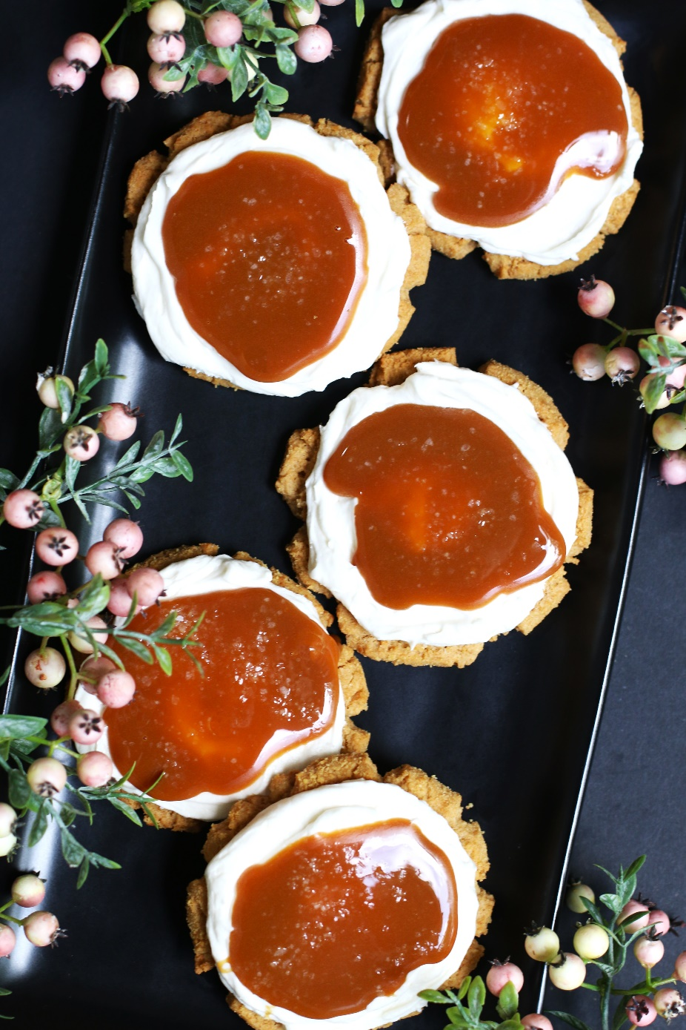

Step into the world of indulgence with Salted Caramel Cheesecake Cookies - a delectable treat that combines the creaminess of cheesecake with a soft, chewy cookie base, the irresistible allure of silky salted caramel, topped with a sprinkle of flaky sea salt. Get ready for a cookie experience that's equal parts chewy, gooey, and downright delightful! Whether you're a baking enthusiast or just someone with a sweet tooth, these Crumbl-inspired cookies are about to become your new obsession! These cookies are one of my most-requested by family and friends – the combination of textures and flavors is simply out of this world.
So fast and easy to make, Salted Caramel Cheesecake Cookies are always a favorite for special occasions and everyday treats. Take it from this cookie lover - better than Crumbl? Without a doubt!
INGREDIENTS:
GRAHAM CRACKER COOKIE BASE:
1 large egg (room temperature)
½ cup (1 sticks) unsalted butter (softened)
¾ cup (165g) light or dark brown sugar
¼ cup (50g) granulated sugar
1-1/3 cups (160g) all-purpose flour
1-1/4 cups (150g) graham cracker crumbs (plus an extra ½ cup (60g) for rolling dough)
1 Tablespoon cornstarch
1 Tablespoon milk powder
¾ teaspoon baking soda
½ teaspoon baking powder
½ teaspoon salt
1 Tablespoon light corn syrup
1 teaspoon pure vanilla extract

SALTED CARAMEL CHEESECAKE FROSTING:
8 ounces cream cheese (softened)
4 tablespoons (1/2 stick) unsalted butter (softened)
1/3 cup Salted Caramel Sauce
4 cups (480g) powdered sugar
1 teaspoon pure vanilla extract or vanilla bean paste
Pinch of salt

SALTED CARAMEL SAUCE:
1 cup (207g) granulated sugar
1/2 cup water
1/4 cup (56g) unsalted butter
1/2 cup heavy whipping cream
1/2 Tablespoon pure vanilla extract
1/2 to 1 teaspoon salt

GARNISH:
Flaky Sea Salt

HOW I MAKE THESE:
- Set egg and butter out to come to room temperature (this helps them incorporate into the cookie dough better).
- PREPARE GRAHAM CRACKER COOKIE BASE: In a medium bowl, whisk together the flour, graham cracker crumbs, cornstarch, milk powder, baking soda, baking powder and salt until well combined; set aside.
- In a large bowl using a hand-held mixer or stand mixer fitted with a paddle attachment, beat the butter and both sugars on medium speed until completely creamy and fluffy (about 3-4 minutes).
- Scrape down the sides and add in the egg, beating well until fully mixed in.
- Add corn syrup and vanilla extract; beat until well blended.
- Scrape down the sides and add in the flour mixture, ½ at a time, mixing just until blended; add remaining flour mixture and again mix just until blended. This cookie dough will be soft and creamy!
- Using a large cookie scoop (3 Tablespoon size), scoop out cookie dough and roll into a ball with your hands, roll each cookie dough ball in graham cracker crumbs and place on a baking sheet that has been lined with parchment paper. Repeat with remaining dough, cover and refrigerate for one hour.
- Preheat oven to 350 degrees. Line baking sheets with parchment paper; set aside.
- Place six cookie dough balls on each baking sheet, leaving room between each cookie as the cookies will spread slightly when they bake.
- Flatten the cookie dough balls by pressing gently with your hand to about ¾-inch thickness.
- Bake for 11-12 minutes or until the top and edges are just set and no longer glossy. Every oven is a little bit different, so watch your first batch when baking and time accordingly. DO NOT OVERBAKE, as these will lose their softness.
- Remove from oven and allow cookies to cool on the baking sheets for 10 minutes before transferring to a wire rack to cool completely.
- PREPARE SALTED CARAMEL SAUCE: In a medium to large sauce pan, combine the granulated sugar and water. Cook over medium-low heat until the sugar is completely dissolved, about 3 to 5 minutes. Add the butter and let it melt.
- Over medium heat, bring the mixture to a boil. Stop whisking and don’t whisk at all during this part to help avoid crystallization. Allow to boil until the mixture turns a deep golden copper color, about 10-15 minutes, maybe longer depending on your stove. Keep an eye on it, but do not stir. If needed, you can occasionally tip the pan from side to side to help things cook evenly.
- Remove the pan from the heat and immediately add in the heavy whipping cream in a slow, steady stream. The caramel will bubbly up quite a bit, so be careful with this step. Whisk quickly and well as you add the cream, whisking until well combined.
- Add the pure vanilla extract and half a teaspoon of salt and whisk to combine. Add additional salt to your desired saltiness.
- Allow the caramel sauce to cool. It will be fairly thin, but will thicken as it cools. You can prepare the Salted Caramel Sauce ahead of time and refrigerate for up to two weeks.
- PREPARE SALTED CARAMEL CHEESECAKE FROSTING: In the bowl of a stand mixer fitted with a paddle attachment, combine the softened butter and cream cheese, beating until light and fluffy.
- Add Salted Caramel Sauce and powdered sugar and slowly mix until well blended. Add pure vanilla extract and a pinch of salt and beat on medium until light, fluffy and well combined, scraping down the sides of the bowl as necessary.
- This Salted Caramel Cheesecake Frosting should be the perfect consistency for spreading, but if needed, add half & half or heavy cream, 1 tablespoon at a time, until frosting is piping consistency. If your frosting is too thin, add a little bit of powdered sugar and beat until light and fluffy.
- ASSEMBLE COOKIES: Spoon Salted Caramel Cheesecake Frosting into a large piping bag fitted with a large round tip (or you can simply cut the end off the piping bag so that you have a 1/2-inch opening.
- Once cookies have reached room temperature, pipe the frosting onto cookies, starting in the center of the cooking and piping in a circular motion until the cookie is covered evenly.
- Top with a spoonful of Salted Caramel Sauce on the top of each cookie. Sprinkle the top of each cookie with just a touch of flaky sea salt. Cover and chill in the fridge until ready to serve.
- The Salted Caramel Sauce and Salted Caramel Cream Cheese Frosting both need to be refrigerated. Assembled cookies should be covered and stored in the fridge until ready to serve.
- These cookies are best served slightly chilled. Remove from the fridge 10-15 minutes before serving so that the Cheesecake Frosting has a few minutes to soften to the perfect texture. You can also serve these directly from the refrigerator if you prefer chilled cookies.
- Store cookies in an airtight container in the refrigerator for 3-4 days – if they last that long!
YIELD: Makes 15 (three-inch) cookies (and 1-1/4 cups Salted Caramel Sauce)
RECIPE NOTES:
WEIGH INGREDIENTS CAREFULLY FOR BEST RESULTS: If I can only share one baking secret with you, always use a DIGITAL KITCHEN SCALE. You can use measuring cups and spoons for most recipes, but using a digital scale makes for the more consistent and efficient baking. Take this from someone that bakes A LOT!
CAN I USE STORE BOUGHT CARAMEL SAUCE INSTEAD OF MAKING FRESH SALTED CARAMEL SAUCE? Yes - if you want something simple and are running short on time, you can definitely cut corners and use ready-made caramel sauce or salted caramel sauce - BUT this homemade Fresh Salted Caramel Sauce only takes about 10 minutes to prepare, and really takes these cookies to the gourmet level!
DON’T OVERBAKE: For soft and chewy cookies, remove the cookies from the oven when the edges are set but the centers look slightly underdone. Don’t worry! They will continue to bake and set-up as they cool on the cookie sheets – giving you a perfectly soft and chewy texture!
TO KEEP THESE COOKIES FRESH: Frosted cookies will stay soft, chewy and fresh for up to 3 days in an air-tight container kept in the refrigerator. Fully decorated cookies (with Cream Cheese Frosting and Salted Caramel Sauce) should be refrigerated until ready to serve.
MAKE AHEAD TIP: You can bake these cookies and freeze UNFROSTED for up to 2 months – simply defrost and then top with Cheesecake Frosting and add Salted Caramel Sauce before you plan on serving. The Cheesecake Frosting and Salted Caramel Sauce can be made ahead of time and refrigerated in airtight containers for up to 5 days, or freezer for up to 1 month. Baked and frosted cookies freeze well in an airtight container for up to 1 month.
BEFORE FREEZING: With frosted cookies, it’s important to freeze the cookie prior to placing them into a container so that the frosting remains intact. Place all frosted cookies on a parchment paper lined baking sheet and pop it in the freezer. Once the icing is set and hard (usually an hour) or the cookies are frozen solid, the cookies can be frozen in containers with parchment paper between layers.
HOW TO THAW FROSTED COOKIES: For frosted cookies or “served chilled” cookies, thaw them in the fridge and NOT at room temp. For chilled cookies, you need to maintain refrigeration throughout the thawing process up until the time you eat the cookie for food safety. To keep your cookies from getting soggy and frosting from losing shape and texture, remove from the freezer and place the unopened container in the refrigerator overnight to thaw, and top with Salted Caramel Sauce right before serving.
CAN I MAKE GLUTEN-FREE SALTED CARAMEL CHEESECAKE COOKIES? You can easily make this recipe gluten-free by substituting your favorite 1:1 gluten free flour for the all-purpose flour - I use and recommend King Arthur, Measure for Measure Flour and Bob's Red Mill Gluten Free 1-to-1 Baking Flour. You will also need to replace the graham crackers with gluten-free graham crackers (made with a gluten free flour blend). Most graham crackers are made with graham flour, wheat flour, or whole wheat flour and are not gluten-free—but fortunately, there are many gluten-free graham crackers available. Note that not all gluten-free grahams are not created equal when it comes to taste and texture – so make sure to substitute one that you have tried and like!
RECIPE VARIATIONS:
RASPBERRY CHEESECAKE COOKIES: Substitute Fresh Raspberry Sauce for the Salted Caramel Sauce and top with fresh raspberries; Raspberry Pie Filling works well too!
STRAWBERRY CHEESECAKE COOKIES: Substitute Fresh Strawberry Sauce for the Salted Caramel Sauce and top with a fresh strawberry; Strawberry Pie Filling works well too!
LEMON CHEESECAKE COOKIES: Substitute Lemon Curd for the Salted Caramel Sauce; Lemon Pie Filling works well too!
KEY LIME CHEESECAKE COOKIES: Substitute Key Lime Curd or Lime Curd for the Salted Caramel Sauce
MARGARITA (STRAWBERRY LIME) CHEESECAKE COOKIES: Substitute Fresh Strawberry Sauce and Lime Curd for the Salted Caramel Sauce
BLACKBERRY CHEESECAKE COOKIES: Substitute Fresh Blackberry Sauce for the Salted Caramel Sauce; Blackberry Pie Filling works well too!
RHUBARB RASPBERRY CHEESECAKE COOKIES: Substitute Fresh Rhubarb Raspberry Sauce for the Salted Caramel Sauce
CHERRY CHEESECAKE COOKIES: Substitute Fresh Cherry Sauce for the Salted Caramel Sauce; Cherry Pie Filling works well too!
HAZELNUT CHOCOLATE CHEESECAKE COOKIES: Replace the Salted Caramel Sauce with Nutella or Chocolate Hazelnut Spread – simply warm 1 cup in a microwave save bowl until warm and pourable
APRICOT CHEESECAKE COOKIES: Substitute Apricot Preserves or Jam for the Salted Caramel Sauce (warm and stir until easily spoonable)
BLUEBERRY CHEESECAKE COOKIES: Replace the Salted Caramel Sauce with Fresh Blueberry Sauce and top with fresh blueberries if desired
REESE’S PEANUT BUTTER CHEESECAKE COOKIES: Add ½ cup creamy peanut butter to the Cream Cheese Frosting and increase powdered sugar by ½ cup; replace the Salted Caramel Sauce with chopped Reese’s Miniature Peanut Butter Cups
DULCE DE LECHE CARAMEL CHEESECAKE COOKIES: Replace the Salted Caramel Sauce with Dulce De Leche Caramel
CARAMEL PECAN TURTLE CHEESECAKE COOKIES: Sprinkle the top of each cookie with chopped pecans or chopped Chocolate Caramel Pecan Turtle candies, drizzle with chocolate ganache
OREO CHEESECAKE COOKIES: Replace the graham cracker crumbs with Oreo Cookie Crumbs; add 1 cup crushed Oreos to the Cream Cheese Frosting and top with chopped Oreo Cookies

Original recipe created by Snowflakes & Coffeecakes; published January 2024.
© SnowflakesandCoffeecakes. All images, attachments & content are copyright protected. All rights reserved. Please do not use my images without prior permission. If you want to republish this recipe, please re-write the recipe in your own words, or link back to www.snowflakesandcoffeecakes.com for the recipe.

Tried it and loved it? Snap a picture and share it with me on Instagram @SnowflakesandCoffeecakes and by using the hashtag #SnowflakesandCoffeecakes.

