moss bunny chocolate sugar cookies
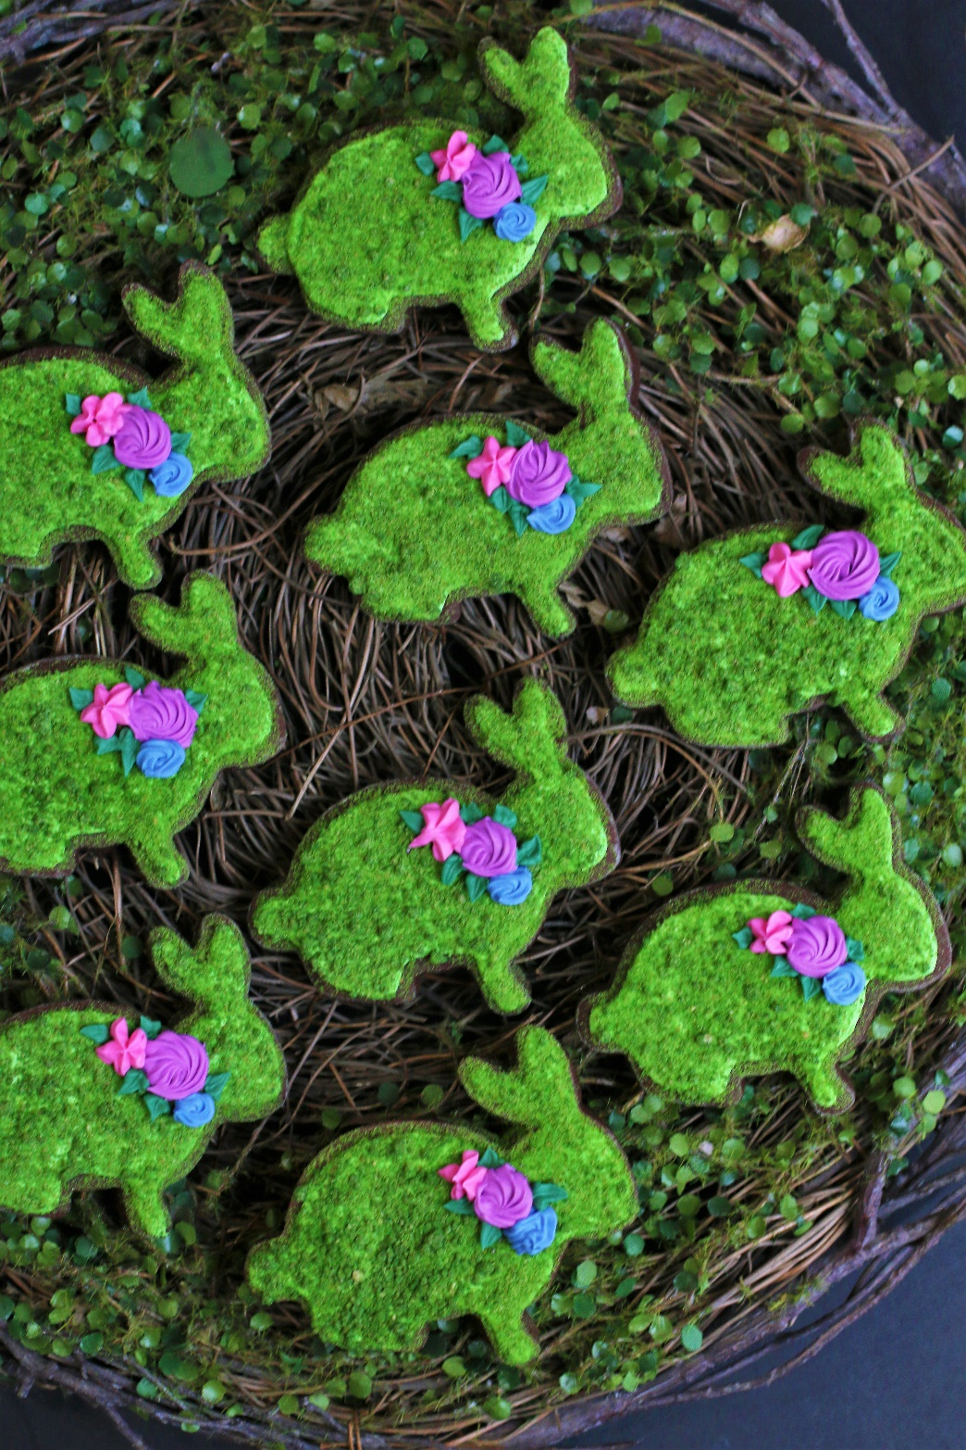

I’m obsessed with these Moss Bunny Chocolate Sugar Cookies! Perfect for Easter or garden parties, they are almost too cute to eat! The secret to getting a realistic moss effect that tastes wonderful is graham cracker crumbs – the brown undertones of the graham crackers and green food coloring really give these cookies an earthy quality! Perfect Chocolate Sugar Cookies and easy Royal Icing, topped with a deliciously deep green Cookie Moss and decorated with colorful Royal Icing flowers and leaves.
INGREDIENTS:
CHOCOLATE SUGAR COOKIES:
3/4 cup (172g) unsalted butter (softened to room temperature)
1 cup (200g) granulated sugar
1 large egg, at room temperature
1 teaspoon pure vanilla extract
1 and 1/2 cups (188g) all-purpose flour
3/4 cup (63g) unsweetened natural cocoa powder
1 teaspoon baking powder
1/8 teaspoon salt

COOKIE MOSS:
2 cups graham cracker crumbs
¼ to ½ cup vodka
AmeriColor green gel food coloring

FROSTING:
EASY ROYAL ICING:
4 cups powdered sugar
3 Tablespoons Meringue Powder
1 Tablespoon corn syrup (Karo)
2 Tablespoons flavoring (I use clear vanilla)
8-10+ Tablespoons water (room temperature)
AmeriColor Soft Gel Food Coloring (strongly recommended!)

FOR DECORATING: Royal Icing

SPECIAL EQUIPMENT:
- Cookie cutter(s)
- Rolling pin (wooden Joseph Joseph Rolling Pin works the BEST for these cookies!)
- Large baking sheets
- Silicone Baking Mats or Parchment Paper
- Piping Bags & Tips

HOW I MAKE THESE:
- Set butter and egg out to warm to room temperature.
- Sift the flour and cocoa powder together in a medium bowl, whisk in the baking powder and salt; set aside.
- In a large bowl using a hand-held mixer or stand mixer fitted with a paddle attachment, beat the butter on medium speed until completely smooth and creamy (about 2 minutes). Add the sugar and beat on medium high speed until light and fluffy, about 2 minutes. Add in the egg and vanilla extract and beat on high speed for another minute. Scrape down the sides and bottom of the bowl as needed between additions.
- On low speed, slowly mix half of the flour mixture into the wet ingredients just until combined; add remaining flour mixture and again mix just until combined. This cookie dough will be really soft and creamy!
- Cut two pieces of parchment paper that will fit your baking sheets.
- Divide the dough into two equal parts. Generously sprinkle your parchment paper and rolling pin with either flour or cocoa powder. Place one piece of cookie dough on top of a parchment paper. Roll each half to a ¼-inch thickness (you will need to re-flour or re-cocoa powder your rolling pin periodically to keep the dough from sticking). The rolled-out dough can be any shape, as long as it is evenly 1/4-inch thick. We’re rolling the cookie dough out BEFORE chilling it, which isn’t typical for most sugar cookie recipes – but this is a great trick! The dough is so much easier to roll out before it’s chilled.
- Stack the pieces, with parchment paper between the two and a single piece of parchment paper on top, onto a baking sheet and refrigerate for at least 2 hours and up to overnight. Chilling is mandatory for this cookie dough, so that the cookies will keep their shape when baked.
- The next day, preheat oven to 350°. Line 2-3 large baking pans with parchment paper (I prefer parchment paper over silicone baking mats for these cookies).
- Remove one of the chilled cookie dough pieces from the refrigerator. The dough will seem very hard, but it’s softer than it appears! Immediately cut into shapes with cookie cutters that have been dipped in flour or cocoa powder. Place each cookie about 2 inches apart on prepared baking sheets. Re-roll dough scraps until all the dough is shaped. Repeat with remaining cookie dough. Refrigerate cut cookie dough on baking sheets for 10-15 minutes before baking (this will help keep them from spreading). HELPFUL HINT: I usually place one completed pan in the refrigerator while working on cutting out the next pan, rotating between cutting, chilling and baking.
- For 3-inch cookies, bake for 10 minutes – the cookies will still appear soft. Make sure you rotate the baking sheet halfway through bake time. If your cookie cutters are smaller than 3 inches, bake for about 9-10 minutes. If your cookie cutters are larger than 3 inches, bake for about 12-13 minutes. Every oven is a little bit different, so watch your first batch when baking and time accordingly. DO NOT OVERBAKE! The cookies don’t spread much when they’re baking, so they will stay around ¼-inch thick. These are thick sugar cookies! Be sure not to overbake these as they’ll lose their softness.
- Allow cookies to cool on the baking sheet for 5 minutes. Transfer the parchment paper together with the cookies to a cooling rack to cool completely. Once completely cool, decorate with either Bakery Frosting or Chocolate Royal Icing and sprinkles (Bakery Frosting is easier for little ones…)
- TO MAKE COOKIE MOSS: Crush graham crackers in a heavy plastic ziplock bag with a heavy rolling pin until crushed into fine crumbs (you can also pulse in the bowl of a SMALL food processor until you have fine crumbs). Pour into a small deep bowl.
- In a small glass, mix together ¼ cup vodka and several drops of dark green/moss gel food coloring until the food coloring is fully dissolved. (The vodka mixes the best with gel food coloring and evaporates when baked, and unlike water, doesn’t make the graham cracker crumbs soggy.)
- Pour the colored vodka over the top of the cookie crumbs and stir with a small spoon until the color evenly coats the cookie crumbs, adding more color mixture if needed.
- Preheat oven to 200 degrees. Line a small baking sheet with parchment paper. Spread moss mixture evenly in pan and bake for 20 minutes. Remove from oven and allow to cool to room temperature. Place baked moss mixture in a small bag or bowl and crush again into a fine mixture; set aside.
- TO MAKE EASY ROYAL FROSTING: In the bowl of a stand mixer fitted with a paddle attachment, add the ½ cup room-temperature water and meringue powder and dissolve on low (do not use a whisk attachment) for a minute or two. Once dissolved and slightly frothy, add all the powdered sugar and begin to mix on low. Add the karo syrup as it all starts to come together. Turn your mixer up to medium-high speed and beat for 5 minutes or until stiff peaks form. BE SURE NOT TO OVERMIX! Once still peaks form, it’s enough. If you overmix, the icing can become crumbly after it dries on your cookies.
- After five minutes of beating, lift the paddle up off the icing - the icing should drizzle down in a ribbon and smooth out within 10-15 seconds with the frosting in the bowl. If it's too thick, add a little more water (a teaspoon at a time). If it's too thin, add a little more sifted confectioners' sugar (a tablespoon or two at a time).
- At this point, you will use the Royal Icing as a base – divide as appropriate and add additional water a little bit at a time so that you have the right consistency for outlining, detail and flooding. For outlining and flooding, add AmeriColor Electric Green gel food coloring.
- If you haven’t made royal icing before, you maybe not be familiar that this icing crusts VERY quickly! When exposed to air icing forms a crust on the surface within 5-10 minutes. To prevent this from happening, you need to cover royal icing when you’re not working directly with it - for the short term you can cover the bowl with a damp kitchen towel or damp paper towel.
- FROST & DECORATE! Pipe or frost completely cooled cookies one at a time, outlining and flooding the rabbit with the green icing.
- SPRINKLE WITH THE COOKIE MOSS: Carefully hold the cookie over a small bowl and sprinkle with the moss crumbs, shaking off the excess crumbs. Set on parchment paper and allow to dry overnight.
- The next day, decorate with optional Royal Icing flowers and leaves.
- Allow decorated cookies to set and dry completely before storing – keep parchment paper between each layer or place cookies in individual self-sealing bags for easy freezing and serving.
YIELD: Makes about 30 (three-inch) cookies (or 24 4-inch cookies)
RECIPE NOTES:
- COCOA POWDER: For this recipe you can use either Dutch-processed or natural cocoa powder. Dutch-processed cocoa powder is typically paired with baking powder, but either works for this cookie recipe. Always use the best quality baking cocoa for the best results!
- SIFTING: Sifting the flour and cocoa powder together is imperative to ensure the two are perfectly blended and aerated, and eliminates any lumps!
- SOFT & CHEWY COOKIES: These cookies will stay fresh in an air-tight container at room temperature for up to 3 days or in the refrigerator for up to 1 week.
- FOR THE BEST CHOCOLATE SUGAR COOKIES: I recommend sprinkling cocoa powder on your work surface and rolling pin for rolling out the cookie dough, rather than flour. You may also find it helpful to dip your cookie cutters in cocoa powder between cutting cookies out. Cocoa powder added extra chocolate flavor and chocolate color to these cookies (regular flour may make your cookies bake up with a white surface).
- MAKE AHEAD TIP: Plain baked chocolate sugar cookies freeze well up to 1 month. Thaw overnight in the refrigerator before decorating.
- TO KEEP THESE COOKIES SOFT: Pop some large fresh marshmallows in the container to keep the cookies soft – replace every day or so, as soon as the marshmallows dry out and harden. It’s a sweet little trick! These cookies will stay fresh in an air-tight container at room temperature for up to one week.
- MAKE AHEAD TIP: Plain baked cookies freeze well up to 1 month. Thaw overnight UNOPENED on your kitchen countertop before decorating.
- FOR PARTIES: I package cookies individually in self-sealing clear cellophane cello bags (Pack It Chic are my favorite brand). Make sure cookies are completely dry after decorating before packaging. To make ahead, place individually wrapped and sealed cookies in a larger airtight container and freeze. Thaw on your countertop before serving - do not thaw in refrigerator (you are trying to minimize moisture during defrosting, which can cause your frosting designs to run or bleed).
Originally published March 2021.
© SnowflakesandCoffeecakes. All images, attachments & content are copyright protected. All rights reserved. Please do not use my images without prior permission. If you want to republish this recipe, please re-write the recipe in your own words, or link back to www.snowflakesandcoffeecakes.com for the recipe.

WHAT IS THE SECRET OF PERFECT CHOCOLATE SUGAR COOKIES?

To ensure the wonderfully soft sugar cookies of your dreams, you want to roll the dough about ¼-inch thick. This may seem too thick when you are rolling and cutting, but it’s absolutely key if you want perfect sugar cookies for munching and decorating!
​
If you’ve found your cut-out sugar cookies lose their shape in the past, it could have been due to a few factors (too much butter in the recipe, dough too warm, dough not rolled thick enough, etc.), but I can tell you that this recipe yields absolutely beautiful edges that do not spread if you take care to roll to the appropriate thickness (if rolled too thin then they can spread) and chill the cut-out dough before baking.​

CHOCOLATE SUGAR COOKIE TIPS & TRICKS:
- Baking sheets: I use my favorite USA Pan Bakeware half sheet pans, which are aluminized steel, warp resistant and nonstick. I always line with parchment paper, not a silicone baking mat (which I find causes more spread).
- Cocoa Powder: For this recipe you can use either dutch-processed or natural cocoa powder. Dutch-processed cocoa powder is typically paired with baking powder, but either works for this cookie recipe. Always use the best quality baking cocoa for the best results!

- Sifting: Sifting the flour and cocoa powder together is imperative to ensure the two are perfectly blended and aerated, and eliminates any lumps!
- Marble pastry board: This isn’t necessary, but if you have one, it’s great for keeping sugar cookie dough and pie crust cold!
- Rolling pin: A simple wooden one is all you need, but my favorite is my Joseph Joseph Wooden Rolling Pin with adjustable rollers.
- Flavors: I adore the pure vanilla flavor, but some people like a little bit of almond – I would recommend starting with ¼ teaspoon of almond extract in addition to the vanilla. For other fun-flavored sugar cookies, you can also replace the vanilla with your favorite extract or emulsion to the cookie dough if you’d like!
- Cookie cutters: You can use absolutely any, so pick your favorites! I have a mixture of plastic and metal and they all work amazingly well with this recipe. It holds its shape for intricate designs, as well. I always dip mine in flour before cutting for a nice, clean release.
- Scaling: You can double (or more!) this recipe without issue.
- Buttercream frosting: If you want to do a simple frosting (with or without sprinkles!), then I recommend my favorite Vanilla Buttercream or Chocolate Buttercream Frosting.
- Royal Icing: To do more detailed decorating, I prefer to use Royal Icing.
- Storage: The cookies can be stored in an airtight container at room temperature for up to 5 days.
- Make-Ahead: While I love that you can whip up these cookies immediately, you can mix together the dough, divide in half and form into disks, wrap in plastic wrap, and refrigerate for up to 2 days. You can also freeze the dough (place the wrapped disk in a ziploc freezer bag) for up to 1 month; thaw in the refrigerator overnight, then bring it to almost room temperature, roll out, and proceed with the recipe.
- Freezing: These cookies freeze exceptionally well! You can freeze them plain or decorated; if decorated, let the icing set before freezing. Store in an airtight container or ziplock freezer bag with parchment paper between the layers. The cookies can be frozen for up to 3 months.

TIPS & TRICKS FOR THE BEST EASY ROYAL ICING:

- Sifting: Sifting the powdered sugar to eliminate any lumps in your icing!

- Corn Syrup: Adds a sheen and soft bite to Chocolate Royal Icing, but it will take a bit longer to dry than standard Royal Icing. I find that it usually takes overnight for the icing to set and dry properly
- Consistency: There are three primary consistencies for Royal Icing – Outline, Flood, and Detail.
- Coloring: There is no shortcut to great Royal Icing colors! Start with a great royal icing recipe, and use quality gel food coloring to get the best results. I recommend and use AmeriColor gel food coloring. Start with a few drops and add more food coloring only as necessary. Note that the colors will darken as they sit.
- Decorating with Dark Colors: For deep or dark colors, you will use more food coloring, and for deepest black, red and green colors, for best results I make the royal icing and color the day before I’ll be decorating. It takes time and patience for the colors to fully develop.
- Color Bleeding: To prevent colors from bleeding into one another, start by coloring your base recipe of Royal Icing with white food coloring. Sounds crazy, but it helps!
- Take your Time: Allow each layer of icing to dry completely before adding the next layer.

CREATING REALISTIC MOSS COOKIES:
- Graham Cracker Crumbs: I The secret to getting a realistic moss effect that tastes good is to use graham cracker crumbs as a base. The brown undertones of the graham crackers and green food coloring create an earthy quality.
- You can use premade Graham Cracker Crumbs, or make your own! To make at home, place graham crackers in a heavy ziplock bag and pound with a heavy rolling pin until crushed into fine crumbs. You can also pulse in the bowl of a SMALL food processor if you have one.
- Alcohol is key. It’s hard to spread color throughout the graham cracker crumbs using food coloring alone. To help incorporate the color, I thin AmeriColor green gel coloring with a small amount of vodka. (The vodka will evaporate when baked, and unlike water, doesn’t make the graham cracker crumbs soggy. It also is tasteless!)
- Green Gel Food Coloring: I used a mixture of AmeriColor Electric Green, Leaf Green and Moss Green to get the moss shade I was looking for.
- Create Cookie Moss: Pour the color mixture over the crumbs and stir with a spoon until the crumbs are evenly colored throughout. You may need to add additional color mixture to get good coverage.
- Bake the Crumbs: If you find the crumbs are too soggy after adding the liquid, don’t fret. Bake in a 200 degree oven for 20 minutes to dry them out, and any previously wet chunks will break apart easily.
- Use Green Royal Icing as Base: Outline and flood the top of each cookie with Royal Icing that has been tinted light, bright or mossy green to hide any empty spots after you apply the Cookie Moss.
- Wait A Few Minutes: After each cookie is flooded with Royal Icing, wait a few minutes for the icing to firm up and slightly crust; this will prevent the crumbs from sinking into the icing. After sprinkling the Cookie Moss over the entire cookie, gently tip and shake off the excess. Press down lightly with your finger to help the moss “adhere” to the top of the cookie.
- Allow Cookies to Dry: Set cookies aside to dry completely – at least overnight for best results.

