OLD FASHIONED
GINGERBREAD snowflakes
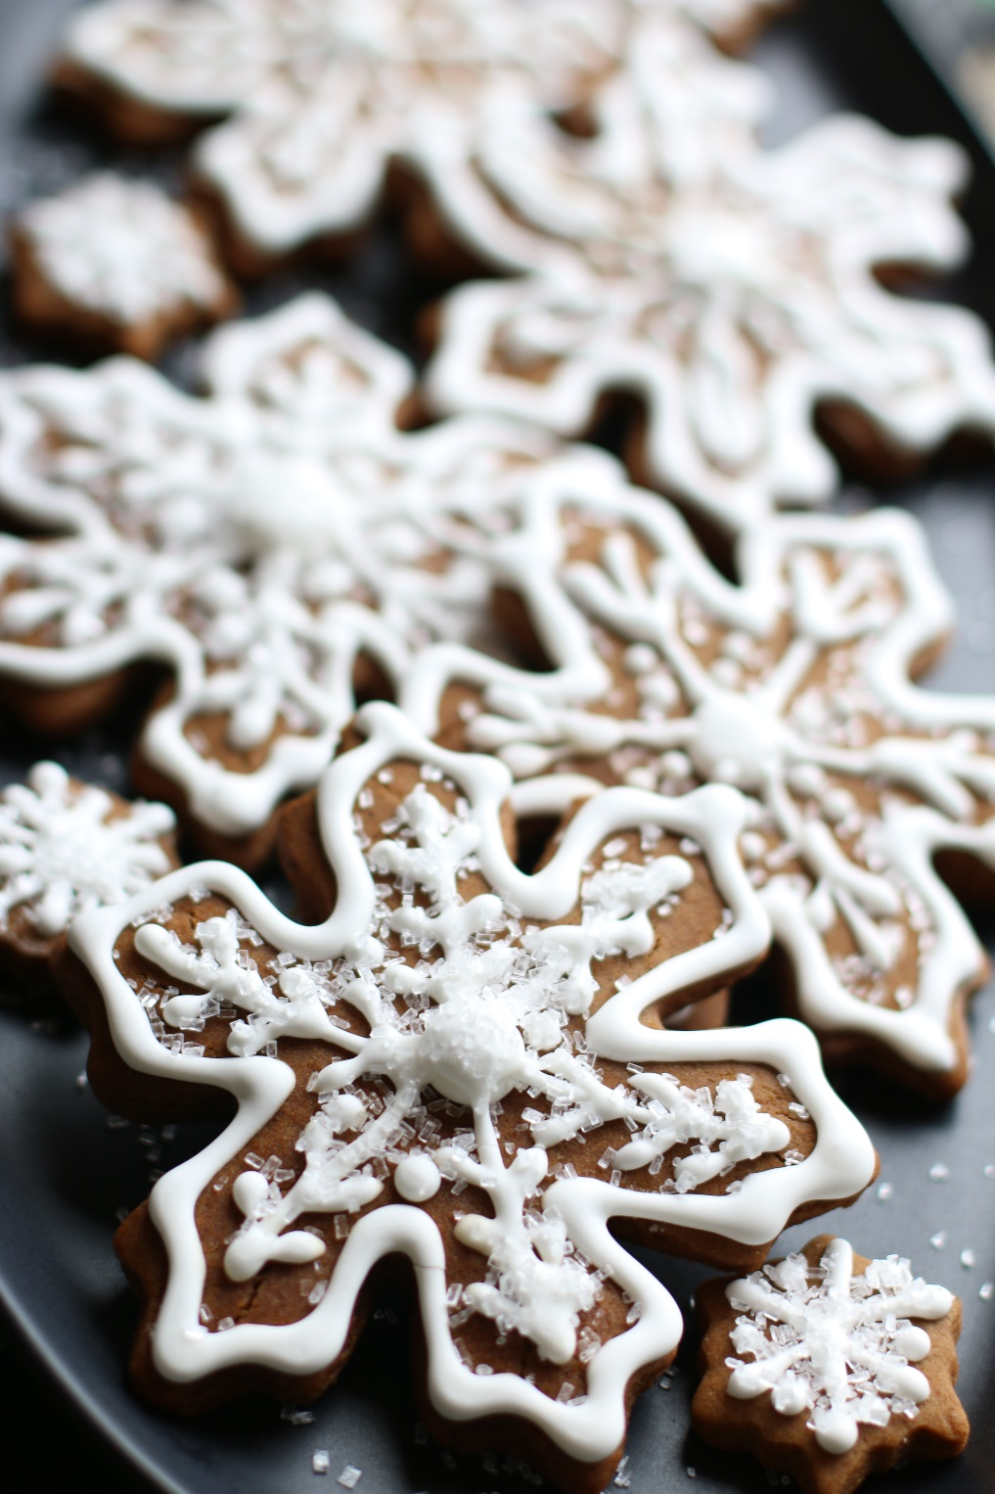

Our family-favorite recipe for gingerbread cookie cutouts! Whether it’s gingerbread people or gingerbread snowflakes, these get more perfect over time – thick & spicy, soft and chewy!
INGREDIENTS:
3 and 1/2 cups (437g) all-purpose flour (sifted, spooned & leveled)
1 teaspoon baking soda
1/2 teaspoon salt
1 Tablespoon ground Rodelle Ginger
1 Tablespoon ground Rodelle Cinnamon
1/2 teaspoon allspice
1/2 teaspoon ground cloves
10 Tablespoons (2/3 cup) unsalted butter (softened to room temperature)
3/4 cup (150g) packed light or dark brown sugar
2/3 cup (200g) molasses (I use Grandma's Molasses brand)
1 large egg (room temperature)
1 teaspoon Rodelle Pure Vanilla Extract

FOR DECORATING: Easy Royal Icing (snowflakesandcoffeecakes.com)

SPECIAL EQUIPMENT:
- Cookie cutter(s)
- Rolling pin (my wooden Joseph Joseph rolling pin works the BEST for these cookies!)
- Large baking sheets
- Silicone Baking Mats or Parchment Paper

HOW I MAKE THESE:
- In a medium bowl, whisk together the flour, baking soda, salt, ginger, cinnamon, allspice, and cloves.
- In a large bowl using a hand-held mixer or stand mixer fitted with a paddle attachment, beat the butter for 1 minute on medium speed until completely smooth and creamy. Add the brown sugar and molasses and beat on medium high speed until combined and creamy-looking. Add in the egg and vanilla and beat on high speed for 2 full minutes. Scrape down the sides and bottom of the bowl as needed. Don’t worry if your butter separates!
- On low speed, slowly mix half of the flour mixture into the wet ingredients just until combined; add remaining flour mixture and again mix just until combined. The cookie dough will be thick and slightly sticky.
- Divide dough in half and place each onto a large piece of plastic wrap. Wrap each up tightly and pat down to create a disc shape. Chill dough discs at least overnight and up to 2 days. Chilling is mandatory for this cookie dough!
- The next day, preheat oven to 350°F. Line 2-3 large baking sheets with parchment paper or silicone baking mats.
- Remove 1 disc of chilled cookie dough from the refrigerator and let it sit at room temperature for about 15 minutes. Generously flour a work surface, as well as your hands and the rolling pin. Don't be afraid to continually flour the work surface as needed - this dough can be sticky, and any excess flour on the outside of the cookie dough will disappear when they bake. Roll out disc until evenly 1/4-inch thick. Cut into shapes. Place each cookie about 1 inch apart on prepared baking sheets. Re-roll dough scraps until all the dough is shaped. Repeat with remaining disc of dough.
- Bake cookies for about 9-10 minutes. If your cookie cutters are smaller than 4 inches, bake for about 8 minutes. If your cookie cutters are larger than 4 inches, bake for about 11 minutes.
- Allow cookies to cool for 5 minutes on the cookie sheet. Transfer to cooling rack to cool completely. Once completely cool, decorate with Easy Royal Icing.
YIELD: Makes 24 (four-inch) cookies.
NOTES: TO KEEP THESE COOKIES SOFT: I keep a slice of sandwich bread in the container to keep the cookies soft – replace every day or so, as soon as the slice of bread dries out. It’s a sweet little trick! These cookies will stay fresh in an air-tight container at room temperature for up to one week. Baked these freeze well – plain, or even if frosted or decorated!
Originally published December 2012, Revised & Republished December 2017
© SnowflakesandCoffeecakes. All images, attachments & content are copyright protected unless otherwise indicated. All rights reserved. Please do not use my images without prior permission. If you want to republish this recipe, please re-write the recipe in your own words, or link back to www.snowflakesandcoffeecakes.com for the recipe.

