UPSIDE-DOWN CARAMEL PECAN APPLE PIE
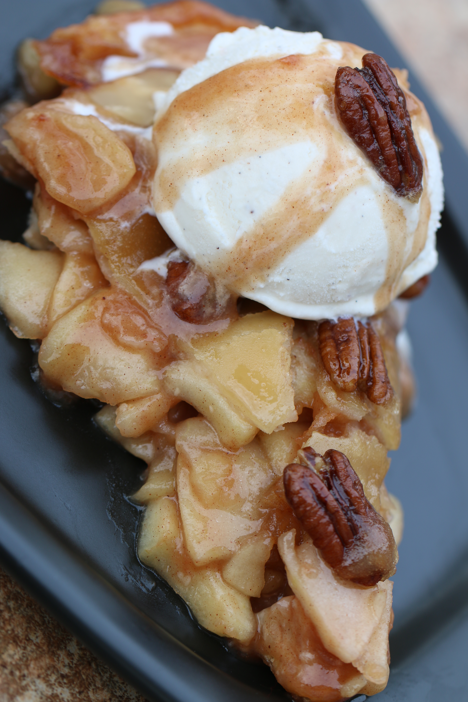

If you want to make a pie with WOW factor – this is the one! Our family and guests will do tricks for a second piece of this pie! I usually serve warm, with a scoop of Butter Pecan or French Vanilla ice cream on top, drizzled with a spoonful of caramel pie sauce from the bottom of the pie plate. So good!

INGREDIENTS:
Glaze & Crust:
1/2 cup dark brown sugar (packed)
2 tablespoon butter (room temperature)
2 tablespoon corn syrup
½ cup pecans (halves or chopped)
1 box Pillsbury refrigerated pie crusts
1 egg white (room temperature)
Cinnamon Sugar

Filling:
2/3 cups granulated sugar
2 tablespoons all-purpose flour1 tsp cinnamon
6 cups thinly sliced, peeled apples (6 medium)
2 tablespoons all-purpose flour
1 tablespoon butter

HOW I MAKE THIS:
- In a heavy Dutch oven, stir together apple slices, sugar and cinnamon. Cook over medium heat, stirring occasionally, about 15 minutes (or until apple slices start to become tender and translucent). Stir in flour. Remove from heat, stir in 1 tablespoon butter and cool to room temperature.
- In a small pan, mix together brown sugar, butter and corn syrup. Over medium-high heat, cook for 5 minutes, stirring constantly. Remove from heat and set aside.
- Heat oven to 425 degrees.
- Spray a 9-inch deep dish pie plate with non-stick cooking spray. Pour caramel mixture into bottom, spread evenly over bottom; sprinkle with pecans.
- Remove dough from refrigerator and allow to soften slightly (about 10 minutes) before rolling.
- On a lightly floured counter, roll dough into a 12-inch circle on floured counter.
- Gently place bottom crust over caramel mixture, pressing gently into sides and bottom of pie plate. Pour apple filling into pie crust.
- Top with second crust; seal edge and flute. Cut slits in several places in top crust.
- Beat egg white, brush over top of pie. Sprinkle with cinnamon sugar.
- Place pie in middle oven rack; bake 10 minutes. Cover edge with pie plate protector and reduce oven temperature to 350 degrees. Bake 40 to 45 minutes longer until crust is golden brown.
- Remove pie from oven and immediately run knife around edge of pie to loose. Place serving plate upside down over pie; turn serving plate and pie over. Gently lift off pie plate.
(Recipe adapted from Pillsbury.)
YIELD: One 9-inch pie
© SnowflakesandCoffeecakes. All images, attachments & content are copyright protected unless otherwise indicated. All rights reserved. Please do not use my images without prior permission. If you want to republish this recipe, please re-write the recipe in your own words, or link back to www.snowflakesandcoffeecakes.com for the recipe.


