RASPBERRY CRUMBLE COOKIES
(COSTCO COPYCAT RECIPE)
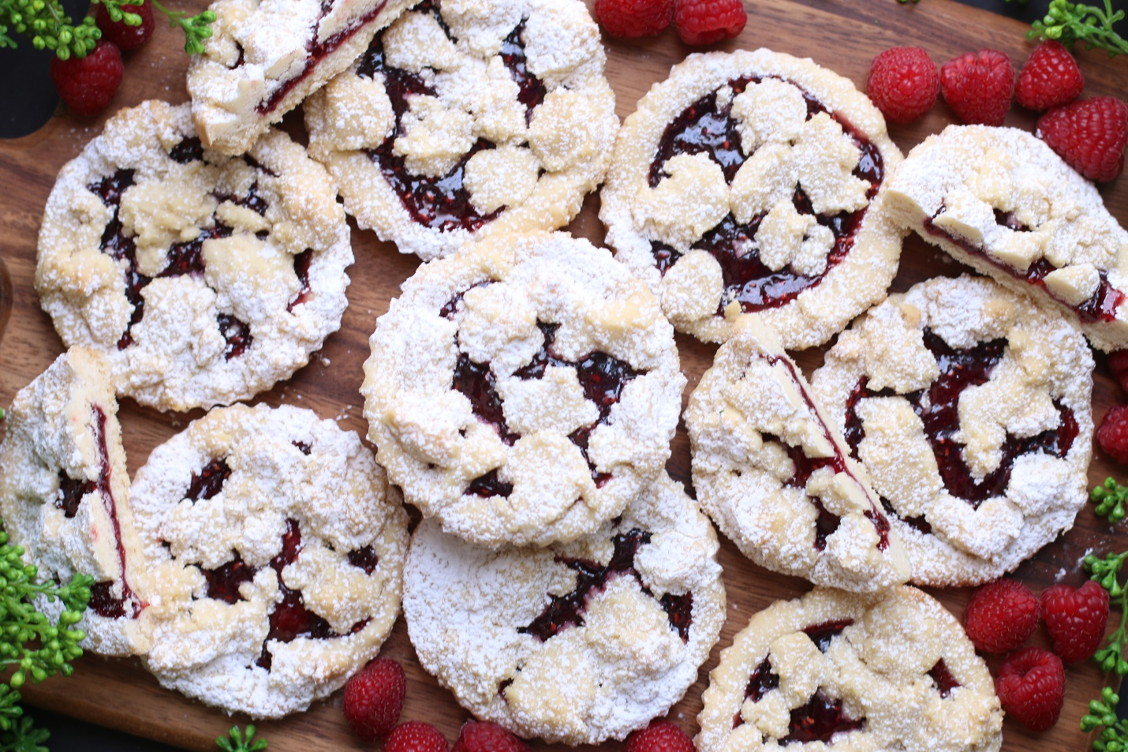

Everyone has been begging me to create a recipe for Raspberry Crumble Cookies, which are inspired by the famous Costco Raspberry Crumble Cookies. These tender shortbread cookies are incredibly thick and soft, and melt-in-your-mouth wonderful! Paired with raspberry jam they are sublime, but feel free to use your favorite fruit jam or jelly – they are the perfect sugar cookies for celebrations or to enjoy with a cup of hot tea or coffee!
INGREDIENTS:
SHORTBREAD COOKIES & CRUMB TOPPING:
1 cup (2 sticks) unsalted butter (softened)
⅓ cup (35g) powdered sugar
¼ cup (50g) granulated sugar
2 teaspoons pure vanilla extract
1 teaspoon pure almond extract
2 ¼ cups (282g) all-purpose flour
¼ teaspoon kosher salt
1 cup raspberry jam or preserves (room temperature)
Powdered sugar (for sprinkling on top after baking)
FOR DECORATING: Powdered Sugar or Sparkling Sugar (optional)
SPECIAL EQUIPMENT: You will need 4-inch round baking pans, 4-inch mini-tart pans or jumbo muffin tins to create these cookies
HOW I MAKE THESE:
- Remove butter and raspberry jam from refrigerator and allow to soften.
- Preheat oven to 350℉.
- Line wells of mini-tart pans or jumbo muffin tins with non-stick parchment paper liners. Press the liner into each well, leaving a ½-inch edge around the outside; set aside.
- PREPARE SHORTBREAD DOUGH: In the bowl of a stand mixer, cream the butter, granulated sugar, powdered sugar, vanilla extract and almond extract on medium speed until light and fluffy, about 3 minutes.
- In a medium bowl, whisk together the flour and salt. Add the flour mixture and blend on slow speed just until mixed – DO NOT OVERMIX! This will keep your cookies tender and flaky. The dough will be a bit crumbly, but will hold together if you squeeze the dough gently in your hand.
- Reserve about 1 cup of the cookie dough mixture and place in the refrigerator to chill while you prepare the cookie bases.
- Using a medium cookie scoop, divide the remaining dough evenly into the bottom of each well (about ¼ cup in each).
- Using a glass or metal measuring cup, press lightly into each well to evenly spread the cookie dough, creating a well to hold the jam in the center of each cookie and an edge around the outside, being careful not to press to hard or “pack” the cookie dough – you want to keep the crumble texture as much as you can. If the dough sticks to the bottom of your cup, dip it in flour so that it releases easily.
- Stir the raspberry jam until it is soft and smooth. Pour 1 tablespoon of raspberry jam into the center of each cookie, spreading it evenly with the back of a spoon.
- Remove crumble topping from refrigerator and sprinkle about 1 tablespoon on top of the jam layer of each cookie.
- Bake the cookies in pre-heated oven for 18 to 20 minutes, or until the tops are just beginning to turn golden.
- Remove pans from oven and allow to cool completely before removing cookies from pans.
- Sprinkle with additional powdered sugar or sparkling sugar before serving.
- Store cookies in an airtight container at room temperature for up to 3 days, or in the refrigerator for up to 1 week.
YIELD: Makes 12 (four-inch) cookies
RECIPE NOTES:
- USE SOFT BUTTER! For best texture, make sure to use butter that is softened.
- DON’T OVERMIX! The secret to buttery and tender shortbread is to be careful not to overmix the cookie dough when adding the flour.
- NO TART PAN? If you don’t have a mini tart pan or jumbo muffin pan, you can use a regular muffin pan and make smaller cookies – adjust shortbread dough, jam, and baking time as necessary.
- TO KEEP THESE COOKIES SOFT: These cookies will stay soft and fresh in an air-tight container at room temperature for up to 3 days, or refrigerated for up to 1 week.
- TO FREEZE: These cookies can be frozen for up to 2 months! After baking and cooling, place them in an airtight, freezer safe container. If you need to layer the cookies, place parchment paper in between each layer to avoid sticking or freezing together. Thaw to room temperature and sprinkle with powdered sugar when ready to enjoy!
- FOR PARTIES: I package cookies individually in self-sealing clear cellophane cello bags (Pack It Chic are my favorite brand). Make sure cookies are completely cool before packaging.
​RECIPE VARIATIONS:
FRUIT FLAVORS: Replace the Raspberry Jam with your favorite fruit jam or fruit spread – apricot, blueberry, strawberry, peach, apple, raspberry rhubarb, blackberry and cherry are all wonderful! In the autumn, try a Cranberry Raspberry Crumble Cookie variation – replace fresh cranberry raspberry sauce for the jam. Lemon Crumble Cookies or Lime Crumble Cookies? You can also use lemon curd or lime curd for a springtime crumble cookie treat!
GLUTEN FREE: You can easily make Gluten-Free Crumble Cookies by substituting your favorite 1:1 gluten free flour for the all-purpose flour. I use and recommend King Arthur, Measure for Measure Flour and Bob's Red Mill Gluten Free 1-to-1 Baking Flour.
VEGAN RASPBERRY CRUMBLE COOKIES: If you use non-dairy butter these could technically be considered vegan cookies, adjust baking time as necessary. When it comes to baking with different ingredients, I always recommend testing before serving to a crowd!
Original recipe created by Snowflakes & Coffeecakes; published January 2023.
© SnowflakesandCoffeecakes. All images, attachments & content are copyright protected. All rights reserved. Please do not use my images without prior permission. If you want to republish this recipe, please re-write the recipe in your own words, or link back to www.snowflakesandcoffeecakes.com for the recipe.

Tried it and loved it? Snap a picture and share it with me on Instagram @SnowflakesandCoffeecakes and by using the hashtag #SnowflakesandCoffeecakes.

