WILD RICE SOUP WITH HAM
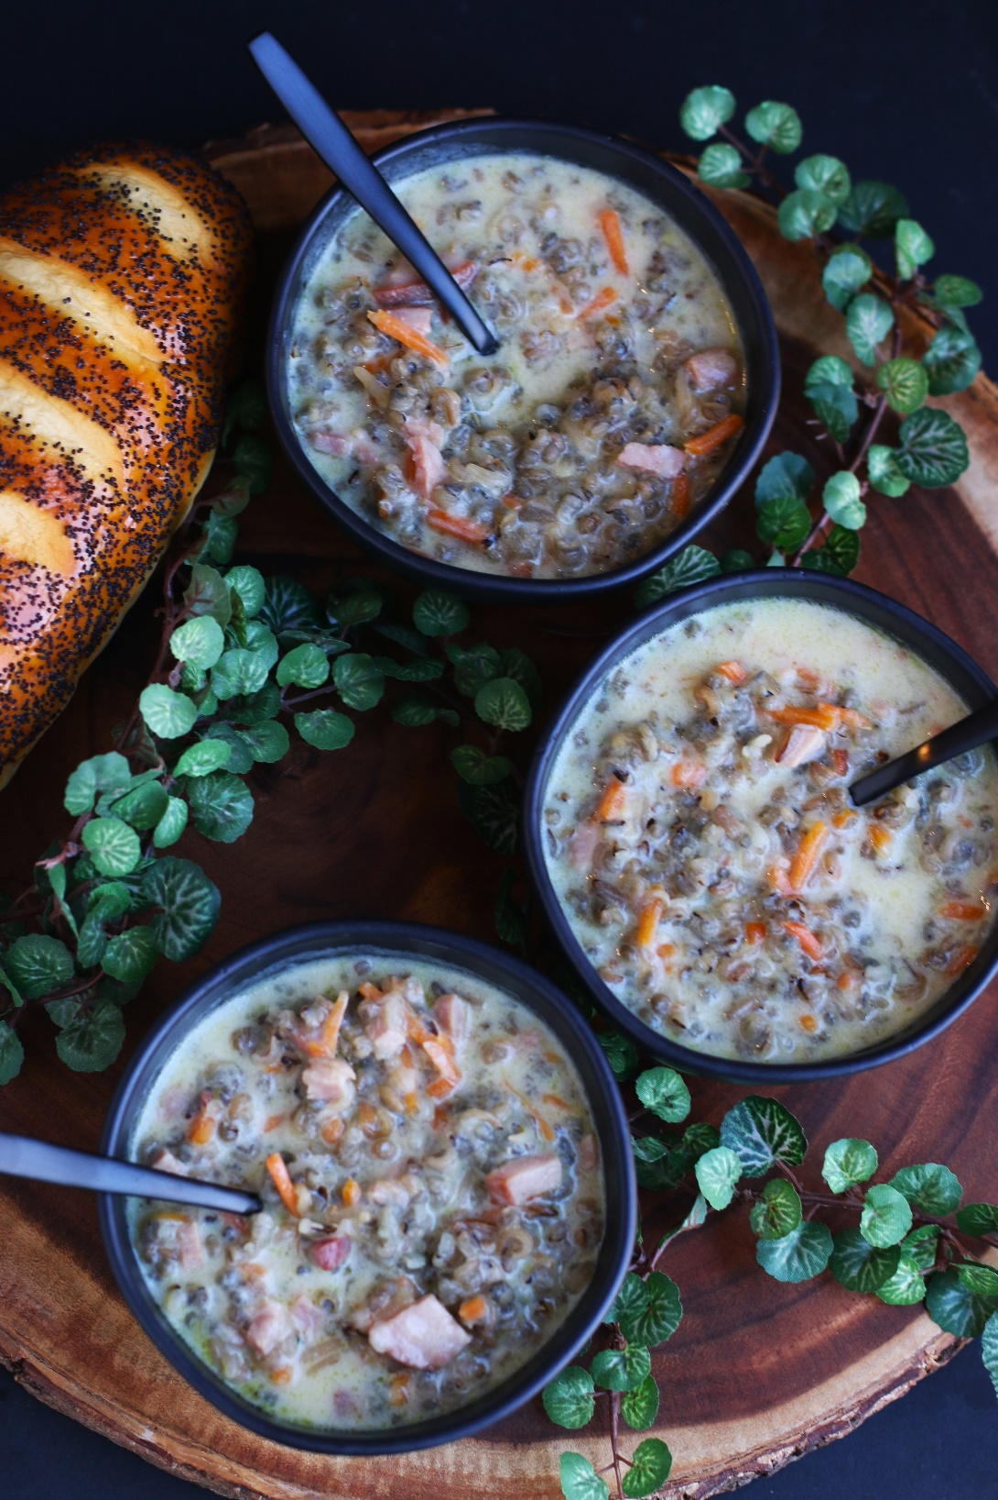

I’m a Minnesota girl and have tried my fair share of Wild Rice Soup. Welcome to my kitchen, where the aroma of heartwarming dishes fills the air and every bite tells a story. Today, I'm thrilled to share a beloved recipe that has been a staple in my family for generations – Byerly's Wild Rice Soup with Ham. This is absolutely and without a doubt the best wild rice soup recipe in the world! This soul-soothing creation blends the earthy richness of wild rice with the savory goodness of ham. Now you can recreate this timeless classic in your own home, bringing warmth and satisfaction in every bowl.
INGREDIENTS:
2 cups cooked Minnesota wild rice (about 1/2 cup uncooked)
1 tablespoon Better Than Chicken boullion
6 Tablespoons unsalted butter
¼ cup finely minced onion
½ cup grated or thin julienned carrots
¼ cup flour
3 cups chicken broth
½ tsp. salt
½ cup minced ham
1 cup half & half or heavy whipping cream
1/3 cup dry sherry
¼ cup slivered almonds
Parsley or chives

HOW I MAKE THIS:
- Place uncooked wild rice in a large strainer and wash thoroughly under cold running water for 3 minutes.
- Place the wild rice with 4 cups water and chicken boullion in a heavy Dutch oven and bring to a hard boil. Reduce heat, cover tightly and boil gently for 30 minutes. Shut off heat, let stand on burner for 25-35 minutes or until the wild has puffed and most of the liquid has been absorbed. Fluff rice with a fork and drain excess water; set cooked wild rice aside.
- In Dutch oven, melt butter; sauté onion and carrots until tender, about 3-5 minutes.
- Blend in flour; stir constantly for 2 minutes.
- Gradually add broth, whisking constantly.
- Cook, whisking constantly, until mixture comes to a boil; boil and stir 1 minute.
- Stir in rice, ham (or shredded chicken), almonds and salt; simmer about 5 minutes.
- Blend in half-and-half and sherry; heat to serving temperature.
- Garnish with snipped parsley or chives and additional slivered almonds.
YIELD: 6 serving (6 cups)

RECIPE NOTES:
- WILD RICE – one-half cup uncooked wild rice equals 2 cups cooked. I use and recommend using Minnesota Wild Rice, Wisconsin Wild Rice, and Lunds & Byerlys Roasted Wild Rice (Minnesota cultivated).
- CHICKEN BOULLION – I like to add a spoonful of chicken boullion to wild rice when cooking – this is optional, but does give it a wonderful flavor profile.

RECIPE VARIATIONS: Whether you stick to the classic recipe or get creative with ingredient substitutions or additions, you're sure to enjoy a bowl of warm and comforting soup that will keep you cozy all winter long:

- WILD RICE BLEND SOUP: Not sure about using all wild rice? You can substitute a wild rice blend and still maintain a lot of the flavor and texture. I recommend Lundberg Wild Rice Blend, which is a combination of wild rice, long grain brown rice, sweet brown rice, Wehani red rice and black rice.
- VEGETABLE WILD RICE SOUP: Enhance the nutritional value of your soup by adding more vegetables. Add diced potatoes, sweet potatoes, peas, corn, celery or mushrooms for added flavor and texture.
- CREAMY WILD RICE SOUP: If you prefer a richer and creamier soup, use heavy whipping cream - this will give your soup a velvety texture and a luxurious taste.
- CHICKEN WILD RICE SOUP: While ham is a traditional choice for wild rice soup, you can switch things up by using different proteins. Try using cooked chicken, turkey, or even smoked sausage for a different flavor profile.
- CHEESY WILD RICE SOUP: For a cheesy twist on Wild Rice Soup, consider stirring in some shredded cheddar, Swiss, or Gruyère cheese towards the end of cooking. The melted cheese will add a creamy richness and texture to your soup.
- VEGAN WILD RICE SOUP: If you're looking to make a vegan version of Wild Rice Soup, simply omit the ham and cream and use vegetable broth instead of chicken broth. Add in your favorite plant-based proteins, such as tofu or tempeh, and plenty of vegetables for a hearty and satisfying vegan meal.
- SPICY WILD RICE SOUP: Give your soup a kick by adding some spices or herbs. Try adding a pinch of smoked paprika, cayenne pepper, or thyme for extra depth of flavor.

Original recipe posted November 2013; revised and reposted February 2024.
© SnowflakesandCoffeecakes. All images, attachments & content are copyright protected. All rights reserved. Please do not use my images without prior permission. If you want to republish this recipe, please re-write the recipe in your own words, or link back to www.snowflakesandcoffeecakes.com for the recipe.

Tried it and loved it? Snap a picture and share it with me on Instagram @SnowflakesandCoffeecakes and by using the hashtag #SnowflakesandCoffeecakes.

