fresh fruit dip
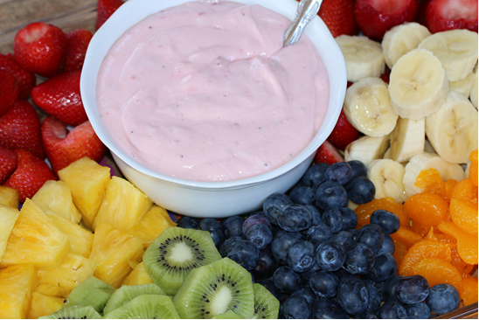

Yes, even my son, who hates fruit dips, LOVES this stuff. Wonderful flavorful goodness on a spoon, fresh fruit, or your finger!

INGREDIENTS:

2 containers strawberry cream cheese
1 jar Kraft marshmallow crème
1 cup fresh strawberries (washed, drained & chopped)

HOW I MAKE THIS:

- In a medium bowl, beat the strawberry cream cheese until it is light and fluffy.
- Add marshmallow crème and beat for at least three minutes, until light and fluffy.
- Add strawberry pieces and whip until you reach your desired consistency (some of you make like the strawberries a little bit chunkier than smooth).
- Chill well before serving with fresh fruit, angel food cake cubes or butter cookies.
- This also tastes pretty good drizzled on ice cream!


