chocolate chip cookie pizza
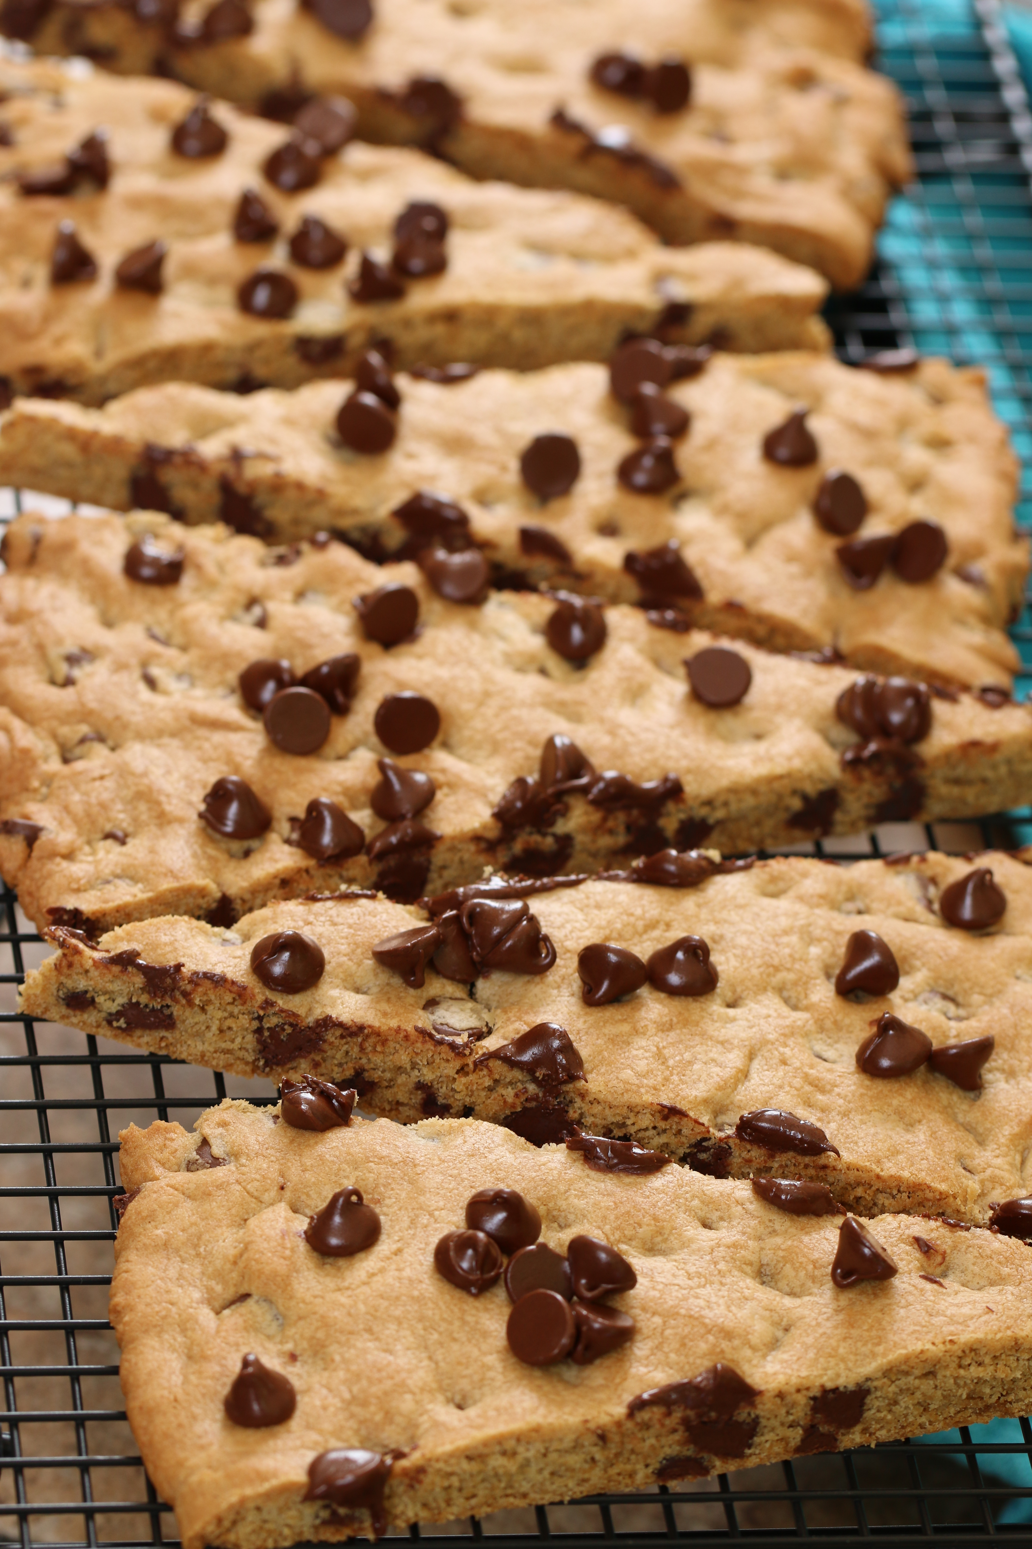

Another family favorite that we hope you will love as much as we do!
The perfect size and shape for dunking in a tall glass of icy cold milk!

INGREDIENTS:
1 cup unsalted butter (room temperature)
½ cup sugar
¾ cup packed brown sugar
2 tsp vanilla
1 large egg (room temperature)
2 cups all-purpose flour
2 tsp cornstarch
1 tsp baking soda
1 tsp salt
2 cups semi-sweet chocolate chips
1 cup chopped nuts (pecans or walnuts, optional)

HOW WE MAKE THIS:
- Preheat oven to 350 degrees. Lightly grease 14” pizza pan or line with parchment paper.
- In a small bowl, whisk together the flour, cornstarch, baking soda and salt.
- Using a hand mixer or stand mixer (with paddle attachment), cream the butter, sugar and brown sugar on medium speed until smooth (2 minutes). Add the egg and beat on high until well blended. Scrape down the sides and bottom of the bowl. Add vanilla and beat on medium for an additional minute.
- Add the dry ingredients (half at a time) and mix just until blended. Stir in chocolate chips and optional nuts. Dough will be soft and thick.
- Press dough into prepared pan, pressing evenly with a spatula or your fingers.
- Bake for 20 to 25 minutes, until puffy and lightly brown. If you like a crispier cookie, bake for a couple extra minutes.
- Remove pan from oven, allow to cool for 10 minutes before serving.
- Cut into slices – the perfect shape to dip into a tall cold glass of milk! You can also drizzle with melted chocolate or serve with ice cream and sprinkles!
YIELD: Makes 12 large servings

© SnowflakesandCoffeecakes. All images, attachments & content are copyright protected unless otherwise indicated. All rights reserved. Please do not use my images without prior permission. If you want to republish this recipe, please re-write the recipe in your own words, or link back to www.snowflakesandcoffeecakes.com for the recipe.

