creamy caramels
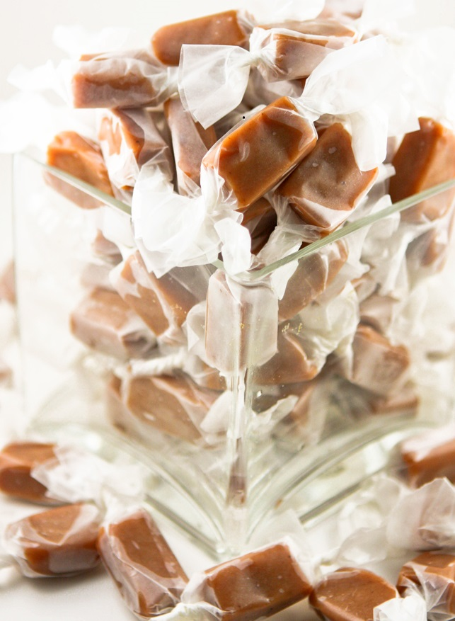

Kelsey is famous for making these homemade caramels every Christmas! These are soft, chewy and totally addictive! We have lots of memories sitting around the kitchen table with Great Gram wrapping these candies!
INGREDIENTS:
1 cup butter
2-1/2 cups light brown sugar (packed)
1 cup light corn syrup
1 (15 oz.) can sweetened condensed milk
1 teaspoon vanilla
Dash salt

HOW I MAKE THESE:
- Spray a 9x13 baking pan with non-stick cooking spray or spread sides and bottom of pan with butter; set aside.
- In a large heavy saucepan, melt butter; add sugar and salt. Stir thoroughly. Stir in corn syrup, mix well. Gradually add sweetened condensed milk, stirring constantly.
- Cook over medium-high heat, about 30 to 45 minutes, stirring constantly. This takes a while – be patient and have help with the stirring if you need to! You may also want to wear a kitchen mitt when stirring, as the pan and caramel mixture is REALLY HOT. Make sure you are stirring constantly and vigorously, so that the mixture doesn’t burn. If you are not using a candy thermometer that clips to the side of your pan, dip a candy thermometer into the middle of the pan occasionally, being careful not to touch the bottom of the pan. Cook until you reach 244 degrees.
- Remove from heat. Stir in vanilla and stir until combined. Immediately pour into your prepared pan.
- Cool completely to room temperature. Flip pan over onto cutting board to remove caramel block from pan. Using a large chef’s knife, cut into squares approximately ½-inch x 1-inch.
- Wrap individually in waxed paper, twisting the ends of the waxed paper.
- Store in an airtight covered container in a cool location (but not the refrigerator).

YIELD: Makes 64 candies
© SnowflakesandCoffeecakes. All images, attachments & content are copyright protected unless otherwise indicated. All rights reserved. Please do not use my images without prior permission. If you want to republish this recipe, please re-write the recipe in your own words, or link back to www.snowflakesandcoffeecakes.com for the recipe.

