FRANGO MINT BROWNIE COOKIES with FRANGO CHOCOLATE MINT GANACHE
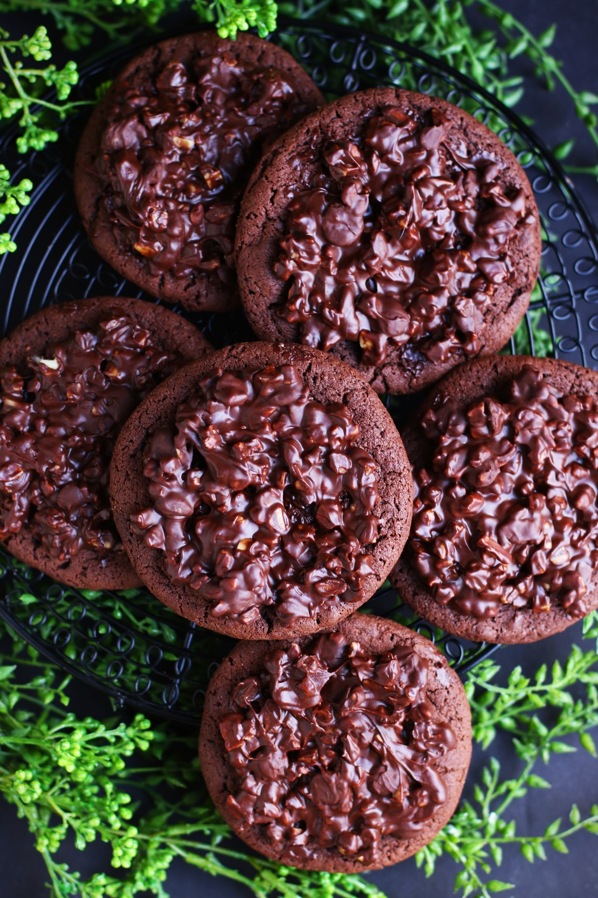

Say hello to irresistible Frango Mint Brownie Cookies with a luscious Frango Chocolate Mint Ganache. Trust me, you won't be able to resist these heavenly treats once you've had a taste! These decadent cookies combine the rich, fudgy goodness of brownie cookies with the refreshing kick of mint chocolate, topped off with a velvety chocolate mint ganache that is studded with even more Frango Mint Chocolate bits. These treats are perfect for special occasions, holidays, or just when you're craving something sweet and luxurious! Whether you're a Frango lover, a chocolate lover, a chocolate mint enthusiast, or just someone who appreciates a good dessert, Frango Mint Brownie Cookies with Frango Chocolate Mint Ganache are sure to satisfy even the most intense chocolate cravings and become a favorite in your recipe collection. Treat yourself to a taste of luxury and delight your senses with these irresistible treats!
INGREDIENTS:
BROWNIE COOKIE BASE:
1 cup (2 sticks or 226g) unsalted butter (softened to room temperature)
2 large eggs (room temperature)
2-1/2 cups (300g) all-purpose flour
1 cup (100g) Dutch-process cocoa powder
1 tablespoon milk powder
1 teaspoon baking soda
1/2 teaspoon salt
¾ cup (150g) granulated sugar
1 cup (200g) brown sugar (light or dark)
1 teaspoon espresso powder
1-1/2 tablespoons light corn syrup
3 teaspoons pure vanilla extract

FRANGO CHOCOLATE MINT GANACHE:
1/2 cup heavy cream
2 cups (16 ounces, 60g) Frango Milk Chocolate Mints or Frango Dark Chocolate Mints (chopped)(divided in half)

HOW I MAKE THESE:
- Set butter and eggs out to come to room temperature (this helps them incorporate into the cookie dough better).
- Preheat oven to 350 degrees. Line three baking sheets with parchment paper; set aside.
- PREPARE COOKIES: In a medium bowl, whisk together the flour, cocoa powder, milk powder, baking soda and salt until well combined; set aside.
- Using a stand mixer fitted with a paddle attachment, beat the butter, granulated sugar, brown sugar and espresso powder for 3 minutes on medium speed until light and fluffy.
- Add the eggs, one at a time, and beat just until blended, scraping down the sides as needed.
- Add vanilla extract and light corn syrup and beat just until blended.
- Scrape down the sides and add in the flour mixture, ½ at a time, mixing just until blended; add remaining flour mixture and again mix just until blended. DO NOT OVERMIX! This cookie dough will be really soft and creamy!
- Using a large cookie scoop (3 Tablespoon size), scoop out cookie dough and roll into a ball with your hands. Repeat with remaining dough.
- Place six cookie dough balls on each baking sheet, leaving room between each cookie as the cookies will spread slightly when they bake.
- Using the palm of your hand, gently press down on each ball just slightly until it creates a very thick disk.
- Bake for 10-12 minutes or until the edges are set and centers of the cookies have puffed up and are no longer glossy. Every oven is a little bit different, so watch your first batch when baking and time accordingly. DO NOT OVERBAKE, as these will lose their softness.
- Remove from oven and allow cookies to cool on the baking sheets for 5 minutes.
- PREPARE FRANGO CHOCOLATE MINT GANACHE: While cookies are cooling, place one-half (1 cup) of the chopped Frango mints in a medium bowl; set aside.
- In a small saucepan, heat the heavy cream until it just begins to simmer.
- Pour the hot heavy cream over the chopped Frango Mints and let sit undisturbed for 3 to 5 minutes.
- After sitting for 3 to 5 minutes, gently whisk the chocolate mints and cream until smooth. Let sit at room temperature for 10 minutes, whisking every few minutes to keep it silky and smooth – it will thicken slightly as it cools.
- When chocolate mint ganache has cooled to room temperature, fold in remaining 1 cup of chopped Frango mint chocolates and stir just until evenly blended – you want the mixture to be “chunky”.
- FROST & DECORATE: Spoon 2 tablespoons of the Mint Chocolate Ganache over each cookie, giving the top a gentle swirl with the back of your spoon for a nice, smooth and swirled look.
- Once the cookies have completely set and cooled, keep in an airtight container until ready to serve. Allow decorated cookies to set and dry completely before storing – keep parchment paper between each layer or place cookies in individual self-sealing bags for easy freezing and serving.
- These cookies are best served chilled or at room temperature.
YIELD: Makes 18 (four-inch) cookies
RECIPE VARIATIONS:
- MINT CHOCOLATE CHIP FRANGO BROWNIE COOKIES: Add a handful of mini chocolate chips to the cookie dough for an extra burst of chocolate flavor and texture. The combination of mint and chocolate chips creates a delightful contrast that will have your taste buds singing!
- DOUBLE CHOCOLATE FRANGO MINT BROWNIE COOKIES: For all the chocoholics out there, why not double up on the chocolate? Stir in ½ cup melted Frango Chocolate Mint chocolate into the cookie dough to create an even richer and more indulgent brownie cookie experience.
- FRANGO MINT OREO BROWNIE COOKIES: Crush up ¾ cup mint-flavored Oreo cookies and fold them into the cookie dough for a fun and crunchy twist. The added cookie bits provide a delightful contrast to the fudgy texture of the brownie cookies perfectly.
- FRANGO MINT BROWNIE COOKIE SANDWICHES: Take Frango Mint Brownie Cookies to the next level by turning them into sandwich cookies. Simply sandwich a dollop of the Frango Chocolate Mint Ganache between two cookies to create a decadent and irresistible treat that is perfect for special occasions or gifting.
- FRANGO MINT BROWNIE COOKIE TRUFFLES: Roll the Frango Mint Brownie cookie dough into balls and dip in melted Frango Chocolate Mint Ganache to create delicious mint brownie cookie truffles. These bite-sized treats are perfect for parties, gatherings, or as a sweet gift for friends and family.
- GLUTEN-FREE FRANGO MINT BROWNIE COOKIES: Indulge in the minty chocolate goodness with a gluten-free twist! Substitute your favorite 1:1 gluten free flour for the all-purpose flour - I use and recommend King Arthur, Measure for Measure Flour and Bob's Red Mill Gluten Free 1-to-1 Baking Flour. Enjoy the same chewy, fudgy texture and heavenly flavors without compromising on taste!
- VEGAN FRANGO MINTO BROWNIE COOKIES: Plant-based dessert lovers, rejoice! We've got you covered with our vegan adaptation of these decadent cookies. By substituting dairy butter with vegan butter and using a flaxseed egg instead of traditional eggs, you can savor the minty delight while staying true to your vegan lifestyle.
- PEPPERMINT BARK FRANGO MINT BROWNIE COOKIES: Give your Frango Mint Brownie Cookies a festive twist by topping with a sprinkle of crushed candy canes on top of the mint ganache. The added crunch and burst of peppermint will transport you to a winter wonderland of flavors!
RECIPE NOTES:
FRANGO MINTS: I use both Frango Milk Chocolate Mints and Frango Dark Chocolate Mints - you can find these at Macys and on Amazon. In a pinch you can substitute Andes Crème de Menthe Baking Chips.
TO KEEP THESE BROWNIE COOKIES SOFT: These cookies will stay soft and fresh in an air-tight container in the refrigerator for up to 5 days. These cookies are best the day you make them – but they are still great chilled.
FOR TENDER, CHEWY COOKIES: Don’t over mix the cookie dough to prevent the dough from getting tough. Don’t overbake your cookies either! Remember, cookies will continue to bake for a few minutes while resting on the baking sheets after you take them out of the oven.
CHECK YOUR OVEN TEMP: Be sure your oven is at the right temperature – using an oven thermometer is helpful to make sure your oven isn’t running hotter or cooler than it should be. Every oven is a little bit different, so watch your first batch when baking and time accordingly.
CHOCOLATE GANACHE: Make sure to remove your heavy cream from the microwave (or stovetop) before it is at a full boil. Make sure to cover the chocolate with the hot cream and let it sit undisturbed for 5 minutes. Mixing prematurely can cause the ganache to be grainy-looking. Freezing chocolate ganache may also cause it to “bloom” with cloudy or white patches.
MAKE AHEAD TIP: Store the cookies in an airtight container at room temperature or in the fridge due to the heavy cream in the ganache. If you want to freeze the baked cookies, I would bake and freeze the cookies without the ganache. The ganache won’t hold up very well in the freezer. For best results, individually wrap the cookies then store in the airtight container for up to 2 months. Thaw cookies completely and then frost with Frango Mint Chocolate Ganache.
FOR PARTIES: I package cookies individually in self-sealing clear cellophane cello bags (Pack It Chic are my favorite brand). Make sure cookies are completely dry after decorating before packaging. To make ahead, place individually wrapped and sealed cookies in a larger airtight container and refrigerate until ready to serve.
INGREDIENT NOTES:
- Dutch-Processed Cocoa: Dutch-processed cocoa powder has a richer chocolate flavor and darker color than natural cocoa powder. It also produces a fudgier baked good than natural cocoa powder, since it isn’t acidic at all. This is how we get rich chocolate flavor and perfect brownie-like texture for gourmet brownies and brownie cookies.
- Can I substitute regular cocoa powder? I would recommend using the cocoa powder listed, since the ingredients and proportions in this recipe are tailored to Dutch-processed cocoa powder.
- Baking Soda rather than Baking Powder? Typically you use baking powder when baking with Dutch-processed cocoa, which is acidic and won’t react with baking soda. Using baking soda in this recipe makes the cookies chewier and more “brownie-like”, whereas baking powder would cause the cookies to be more puffed up and “cake-like”. This recipe is an exception to the standard rule!
- Brown Sugar: You know a cookie will be moist when there is more brown sugar than the granulated sugar! For deeper flavor, I recommend dark brown sugar, but you can use either light or dark brown sugar in this recipe.
- Espresso Powder: A touch of espresso powder greatly enhances and intensifies the chocolate flavor in brownies, cakes and cookies, without adding any mocha flavor.
- Cornstarch: Using cornstarch in the cookie dough makes the cookies tender and chewy.
- Milk Powder: Adding just a tablespoon of nonfat milk powder to your flour, baking powder, baking soda and salt, before you combine them with softened butter, sugar and eggs, adds depth to baked goods. If you are using cocoa powder or chocolate chips in your recipe, it intensifies the flavor of chocolate – making regular chocolate taste more luxurious and vanilla flavor more magical. It is the secret ingredient in these brownie cookies!
- Corn Syrup: Adding even a little bit of corn syrup to cookies will make them stay softer longer!
- Baking Soda: The baking soda will give us some rise to the cookies, but since we are using Dutch-processed cocoa powder, the cookies won’t puff up like cake — which is a good thing!
Original recipe created by Snowflakes & Coffeecakes March 2011; revised & reposted March 2024.
© SnowflakesandCoffeecakes. All images, attachments & content are copyright protected. All rights reserved. Please do not use my images without prior permission. If you want to republish this recipe, please re-write the recipe in your own words, or link back to www.snowflakesandcoffeecakes.com for the recipe.

Tried it and loved it? Snap a picture and share it with me on Instagram @SnowflakesandCoffeecakes and by using the hashtag #SnowflakesandCoffeecakes.

