english toffee oatmeal
chocolate chip cookies
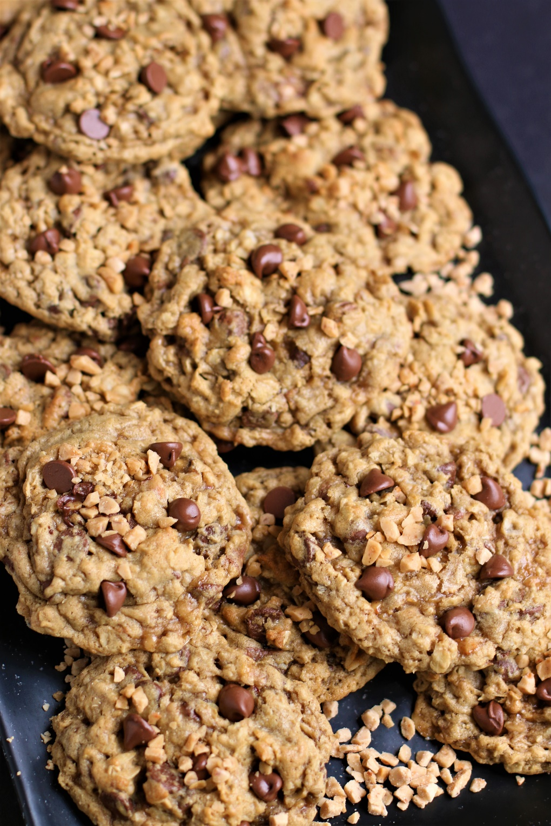

If you're looking for a cookie that will make your taste buds sing and your heart skip a beat, you need to try these bakery-style gourmet English Toffee Oatmeal Chocolate Chip Cookies. Rich and buttery, and loaded with caramelized toffee bits and silky milk chocolate, they have a soft and chewy texture on the inside and perfectly crisp golden edges. It’s like a party in your mouth with every bite, and hands down the best oatmeal cookie variation there is! They're the perfect treat for any occasion, whether you're sharing them with friends or keeping them all to yourself. Trust me, you won't be disappointed!
INGREDIENTS:
1 cup (2 sticks; 235g) unsalted butter (softened)
2 large eggs (room temperature)
1-3/4 cups (219g) all-purpose flour
1 teaspoon baking soda
1 teaspoon baking powder
1 teaspoon salt
1-1/2 cups (300g) brown sugar (light or dark)
2 teaspoons pure vanilla extract
3 cups (270g) whole rolled oats
1-1/3 cups (8 oz. bag) Heath English Toffee Bits or Heath Milk Chocolate English Toffee Bits
1-1/2 cups (270g) milk chocolate chips

HOW I MAKE THESE:
- Remove butter and eggs from fridge and bring to room temperature.
- In a medium bowl, whisk together the flour, baking soda, baking powder and salt; set aside.
- In a large bowl using a hand mixer or a stand mixer fitted with a paddle attachment, beat the butter on medium-high speed until smooth, about 1 minute. Add the brown sugar and beat on medium-high speed until creamed, about 2 minutes. Add the eggs and vanilla and beat on high speed until combined, about 1 minute. Scrape down the sides and up the bottom of the bowl and beat again as needed to combine.
- Add the dry ingredients to the wet ingredients and mix on low until combined. With the mixer running on low speed, add the oats.
- Once combined, beat in the toffee bits and chocolate chips. Dough will be thick and sticky. Cover and chill the dough for at least 20 minutes in the refrigerator (and up to 4 days). If chilling for longer than 1 hour, allow to sit at room temperature for at least 30 minutes before rolling and baking because the dough will be quite hard.
- Preheat oven to 350°F (177°C). Line baking sheets with parchment paper or silicone baking mats; set aside.
- Using a large cookie scoop, scoop balls of dough (3 Tablespoons of dough per cookie) and arrange 3 inches apart on the baking sheets. Bake for 12-14 minutes until lightly browned on the sides. The centers will look very soft. DO NOT OVERBAKE!
- Remove from the oven and allow to cool on baking sheet for 5 minutes before transferring to a wire rack to cool completely. While the cookies are still warm, I like to press a few extra chocolate chips into the tops!
YIELD: Makes 30 (3-inch) cookies
RECIPE VARIATIONS:
- LOVE CRISPIER COOKIES? Replace 1 cup of brown sugar with 1 cup granulated sugar.
- BUTTER PECAN ENGLISH TOFFEE OATMEAL CHOCOLATE CHIP COOKIES: Add 1 teaspoon Butter Pecan emulsion to the recipe and reduce pure vanilla extract to 1 teaspoon.
- TOFFEE CHOCOLATE CHIP PECAN OATMEAL COOKIES: Add 1 cup chopped pecan pieces; reduce toffee bits to 1 cup and milk chocolate chips to 1 cup.
- DARK CHOCOLATE TOFFEE OATMEAL COOKIES: Replace milk chocolate chips with dark chocolate chips or semi-sweet chocolate chips.
- BUTTERSCOTH PECAN TOFFEE CHOCOLATE CHIP COOKIES: Add ¾ cup butterscotch chips and ¾ cup chopped pecans to recipe; reduce milk chocolate chips to 1 cup.
- GLUTEN FREE ENGLISH TOFFEE OATMEAL CHOCOLATE CHP COOKIES: You can easily make this recipe Gluten-Free by substituting your favorite 1:1 gluten free flour for the all-purpose flour. I use and recommend King Arthur, Measure for Measure Flour and Bob's Red Mill Gluten Free 1-to-1 Baking Flour, and by using Quaker Gluten Free Old Fashioned Oats.
RECIPE NOTES:
- WEIGH INGREDIENTS CAREFULLY FOR BEST RESULTS: If I can only share one baking secret with you, always use a DIGITAL KITCHEN SCALE. You can use measuring cups and spoons for most recipes, but using a digital scale makes for the more consistent and efficient baking. Take this from someone that bakes A LOT!
- USE GOOD QUALITY CHOCOLATE! I prefer Guittard or Ghirardelli chocolate chips for this recipe.
- OLD-FASHIONED OATS: Make sure to use whole oats – old-fashioned oats - for this recipe, not quick oats or instant oatmeal.
- MAKE-AHEAD INSTRUCTIONS: You can make the cookie dough and chill it in the refrigerator for up to 4 days. Allow to come to room temperature then continue with step 4. Baked cookies freeze well for up to 3 months. Unbaked cookie dough balls freeze well for up to 3 months. Bake frozen cookie dough balls for an extra minute, no need to thaw.
- Storage: Cookies stay fresh in an air-tight container at room temperature for up to 1 week.
- FOR PARTIES: I package cookies individually in self-sealing clear cellophane cello bags (Pack It Chic are my favorite brand). Make sure cookies are completely set after decorating before packaging. To make ahead, place individually wrapped and sealed cookies in a larger airtight container and refrigerate or freeze. Thaw frozen cookies unopened in the refrigerator - you are trying to minimize moisture during defrosting, which can cause your frosting to soften too much and loose detail.
Original recipe created by Snowflakes & Coffeecakes April 2014; revised and reposted May 2023.
© SnowflakesandCoffeecakes. All images, attachments & content are copyright protected. All rights reserved. Please do not use my images without prior permission. If you want to republish this recipe, please re-write the recipe in your own words, or link back to www.snowflakesandcoffeecakes.com for the recipe.

Tried it and loved it? Snap a picture and share it with me on Instagram @SnowflakesandCoffeecakes and by using the hashtag #SnowflakesandCoffeecakes.

