FUJI APPLE CHICKEN SALAD

WITH SWEET CHAMPAGNE VINAIGRETTE

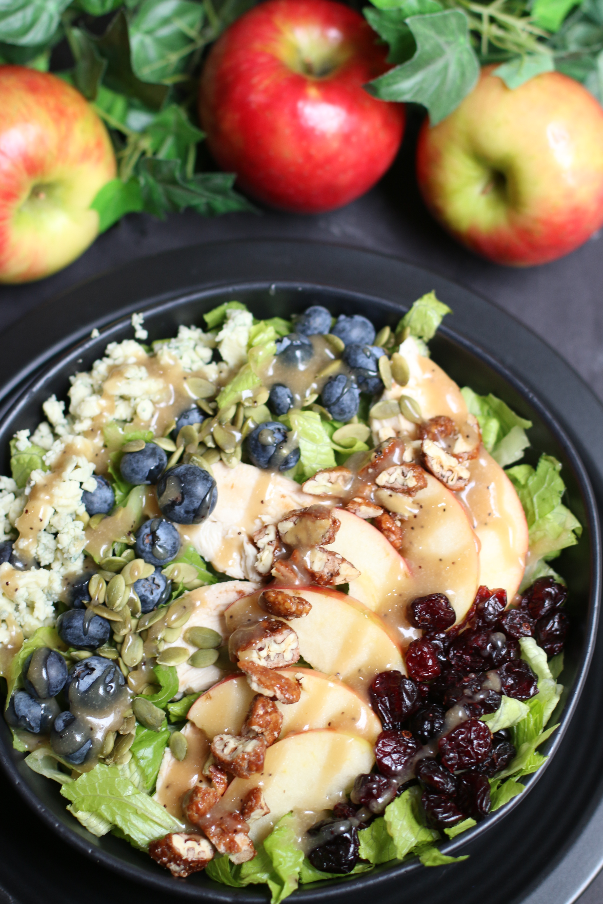

*Fuji Apple Chicken Salad with Sweet Champagne Vinaigrette Dressing is loaded with fresh greens, tender chicken, apple slices, fresh blueberries, and sprinkled with glazed pecans and gorgonzola cheese. The Sweet Champagne Vinaigrette Dressing is perfect drizzled on top – so many layers of flavors!*

**INGREDIENTS:**

***SALAD*:**

1 (10 oz.) bag spring salad mix, romaine or baby spinach

2 fuji apples (thinly sliced) or 2 cups apple chips

2 chicken breasts (grilled and chopped) or 2 cups rotisserie chicken (shredded)

½ cup fresh blueberries (optional)

½ cup craisins or dried cherries

1 cup glazed pecans

1/2 cup Gorgonzola or blue cheese (crumbled)

¼ cup pepitas

***sweet champagne vinaigrette DRESSING***:

1/2 cup extra virgin olive oil

¼ cup champagne vinegar or white balsamic vinegar

3 tablespoons honey

1 tablespoon heavy cream

2 teaspoons Dijon mustard

1/8 teaspoon garlic powder

¼ teaspoon freshly-cracked black pepper

**HOW I MAKE THIS**:

1. **TO MAKE YOUR OWN APPLE CHIPS**: While these aren’t quite as crunch as store-bought apple chips, what these lack in crunchiness they more than make up for with fresh flavor! Preheat oven to 225 degrees. Thinly slice the fuji apples and place the slices in a single layer on the sheet. Bake for 1 hour, then flip the slices and bake for 1 more hour. These can be made ahead of time and stored at room temperature in an airtight container.
2. **PREPARE SALAD**: Wash salad mix and drain well.
3. In a large bowl, mix all salad ingredients.
4. **PREPARE SWEET CHAMPAGNE VINAIGRETTE DRESSING**: Combine salad dressing ingredients together in a small glass jar (with lid) or small bowl. Shake or whisk together, until well blended.
5. Slowly pour desired amount of dressing over salad, toss and serve immediately.

**SERVINGS**: 2 to 4 servings

**INSPIRED** by the Fuji Apple Salad from Panera Bread.

*Originally posted March 2016; revised and reposted October 2020.*

*©* ***SnowflakesandCoffeecakes****. All images, attachments & content are copyright protected. All rights reserved. Please do not use my images without prior permission. If you want to republish this recipe, please re-write the recipe in your own words, or link back to* [*www.snowflakesandcoffeecakes.com*](http://www.snowflakesandcoffeecakes.com) *for the recipe.*