OVERNIGHT CINNAMON ROLLS
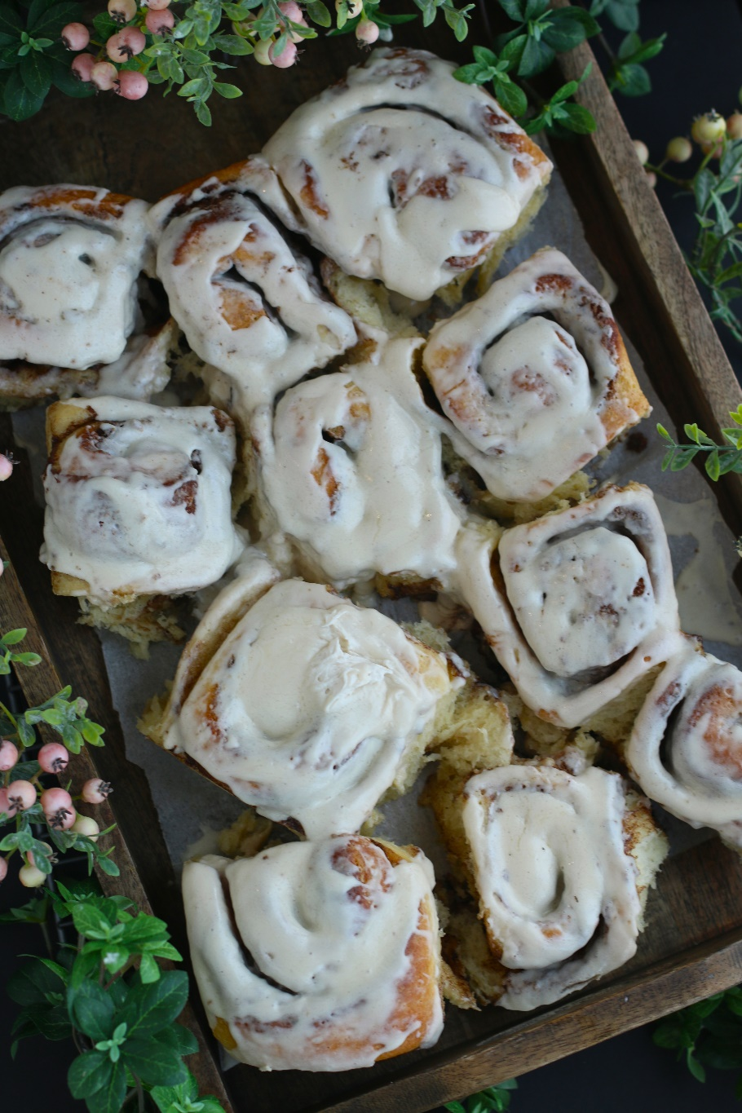

There's nothing quite like waking up to the smell of freshly baked cinnamon rolls wafting through the house, and homemade Overnight Cinnamon Rolls are the perfect way to start your day with a warm and comforting treat! There's something truly special about the process of making cinnamon rolls from scratch and waking up to a freshly baked batch in the morning. And if you've ever been afraid to bake with yeast, this is the recipe to try - these are the EASIEST cinnamon rolls ever! These tender and fluffy rolls are lovingly crafted with a rich and buttery dough that is infused with a generous amount of sweet cinnamon and sugar to create a warm and gooey mixture that will melt in your mouth with each bite. As they bake to golden perfection, the irresistible aroma of warm spices fills the air, creating a sense of warmth and coziness that will make your mouth water! What sets these cinnamon rolls apart is the overnight preparation, allowing the dough to develop its flavor and rise to perfection - this extra time results in a pillowy soft texture. Topped with a decadent cream cheese glaze, these Cinnamon Rolls are a true indulgence that is perfect for breakfast, brunch, or a late-night treat, and sure to become a family favorite!

INGREDIENTS:
SWEET DOUGH:
1/2 cup (8 Tbsp; 113g) unsalted butter (softened to room temperature)
2 large eggs (room temperature)
1 cup (240ml) whole milk (warmed to about 100°F)
2/3 cup (135g) granulated sugar (divided)
1-1/2 Tablespoons (2 standard size packets; 14g) premium instant yeast (or active dry or instant yeast)
1/2 teaspoon salt
4 and 1/2 cups (563g) all-purpose flour or bread flour, plus more as needed
2 teaspoons canola, vegetable, or olive oil for bowl (or use nonstick spray)

CINNAMON FILLING:
1/2 cup (8 Tbsp; 113g) unsalted butter (room temperature)
2/3 cup (135g) light or dark brown sugar
1 and 1/2 Tablespoons ground cinnamon

CREAM CHEESE ICING:
4 ounces (113g) full-fat brick cream cheese (softened to room temperature)
1 cup (120g) confectioners’ sugar
2 Tablespoon (30ml) half & half
1 teaspoon pure vanilla extract

HOW I MAKE THESE:
- Remove eggs and butter from refrigerator and allow to come to room temperature.
- PREPARE DOUGH: Whisk the warm milk, 2 Tablespoons sugar, and the yeast together in the bowl of your stand mixer fitted with a dough hook or paddle attachment. Cover and allow mixture to sit for about 5 minutes or until foamy on top.
- Add the remaining sugar (which should be about ½ cup or 100g). Cut the butter into 4-6 pieces and add to the bowl; beat on low until it is slightly broken up.
- Beat the eggs lightly in a small bowl and add to bowl, along with salt, and beat on medium speed until combined. The butter won’t really be mixing into the mixture, so don’t be alarmed if it stays in pieces. Switch the mixer down to low speed and with it running, add 1 cup of flour at a time, making sure it’s fully incorporated before adding the next. Stop the mixer and scrape down the sides of the bowl as needed. After 4 cups have been added, add the last 1/2 cup and beat until the dough comes together and pulls away from the sides of the bowl, about 3 minutes. The dough will be soft.
- KNEAD DOUGH: Keep the dough in the mixer (and switch to the dough hook if you used the paddle) and beat for an additional 5 full minutes, or knead by hand on a lightly floured surface for 5 full minutes. If the dough becomes too sticky during the kneading process, sprinkle 1 teaspoon of flour at a time on the dough to make a soft, slightly tacky dough. Do not add more flour than you need because you do not want the dough to be too dry.
- After kneading, the dough should still feel a little soft. Poke it with your finger — if it slowly bounces back, your dough is ready to rise. You can also do a “windowpane test” to see if your dough has been kneaded long enough: tear off a small (roughly golfball-size) piece of dough and gently stretch it out until it’s thin enough for light to pass through it. Hold it up to a window or light. Does light pass through the stretched dough without the dough tearing first? If so, your dough has been kneaded long enough and is ready to rise. If not, keep kneading until it passes the windowpane test.
- FIRST DOUGH RISE: Lightly grease a large bowl with oil or use nonstick spray. Place the dough in the bowl, turning it to coat all sides in the oil. Cover the bowl with plastic wrap, and then cover with a clean kitchen towel. Place the bowl in a warm environment with no drafts and allow the dough to rise for 2 hours or until double in size. (I always let it rise on the counter or the oven and it takes about 2 hours.)
- Line the bottom of a metal or glass 9x13-inch baking pan or grease the bottom and sides.
- ROLL OUT DOUGH: Punch down the dough to release the air. Place dough on a lightly floured work surface. Using a lightly floured rolling pin, roll dough into a 12×18-inch rectangle. Make sure the dough is smooth and evenly thick. If the dough keeps shrinking as you roll it out, stop what you’re doing, cover it lightly, and let it rest for 10 minutes to relax the gluten. When you return to the dough, it should stretch out much easier.
- PREPARE CINNAMON SUGAR FILLING: Spread the softened butter all over the dough with a small silicone spatula. The softer the butter is, the easier it is to spread in this step. In a small bowl, mix the sugar and cinnamon together. Sprinkle evenly over the butter. Tightly roll up the dough to form an 18-inch-long log. If some filling spills out, sprinkle it on top of the roll.
- Using dental floss or an extra sharp knife, cut into 12 even rolls, about 1.5 inches each. Arrange in the prepared baking pan. Cover the rolls tightly with plastic wrap.
- SECOND DOUGH RISE: To bake same day, continue on and allow to rise until puffy, about 1 hour (if using the Overnight method, skip to step 13).
- FOR OVERNIGHT CINNAMON ROLLS: Cover the rolls tightly with plastic wrap and refrigerate for 8-12 hours. The next morning, remove from the refrigerator and allow the Second Dough Rise at room temperature for 1-2 hours before continuing with step 14.
- BAKE CINNAMON ROLLS: Preheat the oven to 350°F.
- Bake for 15 minutes, and then tent the top of the pan with a piece of aluminum foil to prevent the tops from browning too quickly.
- Bake for an additional 10-13 minutes or until they are lightly browned on top (or reach an internal temp of 190 degrees on a digital thermometer inserted in the middle of a roll in the center of the pan).
- Remove pan from the oven and place pan on a wire rack for about 10 minutes as you make the icing.
- PREPARE ICING: In a medium bowl using a handheld or stand mixer fitted with a paddle or whisk attachment, beat the cream cheese on medium speed until smooth and creamy. Add the confectioners’ sugar, half & half, and vanilla. Beat on low speed for 30 seconds, then switch to high speed and beat for 1 minute. Spread the icing over the warm rolls and serve immediately.
- Cover leftover frosted or unfrosted rolls tightly and store at room temperature for up to 2 days or in the refrigerator for up to 5 days.
YIELD: 12 cinnamon rolls
RECIPE NOTES:
WEIGH INGREDIENTS CAREFULLY FOR BEST RESULTS: If I can only share one baking secret with you, always use a DIGITAL KITCHEN SCALE. You can use measuring cups and spoons for most recipes, but using a digital scale makes for more consistent and efficient baking. Take this from someone that bakes A LOT!
YEAST: For best results, I use and recommend Red Star Platinum Premium Instant Yeast with Dough Enhancers. You can use either active dry or instant yeast in this recipe. Follow the directions exactly as written regardless of which you choose. You’ll proof the yeast in warm milk with some sugar even if you use instant yeast, which ensures that the yeast is active and not expired. Most yeast these days is already active, but it’s a quick 5-10 minute step that prevents you from wasting your time just in case the yeast has expired. If using active dry yeast, the rise times will be a little longer.
FLOUR: Flour creates the structure of the dough. You can use either all purpose flour or bread flour in this recipe, but you’ll notice the cinnamon rolls are a little chewier if you use bread flour.
TIME: This dough requires 2 rises. Read thru all of the recipe instructions before you start so that you understand the process. Preparation moves pretty quickly – you’ll need to set aside at least 4-5 hours from start to finish or divide between 2 days with the overnight option. Whichever method you use, most of the time involved is allowing the dough to rise.
ICING OPTIONS: Not a fan of Cream Cheese Icing? For something different, you can top these warm Cinnamon Rolls with Vanilla Icing, Maple Icing or Caramel Icing.

RECIPE VARIATIONS:
- MAPLE PECAN CINNAMON ROLLS: Add finely chopped pecans to the Cinnamon Sugar Filling and drizzle maple syrup over the rolls before baking. Top with Cream Cheese Frosting or Maple Icing for a delicious flavor combination!
- RASPBERRY SWEET ROLLS: Use Raspberry Filling in place of the Cinnamon Sugar Filling. Using one 10-oz. package (2.5 cups/300g) frozen raspberries (do not thaw first), toss with 1/3 cup (67g) granulated sugar and 1 teaspoon cornstarch. There is no cooking involved for Raspberry Filling. Sprinkle or spread filling evenly over the dough sheet before rolling.
- APPLE CINNAMON ROLLS: Spread a thin layer of apple pie filling over the rolled-out dough; sprinkle with cinnamon and a touch of nutmeg and roll. Top with a simple Vanilla Glaze or Caramel Glaze for an apple pie inspired treat!
- STRAWBERRY SWEET ROLLS: Use Strawberry Filling in place of the Cinnamon Sugar Filling. To make, place 1-3/4 cups (222g) finely chopped fresh strawberries in a small saucepan over medium heat. Stir constantly for 4 minutes until the strawberries begin to release their sweet juices. Add 1/3 cup (68g) granulated sugar and 1-1/2 Tablespoons cornstarch and continue to stir for another 2 minutes; remove from heat and pour into an airtight container and chill until ready to use; the mixture will thicken as it cools. You do not want to use a warm filling when you spread it evenly on the dough sheet. Top with a Strawberry Cream Cheese Frosting (add 1 tablespoon of crushed dehydrated strawberries to the Cream Cheese Frosting and stir until well combined).
- LEMON BLUEBERRY CINNAMON ROLLS: Use Blueberry Filling in place of the Cinnamon Sugar Filling. To make, place 1-3/4 cups fresh blueberries in a small saucepan over medium heat. Stir constantly for 4 minutes until the blueberries begin to release their juices. Add 1/3 cup (68g) granulated sugar and 1-1/2 Tablespoons of cornstarch and 1 Tablespoon of fresh lemon juice and continue to stir for another 2 minutes; remove from heat and pour into an airtight container and chill until ready to use; the mixture will thicken as it cools. You do not want to use a warm filling when you spread it evenly on the dough sheet. Top with Lemon Cream Cheese Frosting for a refreshing and fruity twist.
- PUMPKIN SPICE CINNAMON ROLLS: Add 1 Tablespoon of pumpkin pie spice to the dough for a seasonal twist. Spread ½ cup pumpkin puree onto the dough sheet, and add 2 teaspoons of apple pie spice to the Cinnamon Sugar Filling before sprinkling on top of the pumpkin puree. Top with Cream Cheese Frosting spiked with a little extra cinnamon and a pinch of nutmeg.
- BIRTHDAY CAKE CINNAMON ROLLS: Replace Cinnamon Sugar Filling with Birthday Cake Filling. In a small bowl, mix together ½ cup (113g) unsalted butter (softened to room temperature) with 2/3 cup (84g) all purpose flour, ¼ cup (50g) granulated sugar, ¼ cup (50g) light or dark brown sugar, ½ cup (85g) rainbow sprinkles (not nonpareils), 2 Tablespoons (16g) powdered coffee creamer or nonfat instant dry milk, 2 teaspoons ground cinnamon, 1 teaspoon pure vanilla extract, and ¼ teaspoon salt. Sprinkle Birthday Cake Filling evenly over dough sheet before rolling. Sprinkle additional rainbow sprinkles on top of your icing for a festive birthday treat!
- NUTELLA CINNAMON ROLLS: Spread dough sheet with a thin layer of Nutella before sprinkling with Cinnamon Sugar Filling; sprinkle chopped hazelnuts over the Nutella layer for added crunch. After baking, drizzle with a mixture of warm Nutella and milk for a decadent chocolatey topping.
- SALTED CARAMEL CINNAMON ROLLS: Drizzle caramel sauce over the cinnamon rolls before baking; sprinkle a little sea salt over the caramel for a sweet and salty contrast. Top with Cream Cheese Frosting or Salted Caramel Glaze.

Recipe inspired by SallysBakingAddiction; revised & reposted February 2024.
© SnowflakesandCoffeecakes. All images, attachments & content are copyright protected. All rights reserved. Please do not use my images without prior permission. If you want to republish this recipe, please re-write the recipe in your own words, or link back to www.snowflakesandcoffeecakes.com for the recipe.

Tried it and loved it? Snap a picture and share it with me on Instagram @SnowflakesandCoffeecakes and by using the hashtag #SnowflakesandCoffeecakes.

