SALTED CARAMEL CUPCAKES
with SALTED CARAMEL buttercream
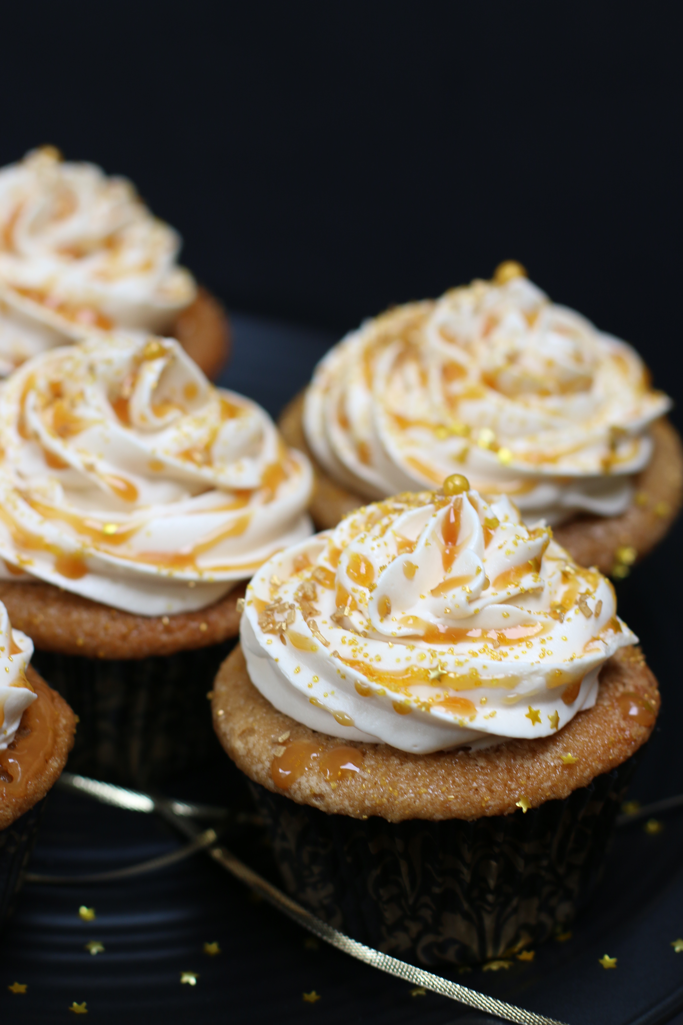

These are the Golden Salted Caramel Cupcakes that everyone goes nuts over! Rich, buttery caramel flavor, topped with golden Salted Caramel Buttercream Frosting. Truly special

INGREDIENTS:
1-1/2 cups all-purpose flour (190g)
¾ teaspoon baking powder
½ teaspoon salt
1 cup packed dark brown sugar
½ cup granulated sugar
½ cup unsalted butter (softened to room temperature)
2 large eggs (room temperature)
1 teaspoon Rodelle Pure Vanilla Extract or Vanilla Paste
½ cup buttermilk (room temperature)

Salted Caramel Buttercream Frosting
Salted Caramel Sauce
SPRINKLES!

HOW I MAKE THESE:
- Set out butter, eggs and buttermilk so that they come to room temperature.
- Preheat oven to 350 degrees. Line a muffin tin with 12 cupcake liners.
- In a mixing bowl whisk together flour, baking soda and salt until well combined, set aside. (I always sift my flour when making this recipe – sift prior to measuring for best results.)
- In a large mixing bowl, beat the butter, sugar and brown sugar at medium-high speed until light and fluffy (about 3 minutes). Add the eggs and vanilla. Continue beating until combined.
- Slowly add flour mixture in two batches, mixing slowly just until combined. Slowly pour in the buttermilk and stir just until combined – DO NOT OVERMIX!
- Divide batter among prepared muffin cups, filling each only half full.
- Bake in preheated oven for 21-23 minutes, or until a toothpick inserted in the center comes out clean.
- Remove from oven, transfer to a wire rack and cool 10 minutes, then transfer to an airtight container (one that doesn't touch tops. I like to do this to seal in moisture) and allow to cool completely before frosting.
- When the cupcakes are completely cool, fill piping bag and frost with Salted Caramel Buttercream Frosting. Decorate with a drizzle of Salted Caramel Sauce and lots of sprinkles – whatever strikes your fancy!
- Store in a domed airtight container in the refrigerator until ready to serve.

YIELD: 12 Cupcakes
© SnowflakesandCoffeecakes. All images, attachments & content are copyright protected unless otherwise indicated. All rights reserved. Please do not use my images without prior permission. If you want to republish this recipe, please re-write the recipe in your own words, or link back to www.snowflakesandcoffeecakes.com for the recipe.

