STRAWBERRY SUGAR COOKIES
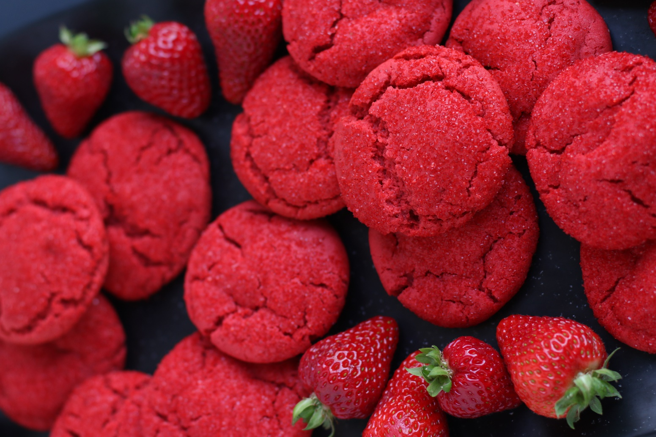

Strawberry Sugar Cookies are a simple and delicious sugar cookie, rolled in Sparkling Strawberry Sugar and simply bursting with fresh, sweet summery strawberry flavor and color! If you’re looking for an easy recipe for scrumptious, buttery cookies with crinkly tops, crisp edges, soft and chewy centers, this is the recipe for you. These are the perfect soft and chewy sugar cookies for sunny summer celebrations, and with the bright color of fresh berries and filled with fresh strawberry flavor, they are also perfect for Valentine’s Day and birthday parties. For special summer fun, layer two Strawberry Sugar Cookies with fresh vanilla or fresh strawberry ice cream for an incredible Strawberry Ice Cream Sandwich treat!
INGREDIENTS:
STRAWBERRY SUGAR COOKIES:
1 cup (2 sticks) unsalted butter (softened)
2 large eggs (room temperature)
3 cups (375g) all-purpose flour
2 Tablespoons cornstarch
2 teaspoons baking powder
1 teaspoon baking soda
2 teaspoons cream of tartar
½ teaspoon salt
1 1/2 cups (300g) granulated sugar
6 Tablespoons (36g) freeze dried strawberry powder
1 teaspoon pure vanilla extract
1 teaspoon pure strawberry extract (Amoretti Artisan Natural Wild Strawberry or Cooks)
1/2 teaspoon red gel food coloring

SPARKLING STRAWBERRY SUGAR:
1/2 cup white or red sparkling sugar (sanding sugar)
1 Tablespoon freeze dried strawberry powder
HOW I MAKE THESE:
- Remove butter and eggs from refrigerator.
- PREPARE FREEZE-DRIED STRAWBERRY POWDER: Blend or process the strawberries in a high speed blender or spice grinder until they become a fine powder. Mix together with the sugar. Store in an airtight container in a cool dry location until ready to use.
- PREPARE SPARKLING STRAWBERRY SUGAR: Stir together freeze-dried fruit powder with sparkling sugar (1 tablespoon of fruit powder for every 1/2 cup of sparkling sugar). Store in an airtight container in a cool dry place until ready to use.
- Preheat oven to 350℉. Line baking sheets with parchment paper; set aside.
- PREPARE COOKIE DOUGH: In the bowl of a stand mixer, cream the butter and granulated sugar on medium speed until light and fluffy, about 3 minutes.
- Add the eggs, one at a time, and blend well with each addition.
- Add vanilla extract, strawberry extract and red gel food coloring and mix until well blended.
- In a medium bowl, whisk together the flour, cornstarch, baking powder, baking soda, cream of tartar, salt and strawberry fruit powder until well blended.
- Add the flour mixture and blend on low speed just until mixed – DO NOT OVERMIX! This will keep your cookies soft and tender.
- Chill cookie dough for at leas2 hours and up to overnight.
- Place Sparkling Strawberry Sugar in a small bowl.
- Using a medium cookie scoop, scoop into 30 cookie dough balls. Roll each piece of dough into a ball in the palms of your hands, and then roll in Sparkling Strawberry Sugar until evenly coated; place each sugared cookie ball onto prepared cookie sheets, at least 2-inches apart.
- Bake the cookies in pre-heated oven for about 10 minutes, or until the tops are just beginning to set.
- Remove pans from oven and allow to cool for 5 minutes on baking sheet before transferring to a cooling rack to cool completely.
- Store cookies in an airtight container at room temperature for up to 3 days, or in the refrigerator for up to 1 week.
YIELD: Makes 30 cookies
RECIPE NOTES:
- USE SOFT BUTTER! For best texture, make sure to use good quality unsalted butter that is softened.
- DON’T OVERMIX! The secret to buttery and tender sugar cookies is to be careful not to overmix the cookie dough when adding the flour.
- WHERE CAN I FIND FREEZE-DRIED STRAWBERRIES? Target and Trader Joes carry so many varieties of freeze-dried fruit, but If you aren't able to find locally, you can purchase online.
- FOOD COLORING: I prefer to use gel food coloring or powdered food coloring when baking, as it’s a high concentration and you can use less than you would of traditional liquid food coloring.
- BAKERY STYLE SUGAR COOKIES? One tip for making these look just like bakery-style cookies is to sprinkle with additional Sparkling Sugar as soon as you remove from the oven, which will settle into all the crackly cookie tops as the cookies cool.
- TO KEEP THESE COOKIES SOFT: These cookies will stay soft and fresh in an air-tight container at room temperature for up to 3 days, or refrigerated for up to 1 week.
- TO FREEZE: These cookies can be frozen for up to 3 months. After baking and cooling, place them in an airtight, freezer safe container. If you need to layer the cookies, place parchment paper in between each layer to avoid sticking or freezing together.
- FOR PARTIES: I package cookies individually in self-sealing clear cellophane bags (Pack It Chic are my favorite brand). Make sure cookies are completely cool before packaging.

RECIPE VARIATIONS: This same concept and recipe can be used for your favorite fruit sugar cookies and sparkling fruit sugar! Substitute your favorite freeze-dried fruit and/or fruit flavor and create:
- Raspberry Sugar Cookies
- Blueberry Sugar cookies
- Mango Sugar Cookies
- Banana Sugar Cookies
- Apple Sugar Cookies (try sprinkling with cinnamon sugar!)
- Cranberry Sugar Cookies
- Sweet Peach Sugar Cookies
- Watermelon Sugar Cookies

GLUTEN FREE STRAWBERRY SUGAR COOKIES: You can easily make Gluten-Free Crumble Cookies by substituting your favorite 1:1 gluten free flour for the all-purpose flour. I use and recommend King Arthur, Measure for Measure Flour and Bob's Red Mill Gluten Free 1-to-1 Baking Flour.
VEGAN STRAWBERRY SUGAR COOKIES: If you use non-dairy butter these could technically be considered vegan cookies, adjust baking time as necessary. When it comes to baking with different ingredients, I always recommend testing before serving to a crowd!
Original recipe created by Snowflakes & Coffeecakes 2014; revised & reposted February 2023.
© SnowflakesandCoffeecakes. All images, attachments & content are copyright protected. All rights reserved. Please do not use my images without prior permission. If you want to republish this recipe, please re-write the recipe in your own words, or link back to www.snowflakesandcoffeecakes.com for the recipe.

Tried it and loved it? Snap a picture and share it with me on Instagram @SnowflakesandCoffeecakes and by using the hashtag #SnowflakesandCoffeecakes.

