vanilla bean cream cheese frosting
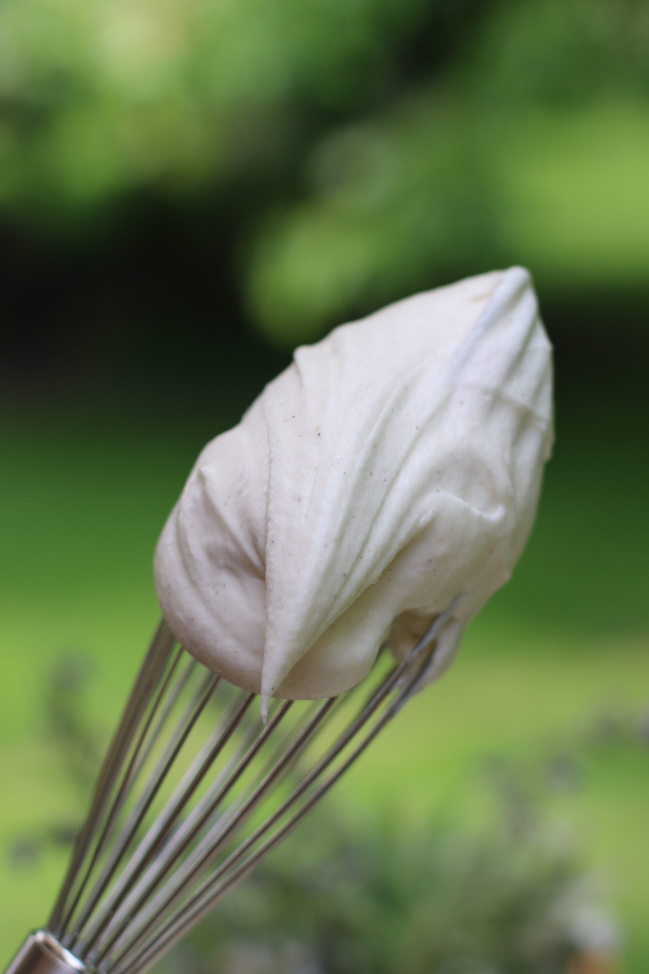

The Vanilla Bean Cream Cheese Frosting takes Banana Bars, Carrot Cake and
frosted sugar cookies to the next level of wonderful!

INGREDIENTS:
6 oz. cream cheese, softened
6 Tablespoon unsalted butter, softened
3 cups powdered sugar
2 Tablespoon half & half or heavy whipping cream
1 Tablespoon Rodelle Vanilla Bean Paste
1/8 tsp. salt

HOW WE MAKE THIS:
- Blend cream cheese and butter and whip until light and fluffy.
- Add Rodelle Vanilla Bean Paste, salt and half of powdered sugar; add 1 tablespoon of cream and remaining powdered sugar. Add remaining tablespoon of cream.
- Whip at high speed for at least 3 minutes. Make any adjustments – if too thick, add additional cream, if too thin add additional powdered sugar.
- Spread over cooled cake, bars or cookies.
- Refrigerate until cool and set before serving.
- Store frosted goods in a cool spot in an airtight container.

Originally posted March 2014; text and photos updated May 2017.
© SnowflakesandCoffeecakes. All images, attachments & content are copyright protected unless otherwise indicated. All rights reserved. Please do not use my images without prior permission. If you want to republish this recipe, please re-write the recipe in your own words, or link back to www.snowflakesandcoffeecakes.com for the recipe.

