peanut butter buttercream frosting
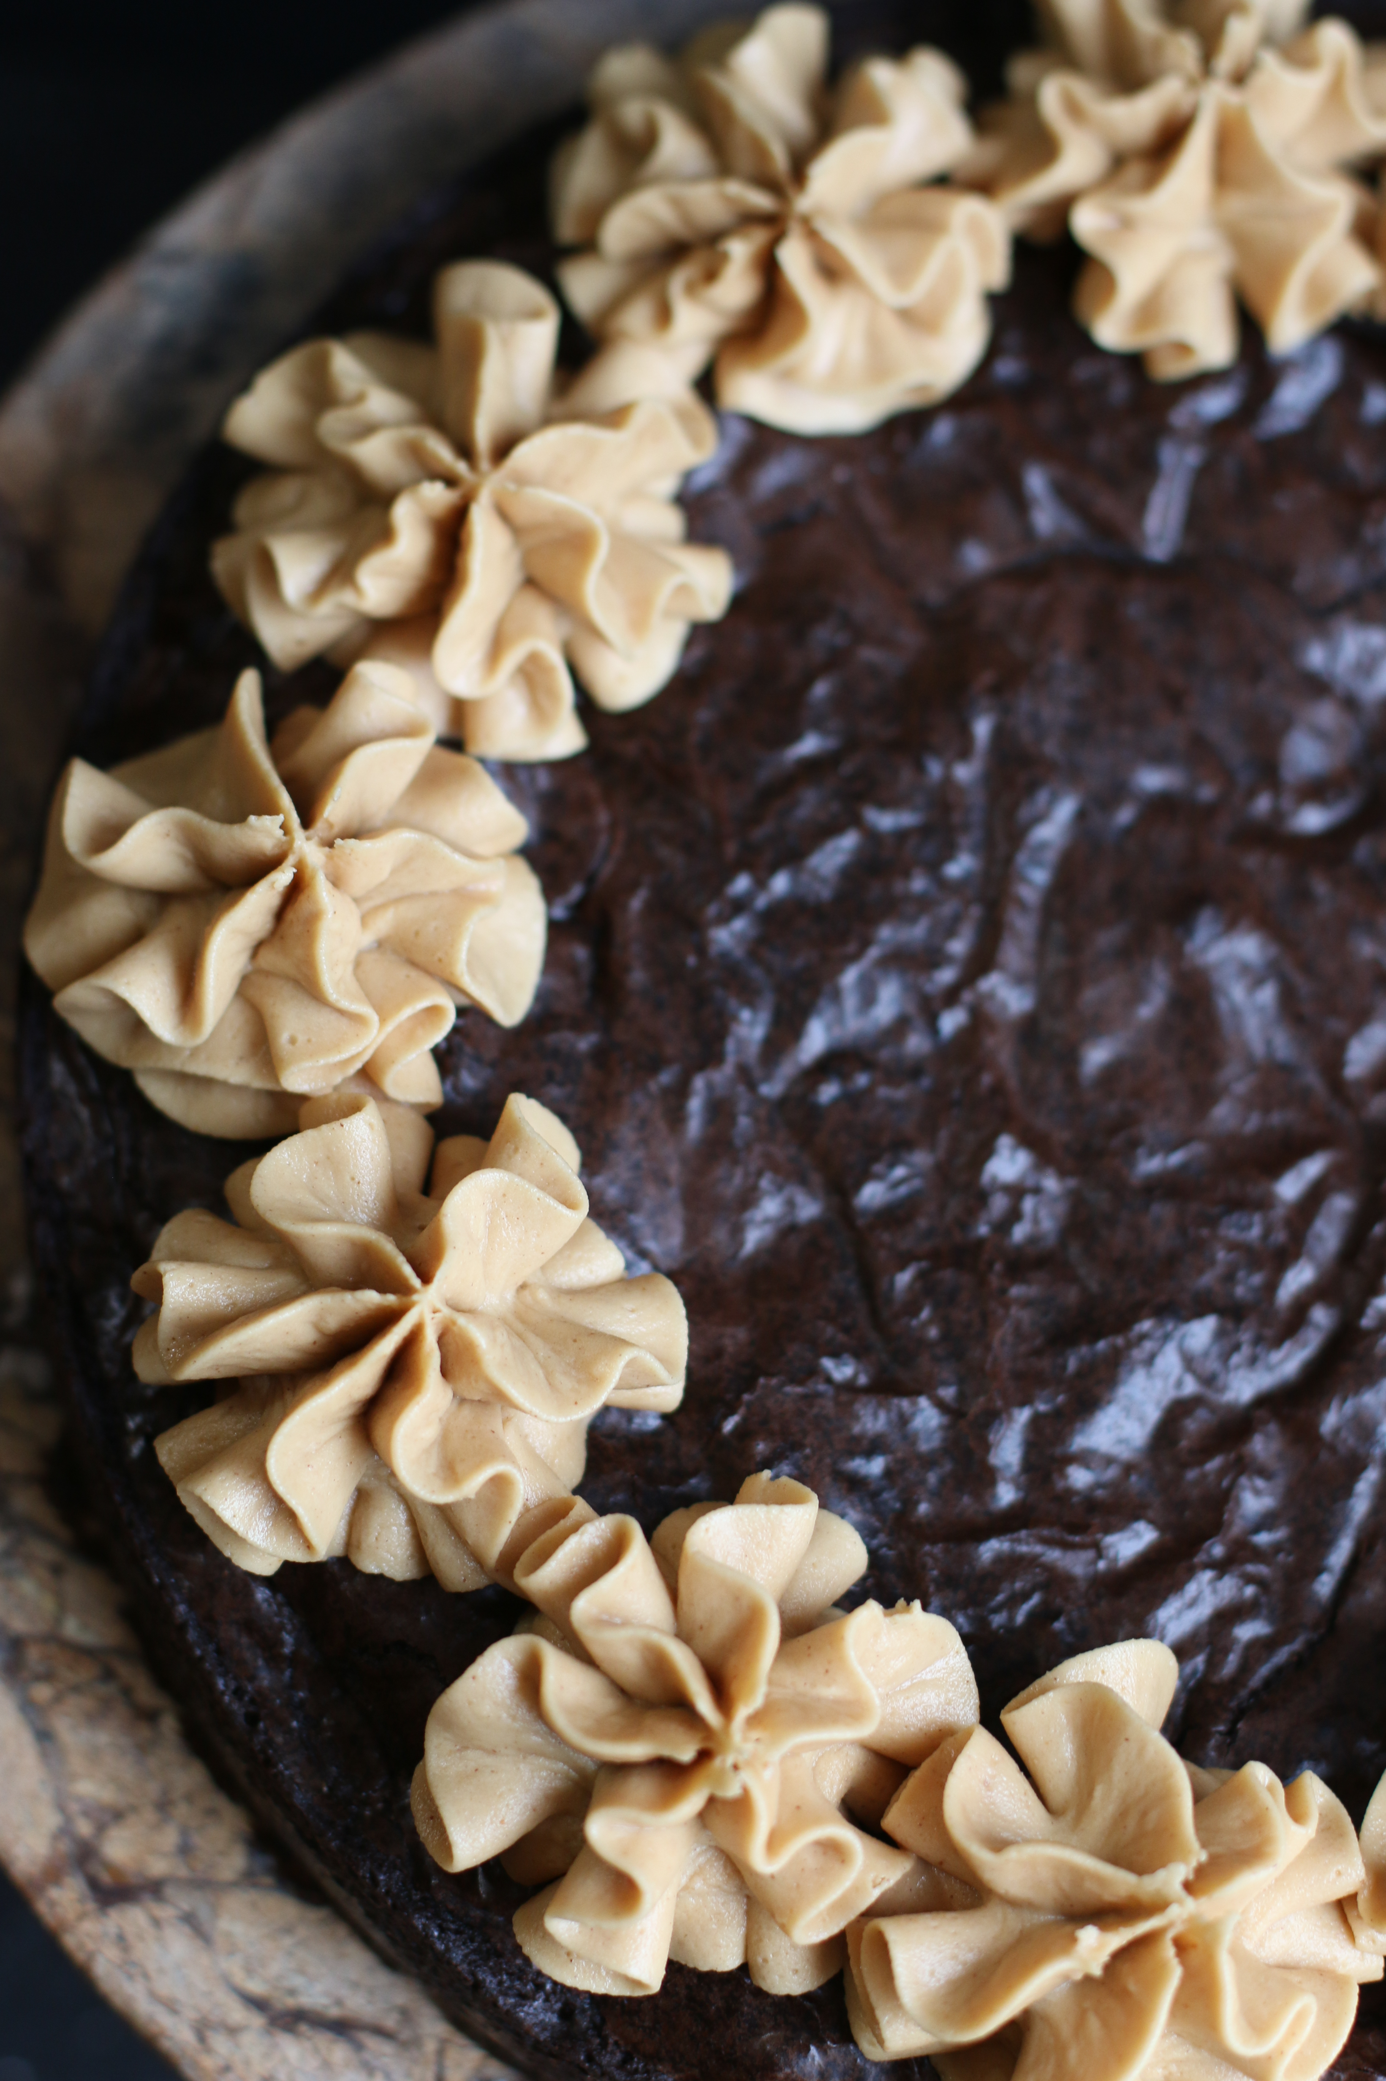

Homemade creamy peanut butter frosting – loaded with peanut butter flavor and so creamy!
The texture and consistency are perfect for piping or swirling.
Another family favorite that we hope you will love as much as we do!

INGREDIENTS:
5 Tablespoons unsalted butter (room temperature)
1 cup creamy peanut butter (Skippy or Jif)
1 cup (120g) confectioners' sugar
1/3 cup heavy cream
1 teaspoon Rodelle Pure Vanilla Extract
¼ teaspoon salt

HOW WE MAKE THIS:
- With a handheld or stand mixer fitted with a paddle or whisk attachment, beat the butter on medium speed until creamy - about 2 minutes.
- Add the peanut butter, confectioners' sugar, heavy cream, vanilla extract and salt. Once everything is in the bowl, increase to high speed and beat until light and creamy, about 3 to 4 minutes.
- Add up to 1/4 cup more confectioners' sugar if frosting is too thin or another tablespoon of heavy cream if frosting is too thick.
- Frost brownies using an offset spatula or fill a piping bag and pipe frosting into nice swirls (I used a 1M tip in the photo above).

NOTES: Use a commercial brand peanut butter such Skippy or Jif. Avoid natural, oily, or homemade peanut butters as the consistency will cause this frosting to separate and curdle.
YIELD: This recipe is enough to frost 12-16 cupcakes or one 9x13 quarter sheet cake.
© SnowflakesandCoffeecakes. All images, attachments & content are copyright protected unless otherwise indicated. All rights reserved. Please do not use my images without prior permission. If you want to republish this recipe, please re-write the recipe in your own words, or link back to www.snowflakesandcoffeecakes.com for the recipe.

