caramel cashew chex mix
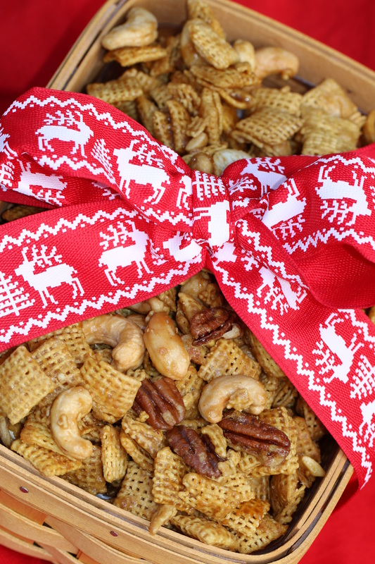

I’m going to warn you now….this stuff is seriously out-of-this-world addictive!

INGREDIENTS:
6 cups total of your choice: Corn, Cinnamon or Honey Nut Chex or Crispix cereal
1-1/2 cups small pretzel twists
1-1/2 cups cashews & pecans
¾ cup packed brown sugar
6 Tablespoons butter (no substitutes)
3 Tablespoons light corn syrup
1 teaspoon vanilla
½ teaspoon baking soda
½ teaspoon cayenne pepper

HOW I MAKE THESE:
- Preheat oven to 300 degrees. Spray roasting pan with non-stick cooking spray.
- Combine cereal, pretzels and nuts in prepared pan.
- In a heavy saucepan, combine butter, brown sugar and corn syrup. Cook and stir over medium heat until mixture comes to a boil. Reduce heat to medium-low and cook without stirring for 5 minutes more.
- Remove pan from heat. Stir in baking soda, vanilla and cayenne pepper. Pour mixture over cereal mixture, gently stirring to coat.
- Bake for 15 minutes. Stir mixture, bake 5 minutes more. Spread caramel corn mixture on a large piece of parchment paper until cool. Break into pieces.
- Store in an air-tight container for up to 1 week. (But it will never last that long!)

YIELD: Makes approximately 9 cups.
© SnowflakesandCoffeecakes. All images, attachments & content are copyright protected unless otherwise indicated. All rights reserved. Please do not use my images without prior permission. If you want to republish this recipe, please re-write the recipe in your own words, or link back to www.snowflakesandcoffeecakes.com for the recipe.

