CHOCOLATE CHIP PUDDING COOKIES
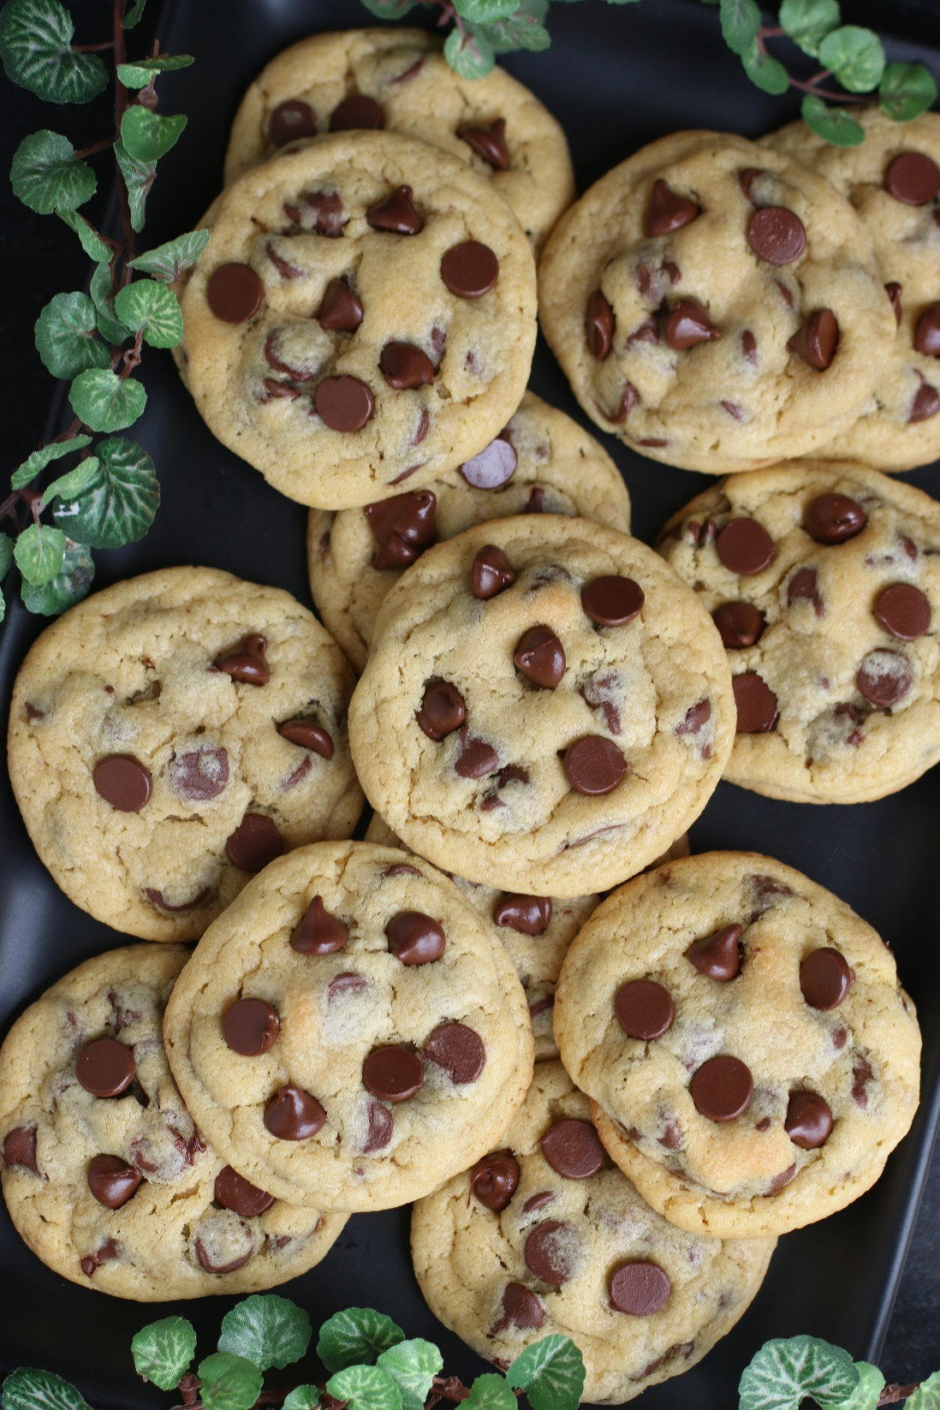

Chocolate Chip Pudding Cookies are the ultimate comfort treat! These soft and chewy cookies are a delightful twist on the classic favorite, featuring a secret ingredient – pudding mix! With a perfect balance of sweetness and texture, these delicious cookies are sure to satisfy your sweet tooth cravings. Whether you’re a cookie enthusiast or a baking novice, this easy-to-follow recipe for Chocolate Chip Pudding Cookies are guaranteed to become a staple in your recipe collection. Perfect for dunking in a cold glass of milk or warm and gooey straight out of the oven. This is the recipe that EVERYONE asks me for!
INGREDIENTS:
1 cup (2 sticks or 226g) unsalted butter (softened to room temperature)
2 large eggs (room temperature)
¾ cup (150g) light or dark brown sugar
¼ cup (50g) granulated sugar
2-1/4 cups (281g) all-purpose flour
1 (3.4 oz) pkg instant vanilla pudding mix
1 teaspoon baking soda
1/2 teaspoon salt
2 teaspoons pure vanilla extract
1 teaspoon LorAnn Butter Vanilla Emulsion
2 cups Ghirardelli semi-sweet chocolate chips

HOW I MAKE THESE:
- Set butter and eggs out to come to room temperature (this helps them incorporate into the cookie dough better).
- Preheat oven to 350 degrees. Line three baking sheets with parchment paper; set aside.
- PREPARE COOKIES: In a medium bowl, whisk together the flour, instant vanilla pudding mix, baking soda and salt until well combined; set aside.
- Using a stand mixer fitted with a paddle attachment, beat the butter, granulated sugar, and brown sugar for 3 minutes on medium speed until light and fluffy.
- Add the eggs, one at a time, and beat just until blended, scraping down the sides as needed.
- Add vanilla extract and butter vanilla emulsion and beat just until blended.
- Scrape down the sides and add in the flour mixture, ½ at a time, mixing just until blended; add remaining flour mixture and again mix just until blended. DO NOT OVERMIX! This cookie dough will be really soft and creamy!
- Fold in the chocolate chips with a silicone spatula until evenly blended.
- Using a medium cookie scoop (2 Tablespoon size), scoop out cookie dough and roll into a ball with your hands. Repeat with remaining dough.
- Place eight cookie dough balls on each baking sheet, leaving room between each cookie as the cookies will spread slightly when they bake.
- Bake for 11-12 minutes or until the edges are set and centers of the cookies have puffed up and are no longer glossy. Every oven is a little bit different, so watch your first batch when baking and time accordingly. DO NOT OVERBAKE, as these will lose their softness.
- Remove from oven and allow cookies to cool on the baking sheets for 5 minutes; transfer to baking rack to cool completely.
- These cookies are best served warm from the oven or at room temperature!
YIELD: Makes 36 cookies
RECIPE NOTES:
BROWN SUGAR: You know a cookie will be moist when there is more brown sugar than granulated sugar! For deeper flavor, I recommend dark brown sugar, but you can use either light or dark brown sugar in this recipe.
INSTANT PUDDING MIX: The cornstarch and milk powder in instant pudding mix makes these cookies perfectly tender and chewy, and adds extra vanilla flavor.
BUTTER VANILLA EMULSION: Adds depth of buttery flavor to homemade cookies. It also intensifies the flavor of chocolate - making regular chocolate chips taste more luxurious and vanilla flavor more magical. It is the secret ingredient in these chocolate chip cookies! If you don’t have this specialty product on hand, you can bake these cookies without it – they are still WONDERFUL!
FOR TENDER, CHEWY COOKIES: Don’t over-mix the cookie dough. Don’t overbake your cookies either! Remember, cookies will continue to bake for a few minutes while resting on the baking sheets after you take them out of the oven.
CHECK YOUR OVEN TEMP: Be sure your oven is at the right temperature – using an oven thermometer is helpful to make sure your oven isn’t running hotter or cooler than it should be. Every oven is a little bit different, so watch your first batch when baking and time accordingly.
TO KEEP THESE COOKIES SOFT: These cookies will stay soft and fresh in an air-tight container for up to 5 days. These cookies are best the day you make them – but they are still great warmed up!
MAKE AHEAD TIP: To freeze cookie dough, roll dough into balls and freeze on a baking sheet. Once they’re frozen solid, transfer to a freezer bag and freeze for up to 6 months. Bake from frozen for 1-2 minutes longer.
TO FREEZE BAKED COOKIES: Once totally cooled, store the cookies in an airtight container and freeze for up to 3 months. Thaw cookies at room temperature, or for a fresh-from-the-oven taste, warm up in microwave or a warm oven.

RECIPE VARIATIONS:
- DOUBLE CHOCOLATE CHIP PUDDING COOKIES: Substitute chocolate instant pudding or chocolate fudge instant pudding mix for the vanilla instant pudding mix for an extra rich and chocolaty flavor. Fold in an additional ½ cup of chocolate chips to intensify the chocolate experience!

- BANANA CREAM CHOCOLATE CHIP PUDDING COOKIES: Substitute banana instant pudding for the vanilla instant pudding – so yummy!

- CONFETTI CAKE CHOCOLATE CHIP PUDDING COOKIES: Replace 1 cup of the chocolate chips with ½ cup rainbow sprinkles and ½ cup white chocolate chips, and replace the Butter Vanilla Emulsion with Birthday Cake Emulsion for festive birthday cookies!

- PEANUT BUTTER CHOCOLATE CHIP PUDDING COOKIES: Substitute chocolate instant pudding or chocolate fudge instant pudding mix for the vanilla instant pudding mix, and replace half (or all) the chocolate chips with peanut butter chips or Reese’s peanut butter pieces.

- M&M CHOCOLATE CHIP PUDDING COOKIES: Add 1 cup of colorful M&M candies to the dough along with 1 cup of chocolate chips. The M&M candies add a pop of color and extra chocolatey goodness!

- BUTTERSCOTCH CHOCOLATE CHIP PUDDING COOKIES: Substitute butterscotch instant pudding mix for the vanilla instant pudding mix in the recipe. The butterscotch flavor pairs well with the chocolate chips and adds a rich, caramel-like taste to the cookies.

- BUTTERSCOTCH CHIP PUDDING COOKIES: Substitute butterscotch instant pudding mix for the vanilla instant pudding mix, and replace the chocolate chips with butterscotch chips for a rich, caramel-like taste.

- COCONUT CHOCOLATE CHIP PUDDING COOKIES: Replace with vanilla instant pudding mix with coconut instant pudding mix, and replace ½ cup of the chocolate chips with ½ cup shredded sweetened coconut to the cookie dough mixture.

- ALMOND JOY CHOCOLATE CHIP PUDDING COOKIES: Replace half of the chocolate chips with milk chocolate chips and add ½ cup of shredded coconut and ½ cup of chopped almonds to the cookie dough mixture. These cookies taste just like an Almond Joy candy bar!

- S’MORES CHOCOLATE CHIP PUDDING COOKIES: Replace ½ cup of the chocolate chips with crushed graham crackers, and add 1 cup of mini marshmallows (or mini freeze-dried marshmallows) to the cookie dough to recreate the flavors of a campfire s'more.

- ESPRESSO CHOCOLATE CHIP PUDDING COOKIES: Dissolve 1 tablespoon of instant espresso powder in 1 tablespoon of hot water and add it to the butter mixture before blending. I like to substitute chocolate espresso chocolate chips for half of the chocolate chips in this recipe, if you are able to find them, for a rich coffee flavor that pairs perfectly with the chocolate chips.

- WHITE CHOCOLATE MACADEMIA NUT PUDDING COOKIES: Add white chocolate chips, chopped macadamia nuts and craisins (a total of 2 cups combined ingredients) in place of the chocolate chips. The combination of white chocolate, macadamia nuts, cranberries and vanilla pudding creates a sweet and nutty cookie with a delicious texture.

- STRAWBERRY & CREAM PUDDING COOKIES: Replace the chocolate chips with 1 cup white chocolate chips and 1 cup strawberry chocolate chips, and replace the Butter Vanilla Emulsion with Fresh Strawberry Emulsion. I also like to add 1/3 cup crushed freeze dried strawberries for extra strawberry flavor!

- LEMON WHITE CHOCOLATE CHIP PUDDING COOKIES: Substitute lemon instant pudding mix for the vanilla instant pudding mix, and replace the chocolate chips with white chocolate chips for a fresh and summery cookie!

- GLUTEN-FREE CHOCOLATE CHIP PUDDING COOKIES: Indulge in cookie goodness with a gluten-free twist! Substitute your favorite 1:1 gluten free flour for the all-purpose flour - I use and recommend King Arthur, Measure for Measure Flour and Bob's Red Mill Gluten Free 1-to-1 Baking Flour. You will also need to substitute gluten-free instant vanilla pudding mix. Enjoy the same chewy texture and heavenly flavors without compromising on taste!

Original recipe created by Snowflakes & Coffeecakes March 2016; revised and reposted March 2024.
© SnowflakesandCoffeecakes. All images, attachments & content are copyright protected. All rights reserved. Please do not use my images without prior permission. If you want to republish this recipe, please re-write the recipe in your own words, or link back to www.snowflakesandcoffeecakes.com for the recipe.

Tried it and loved it? Snap a picture and share it with me on Instagram @SnowflakesandCoffeecakes and by using the hashtag #SnowflakesandCoffeecakes.

