GRINCH sugar cookies
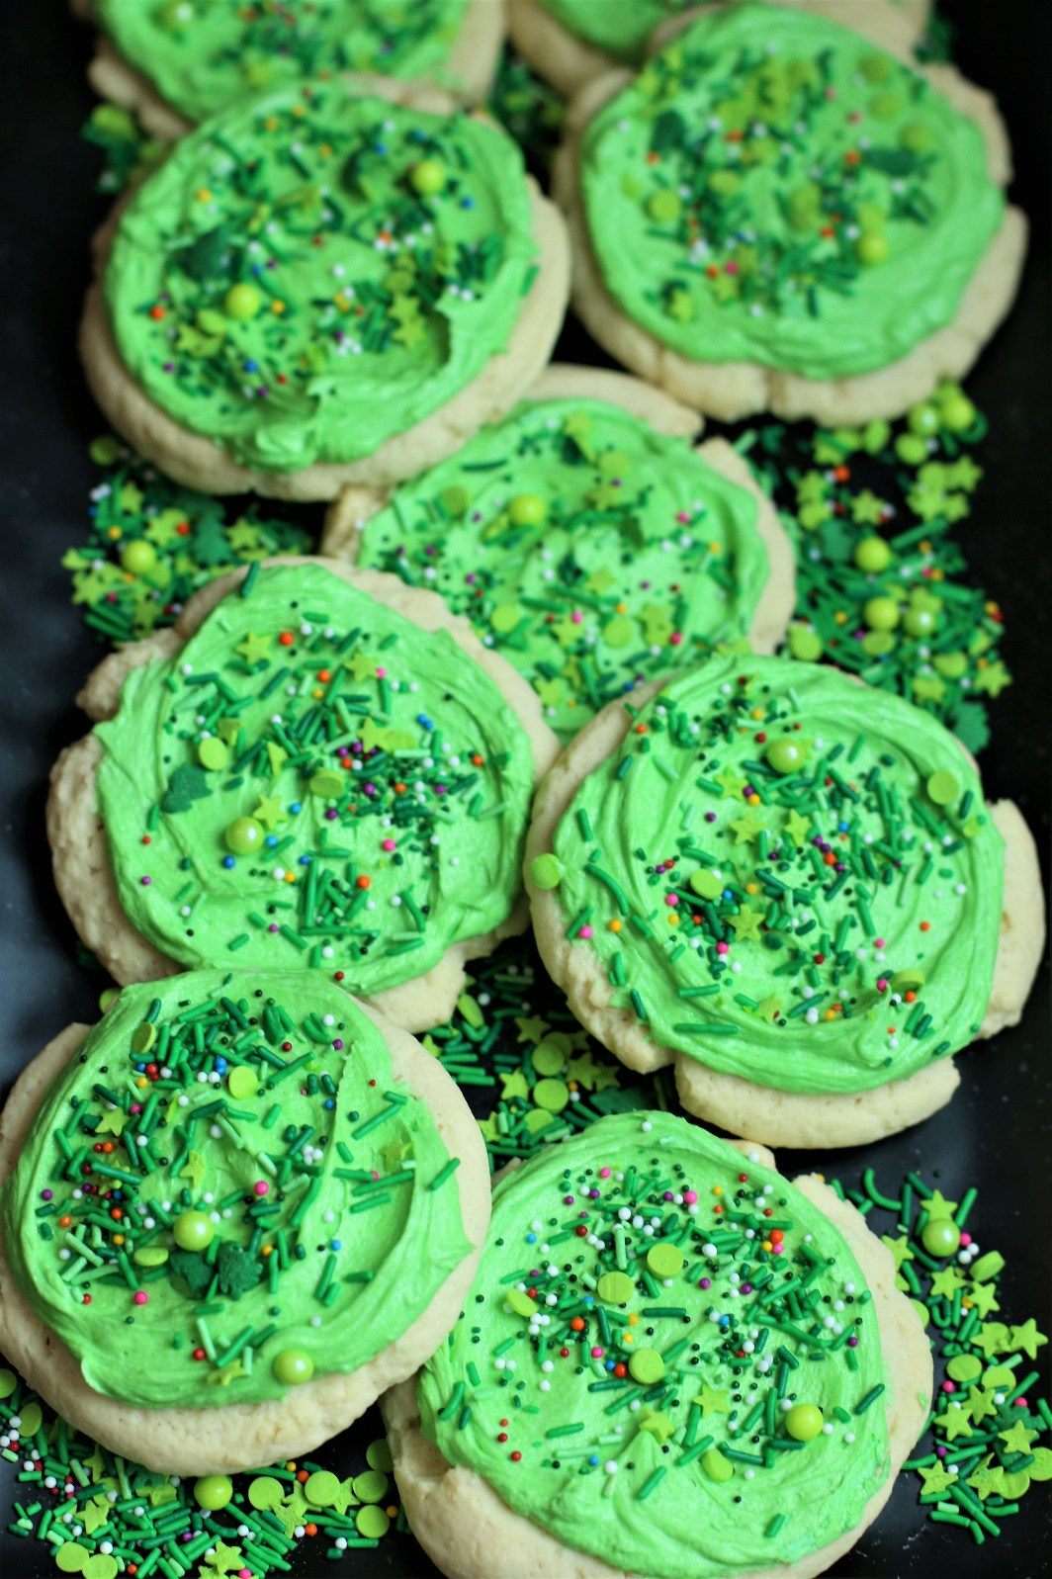

Word has it that these are the favorite Christmas cookies of the Grinch – and they do always disappear quickly from my Christmas cookie jar! Inspired by Dr. Seuss’s How the Grinch Stole Christmas, Grinch Sugar Cookies are big, thick and chewy, and perfectly delicious! With a swirl of silky green buttercream frosting and topped with fun Grinch holiday sprinkles, it’s easy to see why these are always a favorite at our house and in Whoville! I’m famous for my decorated sugar cookies, but sometimes you just want a holiday cookie that is fast, yummy, and warm from the oven!

INGREDIENTS:
SUGAR COOKIES:
1 cup unsalted butter (room temperature)
2 large eggs (room temperature)
3 cups (375g) all purpose flour
2 Tablespoons cornstarch
1 Tablespoon nonfat milk powder
2 teaspoons baking powder
½ teaspoon salt
1 cup (200g) granulated sugar
1 Tablespoon pure vanilla extract
½ teaspoon pure almond extract

SWEET BUTTERCREAM FROSTING:
1/2 cup unsalted butter softened
3 cups (360g) powdered sugar
1 Tablespoon pure vanilla extract
1 teaspoon pure almond extract
¼ teaspoon salt
2-4 tablespoons half & half or whole milk
AmeriColor Soft Gel Food Coloring (Leaf Green & Electric Green for the grinchiest cookies!)
Holiday Sprinkles: Grinch sprinkles are available from Sweetapolita and Etsy

HOW I MAKE THESE:
- Set butter and eggs out to come to room temperature (this helps them incorporate into the cookie dough better).
- Preheat oven to 350 degrees. Line three baking sheets with parchment paper; set aside.
- PREPARE COOKIES: In a medium bowl, whisk together the flour, cornstarch, nonfat milk powder and salt; set aside.
- In a large bowl using a hand-held mixer or stand mixer fitted with a paddle attachment, beat the butter and sugar on medium speed until completely creamy and fluffy (about 3 minutes).
- Scrape down the sides and add in the eggs one at a time, beating well between each is fully mixed in.
- Add vanilla extract and almond extract; beat just until well blended.
- Scrape down the sides and add in the flour mixture, ½ at a time, mixing just until blended; add remaining flour mixture and again mix just until blended. This cookie dough will be really soft and creamy!
- Using a large cookie scoop (3 Tablespoon size), scoop out cookie dough and roll into a ball with your hands. Repeat with remaining dough.
- Place six cookie dough balls on each baking sheet, leaving room between each cookie as the cookies will spread when they bake.
- Flatten the cookie dough by gently pressing the bottom of a drinking glass or measuring cup into the center of each, and press down gently to create a small indentation. To keep your glass from sticking to the cookie dough, it works best to dip the bottom in flour before pressing each cookie. Any flour left behind will “melt” into the cookie as it bakes – not to worry!
- Bake for 9-11 minutes or until the centers of the cookies have puffed up and are no longer glossy. Every oven is a little bit different, so watch your first batch when baking and time accordingly. DO NOT OVERBAKE, as these will lose their softness.
- Remove from oven and allow cookies to cool on the baking sheets.
- PREPARE BUTTERCREAM FROSTING: In the bowl of a stand mixer fitted with a paddle attachment, add softened butter, powdered sugar, salt, vanilla extract, almond extract and 1 tablespoon of half & half or milk.
- Beat on medium speed until light and fluffy; add additional half & half or milk as necessary until the frosting is spreading consistency. If your frosting is too thin, add a little bit of powdered sugar and beat until light and fluffy.
- Add gel food coloring, if desired, and continue beating until well blended, scraping down the sides of the bowl as necessary.
- FROST & DECORATE: Spread the frosting on the cookies while they are still slightly warm, which will melt the frosting slightly and give it a nice, smooth finished look.
- Sprinkle with Grinch holiday sprinkles.
- Once the cookies have completely cooled, chill in the fridge until ready to serve. Allow decorated cookies to set and dry completely before storing – keep parchment paper between each layer or place cookies in individual self-sealing bags for easy freezing and serving.
YIELD: Makes about 18 (four-inch) cookies
RECIPE NOTES:
WEIGH INGREDIENTS CAREFULLY FOR BEST RESULTS: If I can only share one baking secret with you, always use a DIGITAL KITCHEN SCALE. You can use measuring cups and spoons for most recipes, but using a digital scale makes for the more consistent and efficient baking. Take this from someone that bakes A LOT!
TO KEEP THESE COOKIES SOFT: These cookies will stay soft and fresh in an air-tight container for 3 days at room temperature, or refrigerated for up to 7 days.
MAKE AHEAD TIP: Baked and frosted cookies freeze well for up to 1 month. You can also bake the cookies and freeze UNFROSTED for up to 2 months – simply defrost and then frost before you plan on serving.
BEFORE FREEZING: With frosted cookies, it’s important to freeze the cookie prior to placing them into a container so that the frosting remains intact. Place all frosted cookies on a parchment paper lined baking sheet and pop it in the freezer. Once the icing is set and hard (usually an hour) or the cookies are frozen solid, the cookies can be frozen in containers with parchment paper between layers.
HOW TO THAW FROSTED COOKIES: For frosted cookies or “served chilled” cookies, thaw them in the fridge and NOT at room temp. For chilled cookies, you need to maintain refrigeration throughout the thawing process up until the time you eat the cookie for food safety. To keep your cookies from getting soggy and frosting from losing its shape and texture, remove from the freezer and place the unopened container in the refrigerator overnight to thaw. Cookies that are not frosted can thaw overnight UNOPENED on your kitchen countertop.
FOR PARTIES: I package cookies individually in self-sealing clear cellophane cello bags (Pack It Chic are my favorite brand). Make sure cookies are completely set after decorating before packaging. To make ahead, place individually wrapped and sealed cookies in a larger airtight container and refrigerate or freeze. Thaw frozen cookies unopened in the refrigerator - you are trying to minimize moisture during defrosting, which can cause your frosting to soften too much and lose detail.

Original recipe created by Snowflakes & Coffeecakes; published December 2023.
© SnowflakesandCoffeecakes. All images, attachments & content are copyright protected. All rights reserved. Please do not use my images without prior permission. If you want to republish this recipe, please re-write the recipe in your own words, or link back to www.snowflakesandcoffeecakes.com for the recipe.

Tried it and loved it? Snap a picture and share it with me on Instagram @SnowflakesandCoffeecakes and by using the hashtag #SnowflakesandCoffeecakes.

EASY SUGAR COOKIE TIPS & TRICKS:
- Baking sheets: I use my favorite USA Pan Bakeware half sheet pans, which are aluminized steel, warp resistant and nonstick. I always line with parchment paper, not a silicone baking mat (which I find causes more spread).
- Pure Extracts: Always use pure vanilla extract and pure almond extract for the best flavor in cookies. For something different you can also use Vanilla Bean Paste for an extra depth of flavor in this recipe. For other fun-flavored sugar cookies, you can also replace the vanilla with your favorite extract or emulsion to the cookie dough if you’d like!
- Scaling: You can double (or more!) this recipe without issue.
- Buttercream frosting: If you want to do a simple frosting (with or without sprinkles!), then I recommend this simple Buttercream Frosting – it’s our favorite!
- Storage: The cookies can be stored in an airtight container at room temperature or refrigerated for up to 7 days.
- Freezing: These cookies freeze exceptionally well! You can freeze them plain or decorated; if decorated, let the icing set before freezing. Store in an airtight container or ziplock freezer bag with parchment paper between the layers. The cookies can be frozen for up to 2 months.
FOR PERFECT COOKIES EVERY TIME, USE THE RIGHT INGREDIENTS:
For gourmet cookies, only the best ingredients will give you the texture, richness and depth of flavor we all crave. Make sure to use fresh ingredients for the best results! I’ve made so many cakes, cookies and brownies through the years, and these are my recommendations:
- Butter: KerryGold or Land O Lakes Unsalted Butter. With so few ingredients, you want the butter flavor to shine through, and butter with a higher fat content will give you the best flavor and texture! Avoid generic/bargain brands of butter, which often contain water, which will result in a less flavorful cookie dough. I also recommend using unsalted butter in cookies, so that you can control the level of salt easier.
- Eggs: For the best cookie dough, always use large eggs, and at room temperature.
- Flour: King Arthur All Purpose Unbleached Flour is my favorite (it contains more gluten than other brands). Pillsbury All Purpose Flour is my back-up, but weighs differently – make sure to adjust as necessary. (For reference, King Arthur is 120g per cup, Pillsbury is 129g per cup.)
- Granulated Sugar: Domino Pure Cane Sugar
- Milk Powder: The secret ingredient in these cookies!
- Baking Powder: Make sure that you use “aluminum-free” baking powder to avoid a tinny flavor. Rumford is one of the oldest and trusted brands.
- Salt: To avoid a tinny flavor, never use iodized salt in cookies, cakes or brownies. Morten Non-Iodized Table Salt is my preferred brand for cooking and baking. For sea salt flakes, I use Maldon Sea Salt Flakes.
- Vanilla: Rodelle is my preferred brand for Pure Vanilla Extract and Vanilla Bean Paste - both are made with the highest-quality Bourbon vanilla beans from Madagascar.
- Other Extracts & Flavorings: Rodelle (rodellevanilla.com), Cooks (cooksvanilla.com) and Amoretti (amoretti.com) brands make my favorite extracts and emulsions. Keep in mind that extracts and emulsions have different strengths, so watch your measurements and use recommended amounts.
- AmeriColor Soft Gel Food Coloring – strongly recommend for the best and most consistent color when baking and decorating cookies.
- Holiday Sprinkles: For some seriously wonderful holiday sprinkle mixes, Sweetapolita, Sprinkle Pop & Fancy Sprinkles are my favorites! Try to avoid any sprinkles that are manufactured in China.

MILK POWDER IS THE KEY TO BETTER COOKIES, BROWNIES & CAKES!
- The best thing about baking homemade treats is that you can make hundreds of different delicious things using the same few ingredients. Cakes, cookies, pastries and brownies all start more or less the same way – with flour, sugar, eggs and butter.
- Making perfectly textured cakes or crisp and chewy cookies is usually more about baking technique than about ingredients, but there is a secret ingredient that can make almost every baked good taste better – Milk Powder!
- Milk powder, which is also called powdered milk (and should not be confused with malted milk powder) is essentially milk in its most concentrated form. It adds fat, protein and flavor in a way that doesn’t mess with the liquid portion of your baking, and adds a bonus layer of richness, sweetness and creaminess to pretty much anything you bake. It’s the “secret weapon ingredient” that works magic when it’s added to a recipe – it makes frostings and ice creams creamier, denser and silkier, and cookies and brownies chewier. It helps breads rise higher, and flatbreads and pastry more tender.
- Adding just a tablespoon of nonfat milk powder to your flour, baking powder, baking soda and salt, before you combine them with softened butter, sugar and eggs, adds depth to baked goods. If you are using cocoa powder or chocolate chips in your recipe, it intensifies the flavor of chocolate – making regular chocolate taste more luxurious and vanilla flavor more magical. It is the secret ingredient in these wonderful Grinch Sugar Cookies!

