CINNAMON SWIRL BOURBON PECAN FRENCH TOAST CASSEROLE
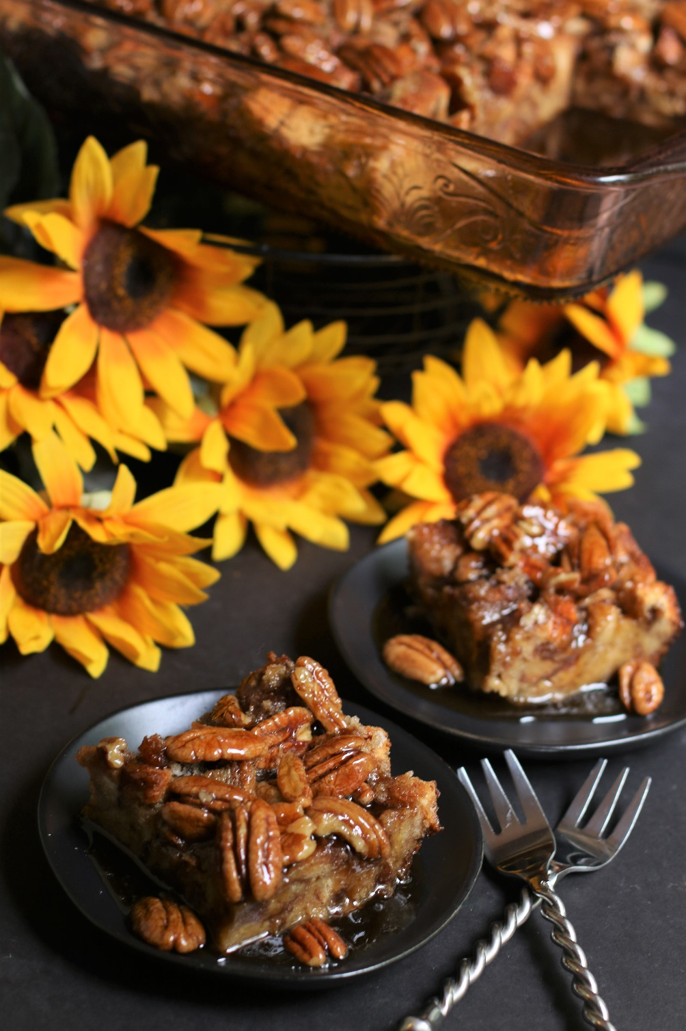

Cinnamon Swirl Bourbon Pecan French Toast Casserole may just be the best thing you’ve ever eaten for a special brunch or holiday breakfast! Who doesn’t love a slice of buttery cinnamon swirled brioche French toast, or a soft cinnamon roll warm from the oven, or a warm caramel pecan roll? Combine them all into a French toast casserole that has a feather-light texture, cinnamon and brown sugar flavor, and the most decadent gooey bourbon pecan maple topping ever! So easy to make the night before, this is the perfect fall holiday breakfast/brunch recipe and always a crowd favorite! This spectacular overnight casserole is perfect for bridal showers, festive holiday brunches or for any special celebration in your life!

INGREDIENTS:
FRENCH TOAST:
21 oz. (1-1/2 loaves) St. Pierre Brioche Cinnamon Twist Bread
1 cup heavy cream
1 cup whole milk
2 teaspoons ground cinnamon
¼ teaspoon ground nutmeg
6 large eggs + 3 large egg yolks (room temperature)
3 tablespoons bourbon
1 Tablespoon pure vanilla extract
1 cup (213g) light brown sugar (packed)

BOURBON PECAN SYRUP:
½ cup (113g) unsalted butter
¾ cup (160g) light brown sugar (packed)
½ teaspoon ground cinnamon
½ cup heavy cream
1/3 cup pure maple syrup
½ teaspoon salt
2 cups (227g) pecans (whole or chopped)
2 tablespoons bourbon
2 teaspoons pure vanilla extract

HOW I MAKE THIS:
- We’re going to start by lightly drying out and toasting the cinnamon swirl bread - this is the same technique I use for my Thanksgiving Classic Herb Dressing for the BEST texture and flavor!
- Preheat oven to 250 degrees. Cut 1-1/2 loaves of St. Pierre Brioche Cinnamon Twist Bread into ½-inch cubes and place in a large roaster. Bake for 1 hour, stirring occasionally.
- Set eggs out to bring to room temperature.
- Lightly grease a 9x13-inch baking dish or spray with nonstick spray.
- Place bread cubes into the prepared baking dish; set aside.
- In a large bowl, beat the eggs and egg yolks until well combined. Add the heavy cream, milk, cinnamon, nutmeg, bourbon, vanilla and half of the brown sugar (1/2 cup or 106g); whisk together until well combined.
- Pour the egg mixture evenly over the bread cubes, and gently toss to ensure all of the bread cubes are soaked with the egg mixture. Sprinkle the top evenly with the remaining brown sugar (1/2 cup or 106g).
- Cover baking dish tightly with aluminum foil and refrigerate overnight (or for at least 6 hours).
- BAKE CASSEROLE: Remove casserole from the fridge and let sit at room temperature for 30 minutes. When ready to bake, preheat oven to 350 degrees.
- Place foil-covered casserole in the oven and bake for 35 minutes.
- After 35 minutes, carefully remove foil and continue to bake for another 30 minutes, or until the top is golden brown and firm in the center.
- Meanwhile, while casserole is baking, prepare Bourbon Pecan Syrup.
- PREPARE BOURBON PECAN SYRUP: In a heavy saucepan, melt the butter.
- Add brown sugar and cook, whisking until the sugar has dissolved and the mixture is bubbling.
- Whisk in the heavy cream, pure maple syrup, cinnamon and salt, mixing until well combined.
- Add in the pecans (whole or chopped) and using a silicone spatula, fold them into the syrup mixture until they are evenly coated.
- Remove from heat and stir in the bourbon and vanilla.
- After removing the baked French toast casserole, pour the warm Bourbon Pecan Syrup evenly over the top.
- Serve immediately while warm!
- Store any leftovers in a covered container in the refrigerator for up to 3 days. Leftovers warm up like a dream in the microwave!
YIELD: 12 servings
RECIPE NOTES:
FOR THE BEST TEXTURE: Don’t skip toasting the bread cubes in the oven before preparing the casserole, which keeps the cinnamon bread toasty and not soggy! With this method, the French toast will bake up and have the texture of a cinnamon roll, with a caramelized pecan topping similar to a caramel pecan roll. It’s spectacular!
BEST BREAD TO USE: While I recommend and use St. Pierre Brioche Cinnamon Twist Bread for the best flavor and texture, you can substitute any other brand or bakery cinnamon swirl bread, or a loaf of crusty sour dough or French bread.
MAKE AHEAD TIP: While I love that you can make this breakfast casserole the night before serving, I sometimes make this (or several) for a large crowd. For easy serving, I prepare this in my Crock-Pot 3.5-Quart Casserole Crock Slow Cooker ceramic insert, baking the casserole in the oven and topping with the Bourbon Pecan Syrup, and then place the casserole insert into the slow cooker with the temperature set to “keep warm” for serving. The best part about this method? The Bourbon Pecan Syrup thickens slightly on the bottom, sides and top of the French toast – for incredibly caramel-like texture! You can also prepare the Bourbon Pecan Syrup ahead of time and reheat when you are ready to serve.
SERVING IDEAS: If you’re feeling extra decadent, serve this with sweetened whipped cream or ice cream - butter pecan, vanilla, or salted caramel ice cream – with an extra batch of warm Bourbon Pecan Syrup to drizzle over the top!
Original recipe created by Snowflakes & Coffeecakes; published October 2022.
© SnowflakesandCoffeecakes. All images, attachments & content are copyright protected. All rights reserved. Please do not use my images without prior permission. If you want to republish this recipe, please re-write the recipe in your own words, or link back to www.snowflakesandcoffeecakes.com for the recipe.

Tried it and loved it? Snap a picture and share it with me on Instagram @SnowflakesandCoffeecakes and by using the hashtag #SnowflakesandCoffeecakes.

