dark chocolate buttercream frosting
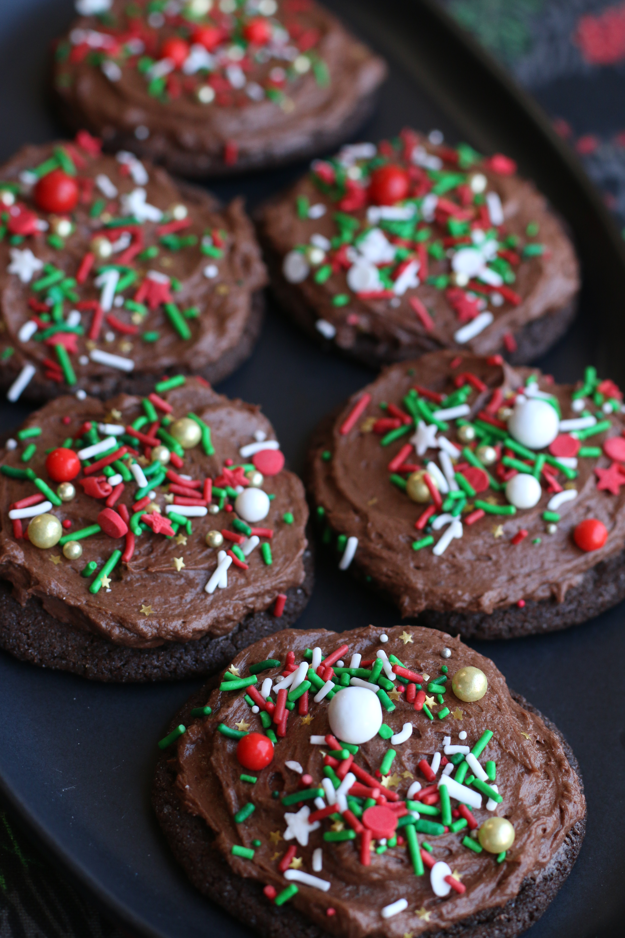

If you love DARK Chocolate, you’re gonna love this truly decadent homemade Dark Chocolate Buttercream Frosting! Perfect on brownies, cookies, cakes & fingers! Another family favorite!

INGREDIENTS:
DARK CHOCOLATE BUTTERCREAM FROSTING:
2 sticks butter
2-1/2 cups powdered sugar
¼ cup Rodelle Gourmet Baking Cocoa
3 tablespoons heavy cream (whipping cream)
2 teaspoons Rodelle Chocolate Extract
¼ teaspoon salt

HOW I MAKE THIS:
- With a handheld or stand mixer fitted with a paddle or whisk attachment, beat the butter on medium speed until creamy - about 2 minutes.
- Add the confectioners' sugar, cocoa, heavy cream, Rodelle Chocolate Extract and salt. Once everything is in the bowl, increase to high speed and beat until light and creamy, about 3 to 4 minutes.
- Add up to 1/4 cup more confectioners' sugar if frosting is too thin or another tablespoon of heavy cream if frosting is too thick.

YIELD: Enough to generously frost 12 cupcakes or 2-1/2 dozen cookies.

© SnowflakesandCoffeecakes. All images, attachments & content are copyright protected unless otherwise indicated. All rights reserved. Please do not use my images without prior permission. If you want to republish this recipe, please re-write the recipe in your own words, or link back to www.snowflakesandcoffeecakes.com for the recipe.

