DOUBLE CHOCOLATE
BROWNIE CRINKLE COOKIES
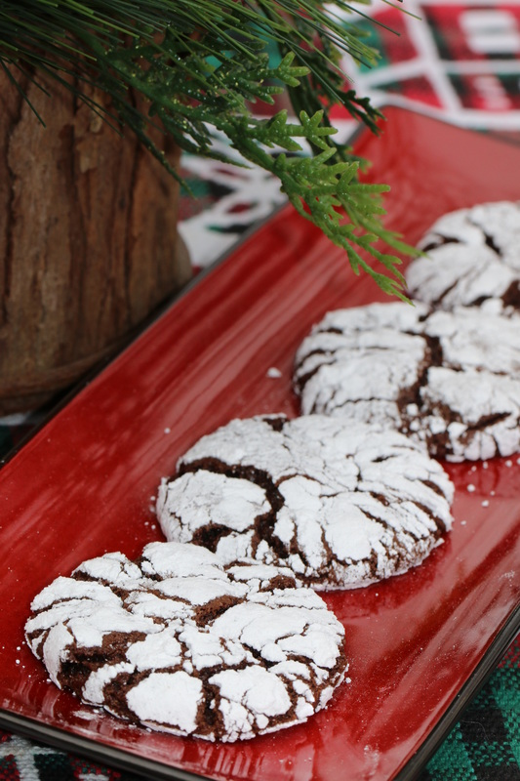

I’m going to warn you now….not only are these pretty and delicious, these are the softest, chewiest, richest & fudgiest brownie crinkle cookies you have ever had! !
INGREDIENTS:
1 cup all-purpose flour (sifted & spooned, not scooped)
½ cup unsweetened cocoa powder (sifted & spooned)
1 teaspoon baking powder
¼ teaspoon baking soda
½ teaspoon salt
1-½ cups light brown sugar
3 large eggs (room temperature)
1 teaspoon vanilla extract
4 ounces quality unsweetened dark chocolate bar, chopped (Ghirardelli or Bakers)
4 tablespoons unsalted butter
½ cup granulated sugar
1/2 cup powdered sugar

HOW I MAKE THESE:
- Preheat oven to 325 degrees. Line 2 baking sheets with parchment paper.
- In a small microwave-safe bowl, combine the unsweetened chocolate and butter and microwave at 50 percent power, stirring occasionally, just until melted, about 2 to 3 minutes. Set aside.
- In a medium bowl, whisk together the flour, cocoa powder, baking powder, baking soda, and salt. In a large bowl, whisk together the brown sugar, eggs and vanilla.
- Whisk the chocolate mixture into the egg mixture until combined. Fold in the flour mixture until no streaks remain. Let the dough sit at room temperature for 10 minutes.
- In separate shallow bowls, pour the granulated sugar in one and the powdered sugar in another. Working with a medium cookie scoop (about 2 tablespoons dough) at a time, roll into balls. Drop dough balls directly into granulated sugar and roll to coat. Transfer dough balls to powdered sugar and roll to coat evenly and generously. Evenly space the dough balls on the prepared baking sheets (about 12 cookies on each pan).
- Bake the cookies, 1 sheet at a time, until puffed and cracked and edges have begun to set but centers are still soft (cookies will look raw between cracks and seem underdone), about 12 minutes, rotating sheet halfway through baking. Let cool completely on sheet before serving. The cookies can be stored at room temperature in an airtight container for up to 5 days.
YIELD: Makes approximately 24 cookies.
© SnowflakesandCoffeecakes. All images, attachments & content are copyright protected unless otherwise indicated. All rights reserved. Please do not use my images without prior permission. If you want to republish this recipe, please re-write the recipe in your own words, or link back to www.snowflakesandcoffeecakes.com for the recipe.

