extra bold chex mix
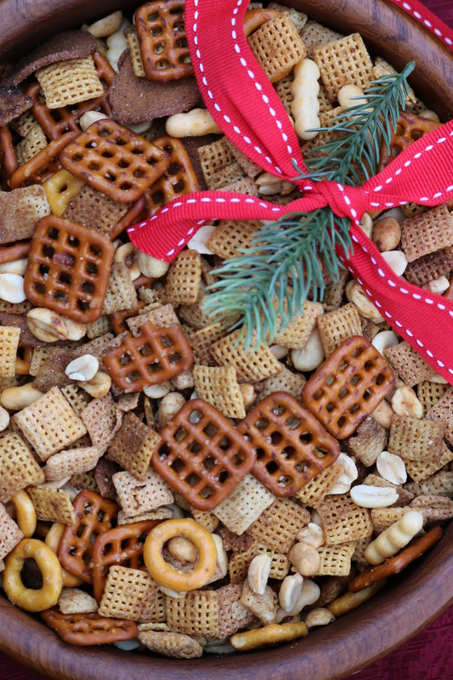

I’m going to warn you now….this stuff is seriously out-of-this-world addictive!

INGREDIENTS:
8 cups total of your choice: Corn, Wheat and Rice Chex Cereal
1-1/2 cups small pretzel twists*
1-1/2 cups bagel chips*
1-1/2 cups miniature bread stick twists or cheese nips*
1 cup peanuts
½ cup butter (no substitutes)
1/3 cup Worcestershire sauce
1-1/2 tablespoon seasoned salt
1 teaspoon garlic powder
1 teaspoon onion powder

*You can substitute an 8.6 oz. bag of GARDETTO’S Original Recipe Snack Mix – which is sometimes easier to find than miniature pretzel twists, bagel chips and mini bread stick twists. For something different, you can also substitute Pepperidge Farms Cheddar Cheese Goldfish for a portion of the bagel chips or bread stick twists – they are pretty good in this mix as well!

HOW I MAKE THESE:
- Preheat oven to 300 degrees. Spray roasting pan with non-stick cooking spray.
- Combine cereal, pretzels, bagel chips, mini-bread stick twists and nuts in prepared pan.
- In a small microwave safe bowl, melt butter. Stir in remaining ingredients and blend well. Drizzle half over the top of the Chex mix; give it a gentle stir with a silicone spatula. Slowly drizzle remaining butter mixture over top and stir again gently.
- Bake for 60 minutes, stirring every 15 minutes gently with your silicone spatula.
- Remove from oven, and spread mixture on a large piece of parchment paper until cool.
- Store in an air-tight container for up to 1 week. (But it will never last that long!)

YIELD: Makes approximately 12 cups.
© SnowflakesandCoffeecakes. All images, attachments & content are copyright protected unless otherwise indicated. All rights reserved. Please do not use my images without prior permission. If you want to republish this recipe, please re-write the recipe in your own words, or link back to www.snowflakesandcoffeecakes.com for the recipe.

