GINGERBREAD WOODLAND COOKIES
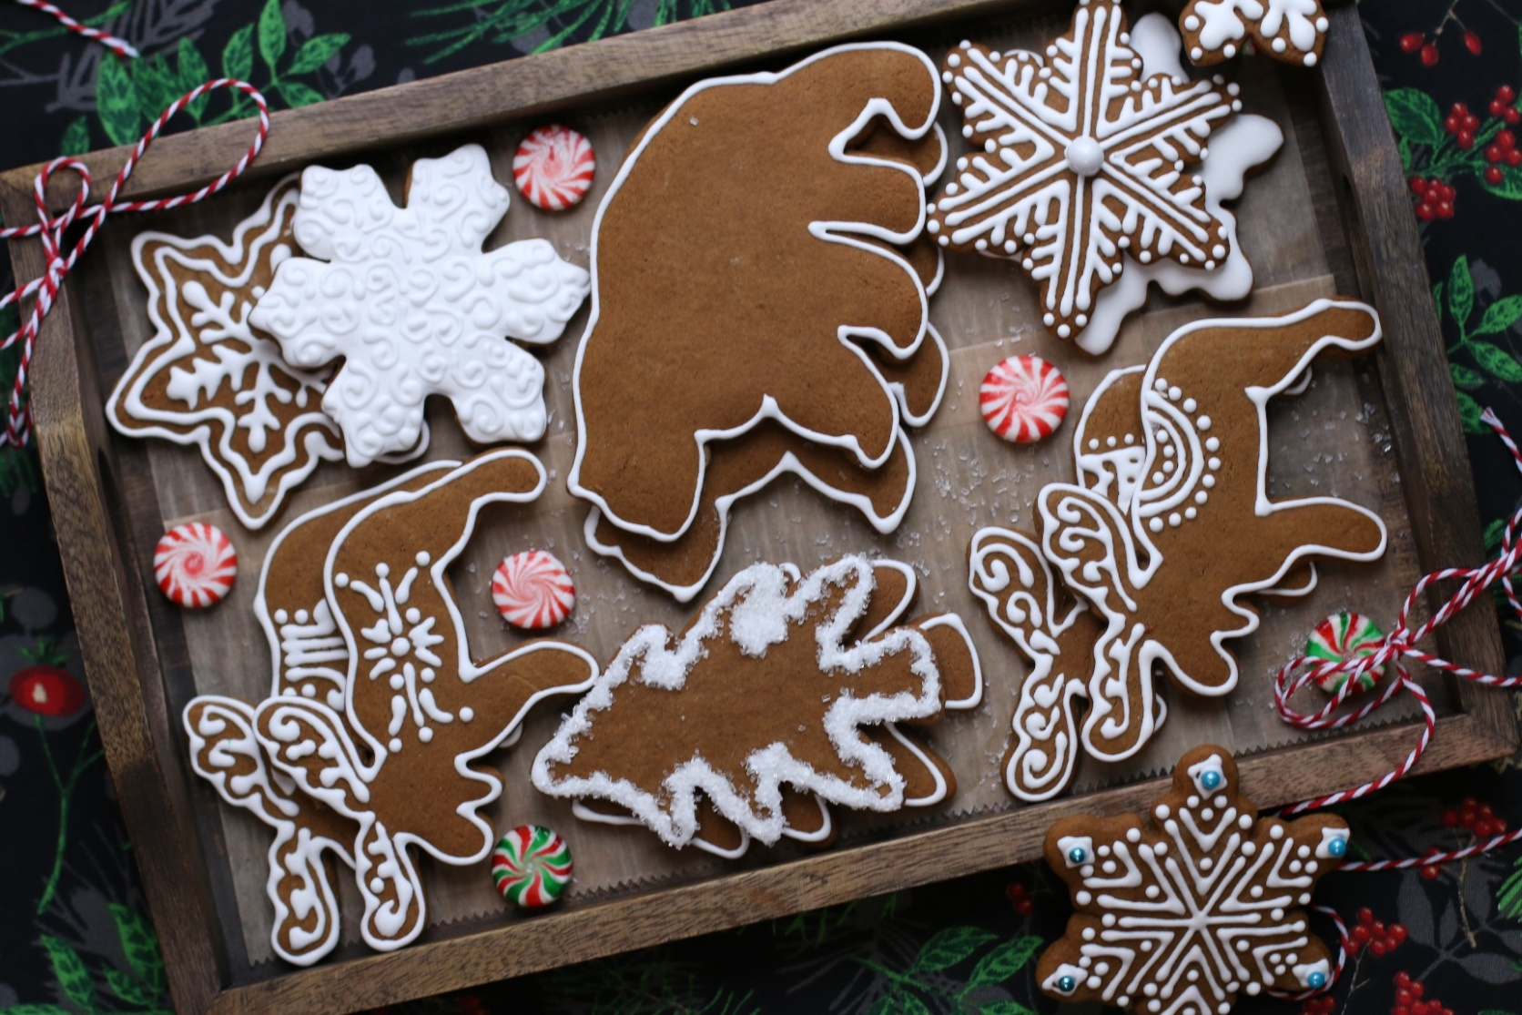

Old-fashioned Gingerbread Woodland Cookies are thick and spicy, soft and chewy, and remind us of fun in the Minnesota Northwoods! Our family-favorite recipe for gingerbread cookie cutouts, whether it’s gingerbread people, gingerbread snowflakes or gingerbread woodland animals, these are so much fun to bake and decorate together, and just get more perfect over time!
INGREDIENTS:
3 and 1/2 cups (437g) all-purpose flour (sifted, spooned & leveled)
1 teaspoon baking soda
1/2 teaspoon salt
1 Tablespoon ground ginger
1 Tablespoon ground cinnamon
1/2 teaspoon allspice
1/2 teaspoon ground cloves
10 Tablespoons (2/3 cup) unsalted butter (softened to room temperature)
3/4 cup (150g) packed light or dark brown sugar
2/3 cup (200g) molasses (I use Grandma's Molasses brand)
1 large egg (room temperature)
1 teaspoon pure vanilla extract

EASY ROYAL ICING:
4 cups powdered sugar
3 tablespoons Wilton Meringue Powder
10-12 tablespoons water (room temperature)
1 teaspoon corn syrup
AmeriColor Soft Gel Food Coloring (strongly recommended!)

FOR DECORATING: Holiday Sprinkles and Sparkling Sugar (both optional)

SPECIAL EQUIPMENT:
- Cookie cutter(s)
- Rolling pin (wooden Joseph Joseph Rolling Pin works the BEST for these cookies!)
- Large baking sheets
- Silicone Baking Mats or Parchment Paper
- Piping Bags & Tips

HOW I MAKE THESE:
- In a medium bowl, whisk together the flour, baking soda, salt, ginger, cinnamon, allspice, and cloves.
- In a large bowl using a hand-held mixer or stand mixer fitted with a paddle attachment, beat the butter for 1 minute on medium speed until completely smooth and creamy. Add the brown sugar and molasses and beat on medium high speed until combined and creamy-looking. Add in the egg and vanilla and beat on high speed for 2 full minutes. Scrape down the sides and bottom of the bowl as needed. Don’t worry if your butter separates!
- On low speed, slowly mix half of the flour mixture into the wet ingredients just until combined; add remaining flour mixture and again mix just until combined. The cookie dough will be thick and slightly sticky.
- Generously flour your work surface and rolling pin. Divide dough into half and place on top of a parchment paper sized for your baking pans. Roll each half to a ¼-inch thickness (you will need to re-flour your rolling pin periodically to keep the dough from sticking). The rolled-out dough can be any shape, as long as it is evenly 1/4-inch thick. We’re rolling the cookie dough out BEFORE chilling it, which isn’t typical for most gingerbread cookie recipes – but this is a great trick! The dough is so much easier to roll out before it’s chilled.
- Stack the pieces, with parchment paper between the two and a single piece of parchment paper on top, onto a baking sheet and refrigerate for at least 2 hours and up to overnight. Chilling is mandatory for this cookie dough, so that the cookies will keep their shape when baked.
- The next day, preheat oven to 350°. Line 2-3 large baking pans with parchment paper (I prefer parchment paper over silicone baking mats for these cookies).
- Remove one of the chilled cookie dough pieces from the refrigerator. The dough will seem very hard, but it’s softer than it appears! Immediately cut into shapes with cookie cutters that have been dipped in flour. Place each cookie about 2 inches apart on prepared baking sheets. Re-roll dough scraps until all the dough is shaped. Repeat with remaining cookie dough. Refrigerate cut cookie dough on baking sheets for 10-15 minutes before baking (this will help keep them from spreading). HELPFUL HINT: I usually place one completed pan in the refrigerator while working on cutting out the next pan, rotating between cutting, chilling and baking.
- Bake cookies for about 9-10 minutes. If your cookie cutters are smaller than 4 inches, bake for about 8 minutes. If your cookie cutters are larger than 4 inches, bake for about 11 minutes. Every oven is a little bit different, so watch your first batch when baking and time accordingly. DO NOT OVERBAKE! The cookies don’t spread much when they’re baking, so they will stay around ¼-inch thick. These are thick old-fashioned gingerbread cookies! Be sure not to overbake these as they’ll lose their softness.
- Allow cookies to cool on the baking sheet for 5 minutes. Transfer the parchment paper together with the cookies to a cooling rack to cool completely. Once completely cool, decorate with Bakery Frosting or Easy Royal Icing and sprinkles (Bakery Frosting is easier for little ones…)
- TO MAKE EASY ROYAL FROSTING: In the bowl of a stand mixer fitted with a paddle attachment, add the powdered sugar, meringue powder, corn syrup and 7-8 tablespoons of room-temperature water and beat on high speed for 5 minutes. (I always start with 7 to 8 tablespoons of water and usually need to add a tablespoon or two more, depending on the weather and humidity.) For bright white Royal Frosting that doesn’t bleed, I usually add a drop or two of Americolor Bright White gel food coloring.
- After five minutes of beating, lift the paddle up off the icing - the icing should drizzle down in a ribbon and smooth out within 10-15 seconds with the frosting in the bowl. If it's too thick, add a little more water (a teaspoon at a time). If it's too thin, add a little more sifted confectioners' sugar (a tablespoon or two at a time).
- If you haven’t made royal icing before, you maybe not be familiar that this icing crusts VERY quickly! When exposed to air icing forms a crust on the surface within 5-10 minutes.
- To prevent this from happening, you need to cover royal icing when you’re not working directly with it (for example, you’ve split the icing into separate bowls to color separately with gel food coloring). For the short term you can cover each bowl with a damp kitchen towel or damp paper towel.
- FROST & DECORATE! Pipe or frost completely cooled cookies and sprinkle with optional sprinkles or decorating sugar.
- This Easy Royal Icing completely dries overnight at room temperature. If you're layering royal icing onto cookies for specific designs and need it to set quickly, place cookies on parchment paper lined baking sheets, with a large fan blowing at low speed to circulate air over the cookies to help speed it up – you’ll need at least 1 hour between layers. This also keeps the icing shiny and prevents it from cracking or “sinking”.
- Allow frosting to set and dry completely before storing – keep parchment paper between each layer or place cookies in individual self-sealing bags for easy freezing and serving.
YIELD: Makes 24 (four-inch) cookies.
NOTES: These cookies will stay fresh in an air-tight container at room temperature for up to 3 days or in the refrigerator for up to 1 week.
MAKE AHEAD TIP: Plain baked cookies freeze well up to 1 month. Thaw overnight in the refrigerator before decorating.
TO KEEP THESE COOKIES SOFT: I keep a slice of sandwich bread in the container to keep the cookies soft – replace every day or so, as soon as the slice of bread dries out. It’s a sweet little trick! These cookies will stay fresh in an air-tight container at room temperature for up to one week.
Originally published December 2012, revised & reposted December 2020
© SnowflakesandCoffeecakes. All images, attachments & content are copyright protected. All rights reserved. Please do not use my images without prior permission. If you want to republish this recipe, please re-write the recipe in your own words, or link back to www.snowflakesandcoffeecakes.com for the recipe.

