stuffed peppers
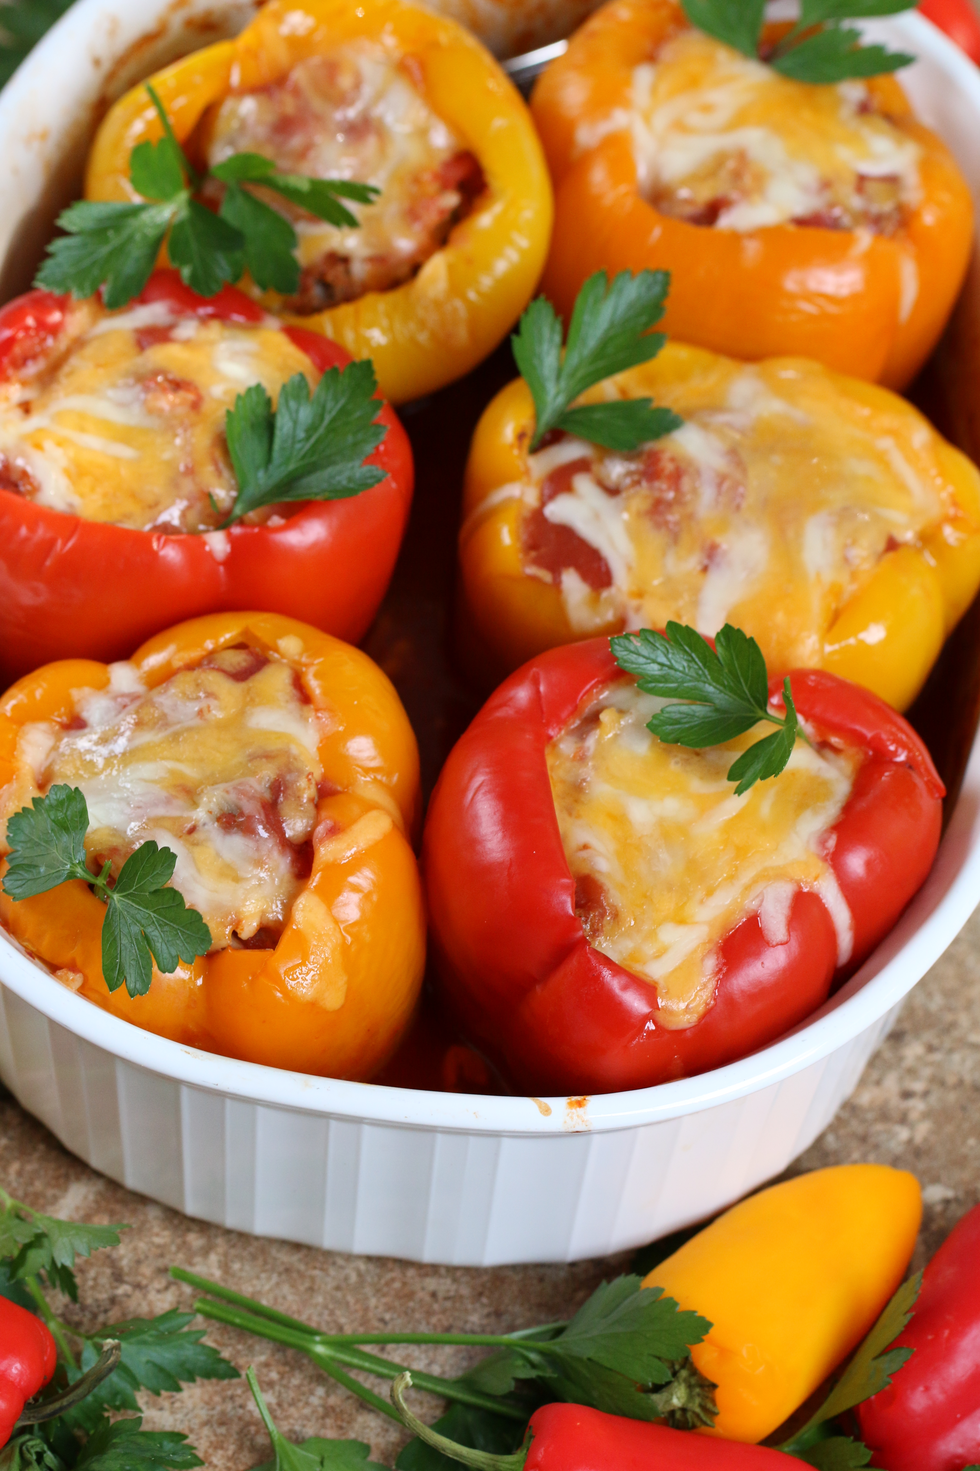

So easy to make, so easy to bake – and so delicious! Saucy, flavorful & cheesy!
Perfect with any color of sweet bell peppers – green, yellow, orange and red! If you are making for a group that includes anyone that doesn’t care for Stuffed Peppers, you can make a mean Mexican Meatloaf with this recipe as well – just skip the peppers!

INGREDIENTS:
6 sweet bell peppers (good shape & size)
2 lbs. ground beef
1 cup white rice, uncooked (NOT instant rice)
1 tablespoon taco seasoning
2 cups chunky salsa (pick whatever spiciness level you like!)
½ cup tomato paste
2 cans (15 oz.) tomato sauce
1-1/2 cup shredded cheese (cheddar, Colby-jack, or Mexican blend)(divided)

HOW WE MAKE THESE:
- Preheat oven to 350 degrees.
- Remove tops and seeds from sweet bell peppers, rinse and drain upside down on paper towels. Decide on whether you want WHOLE peppers, or half peppers – if you choose half peppers, cut them in half vertically from the stem (top) side.
- Spray non-stick cooking spray in casserole dish or baking pan (sized to hold all of the peppers upright (if whole) or horizontally (if halved). Pour the can of tomato sauce into the bottom of the pan.
- In a large bowl, combine ground beef, rice, chunky salsa, tomato paste, taco seasoning, and 1 cup of shredded cheese. Mix well.
- Pack lightly into whole peppers, almost all the way to the top. If you are preparing half-peppers, mound the meat up slightly higher than the sides of the peppers.
- Spoon a tablespoon or two of tomato sauce over top of meat mixture.
- Cover with foil, and bake for 40 minutes.
- Remove foil, spoon another tablespoon of tomato sauce over top of each pepper, sprinkle with additional shredded cheese, and bake for an additional 10 minutes or until cheese is melted and sauce is bubbly!
- Remove from oven and let sit for 10 minutes before serving.
YIELD: Makes 6 servings (whole peppers) or 12 servings (half peppers).
NOTE: If you have any leftovers, they are GREAT warmed up and served in a burrito wrap the next day! Top with some salsa, shredded cheese and sour cream. YUM!
© SnowflakesandCoffeecakes. All images, attachments & content are copyright protected unless otherwise indicated. All rights reserved. Please do not use my images without prior permission. If you want to republish this recipe, please re-write the recipe in your own words, or link back to www.snowflakesandcoffeecakes.com for the recipe.

