taco salad with CREAMY southwestern ranch dressing

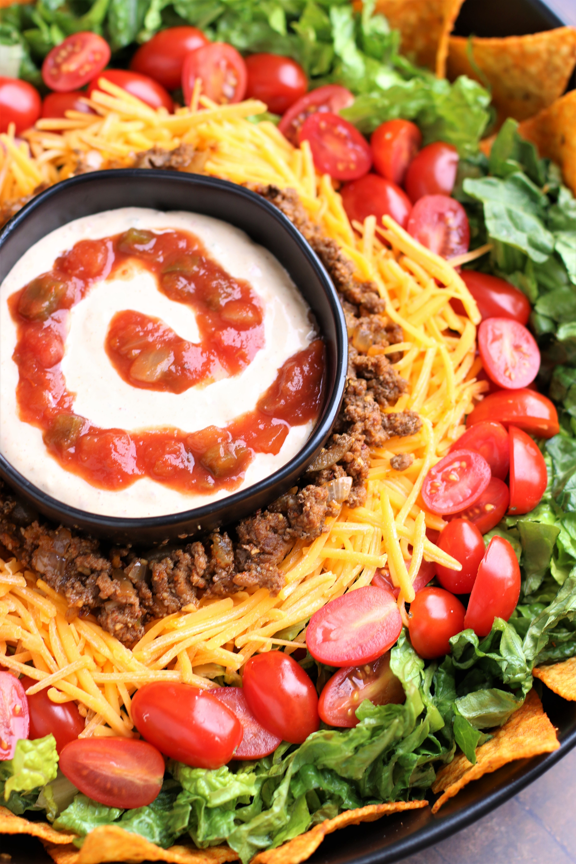

*If you love tacos – and if you love nacho cheese Doritos, you are going to LOVE* ***Taco Salad with Creamy Southwestern Ranch Dressing****! Bursting with fresh veggies, taco-seasoned beef, crunchy nacho cheese Doritos, and drizzled with creamy southwestern ranch dressing, it’s simply irresistible! So many layers of flavors!*

***TACO SALAD*:**

1 lb. ground beef or turkey

1 small sweet onion, diced

2 large cloves garlic, minced

3 Tablespoons taco seasoning

2 to 3 heads of romaine or 1 to 2 heads of iceberg lettuce (rinsed & chopped into bite-size pieces)

4 green onions, sliced

1 pint cherry tomatoes or chopped fresh Roma tomatoes

2 cups shredded cheddar or Mexican blend cheese

1 bag Doritos Nacho Cheese Tortilla Chips (for scooping up the salad and/or for crushing over the salad)

***creamy southwestern ranch DRESSING***:

1/2 cup Buttermilk Ranch Dressing

½ cup sour cream

1/2 cup Salsa

1 Tablespoon Taco Seasoning

***OPTIONAL OR ON THE SIDE:***

Fresh Salsa

South Cream

Diced fresh Avocado or Guacamole

Black Beans (rinsed & dried)

Fresh Cilantro (chopped)

Red Onions (diced) or Picked Red Onions

Niblets Sweet Corn

Jalapeno slices

Fresh Limes (cut into wedges, for squeezing over the top)

**HOW I MAKE THIS**:

1. **PREPARE CREAMY SOUTHWESTERN RANCH DRESSING**: Combine salad dressing ingredients together in a small glass jar (with lid) or small bowl. Shake or whisk together, until well blended. Chill until ready to serve.
2. **PREPARE TACO MEAT**: In a large skillet over medium to medium-high heat, brown the ground meat and onion. When meat is nearly halfway browned, add the garlic. Once meat is browned and onion is softened, remove any excess fat from the pan. Sprinkle taco seasoning evenly over the mixture, stir in 1/3 cup of water, and let mixture simmer over medium heat until mixture is saucy and slightly thickened. Remove pan from heat.
3. Wash lettuce or salad mix and drain well.
4. **THERE ARE TWO WAYS TO PREPARE AND SERVE THIS SALAD:**
   * Layer or place all salad ingredients EXCEPT Dorito chips together in one large bowl; toss lightly. ***To avoid soggy chips, be sure to wait until you are ready to serve to add the crushed Dorito chips on top of the mixed salad.***
   * Place all the salad ingredients, optional sides, and salad dressing(s) in separate bowls, for each person to assemble their own salad. This is a great way to serve this salad for a crowd, or if someone has food allergies.
5. Serve with salad dressing on the side.

**SERVINGS**: 4 generous servings

**RECIPE NOTES**:

* Taco meat and Creamy Southwestern Ranch Dressing can be prepared a day in advance and refrigerated until ready to serve - just warm taco meat up again when you are ready to create your salad.
* **OPTIONAL SALAD DRESSINGS:**  Our family favorite dressing for this taco salad is Creamy Southwestern Ranch Dressing, but other favorites when serving to a crowd are Creamy Taco Salad Dressing, Spicy Buttermilk Ranch, Buttermilk Ranch, or Zesty French Dressing.
* If you happen to have leftover grilled corn on the cob, it is fabulous sliced off the cob and served on this salad!

*Originally posted July 2016; revised and reposted February 2021.*

*©* ***SnowflakesandCoffeecakes****. All images, attachments & content are copyright protected. All rights reserved. Please do not use my images without prior permission. If you want to republish this recipe, please re-write the recipe in your own words, or link back to* [*www.snowflakesandcoffeecakes.com*](http://www.snowflakesandcoffeecakes.com) *for the recipe.*