ultimate magic cookie bars
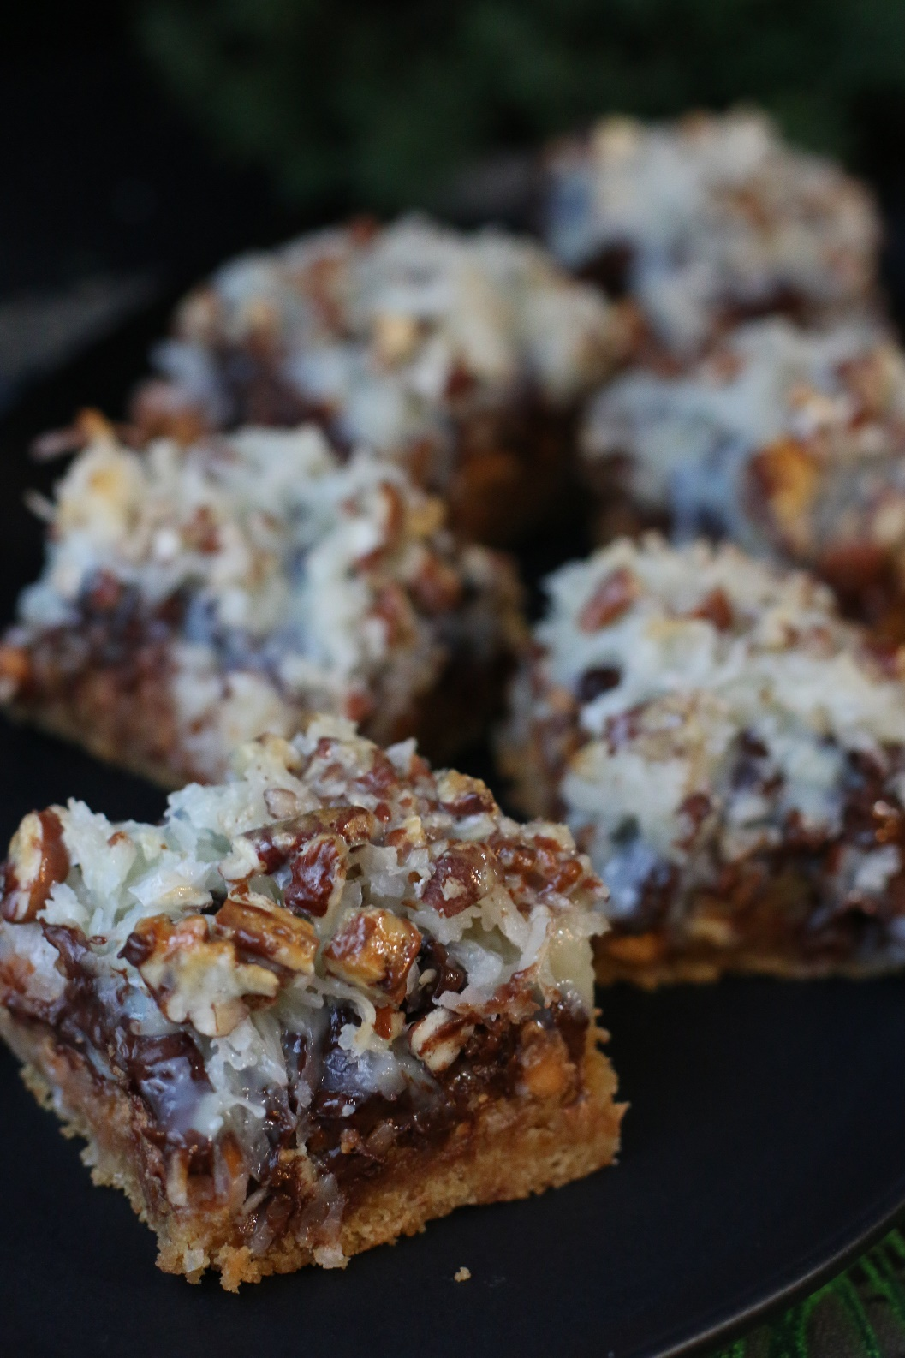

Even better than the original seven layer bar recipe,
all because of a soft-baked brown sugar & graham cracker cookie crust!
Soft, thick and chewy - these make everyone SWOON!
INGREDIENTS:
GRAHAM CRACKER COOKIE CRUST:
1/2 cup unsalted butter (room temperature)
3/4 cup packed light brown sugar
1 teaspoon vanilla extract
1 large egg (room temperature)
1 cup (125g) all-purpose flour
1 cup (100g) graham cracker crumbs (about 9 graham crackers)
1/2 teaspoon baking powder
1/4 teaspoon salt

LAYERS:
1 cup butterscotch chips
1 cup semi-sweet chocolate chips
3/4 cup shredded sweetened coconut
1/2 cup chopped pecans
10 ounces sweetened condensed milk

HOW I MAKE THESE:
- Preheat oven to 350°F. Line a 9-inch square baking pan with parchment paper or aluminum foil, leaving overhang on the sides; set aside.
- In a large bowl, cream the butter and brown sugar together on medium speed with a handheld mixer. Beat for about 2 minutes until smooth and combined. Add the vanilla extract and egg, beating until combined. Scrape the sides of the bowl down as needed.
- Add the flour, graham cracker crumbs, baking powder and salt. On low speed, slowly mix until combined. Press graham cracker dough into the prepared baking pan and bake for 5 minutes.
- Remove from the oven and layer with butterscotch chips, chocolate chips, coconut, and pecans. Drizzle sweetened condensed milk evenly on top.
- Bake the bars until set, about 30 minutes. I loosely covered the pan with aluminum foil halfway through baking to prevent browning. Allow to cool to room temperature (you can refrigerate after the first hour to cool it down more quickly). You don’t want to cut these bars before everything is cooled and “set”.
- Store in an airtight container at room temperature – they will stay fresh for up to 1 week - if they last that long! Bars can be frozen for up to 3 months-- thaw overnight in the refrigerator before serving.
YIELD: Makes 16 thick bars.
Originally published December 2013, Revised & Republished December 2017
© SnowflakesandCoffeecakes. All images, attachments & content are copyright protected unless otherwise indicated. All rights reserved. Please do not use my images without prior permission. If you want to republish this recipe, please re-write the recipe in your own words, or link back to www.snowflakesandcoffeecakes.com for the recipe.

