brown sugar pineapple chicken
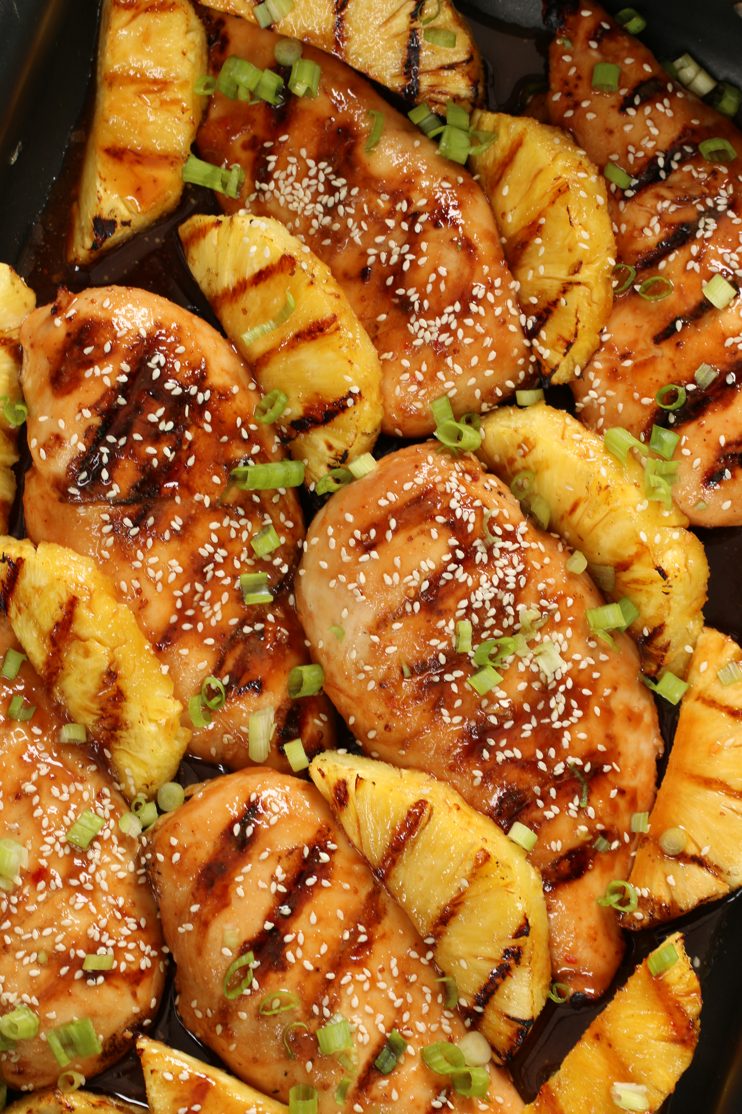

If you love chicken, or fresh grilled pineapple, or just the most fabulous chicken dish ever, this is the one for you! Another family favorite that always disappears fast!

INGREDIENTS:
2 lbs. skinless chicken breasts or tenderloins
¼ cup olive oil
2 tablespoons pineapple juice
2 teaspoons cornstarch
Fresh pineapple, cored and sliced

Marinade & Glaze:
1 cup pineapple juice
1/3 cup + 2 tablespoons packed brown sugar
2 tablespoons fresh lemon juice
2 tablespoons ketchup
2 tablespoons red wine vinegar
2 tablespoons soy sauce
1 tablespoon country style Dijon mustard
2 tablespoons Asian sweet chili sauce
1 teaspoon garlic powder
1 teaspoon ginger powder
1 teaspoon onion powder

Garnish:
Green onions or shallots
Sesame seeds (optional)

HOW I MAKE THIS:
- Whisk the Marinade & Glaze ingredients together in a medium bowl. Place chicken breasts in a large freezer bag. Combine ½ cup Marinade and olive oil in a small bowl; set aside. Refrigerate remaining Marinade, as this will be used to make your glaze.
- Place chicken in a large freezer bag and pour the Marinade & olive oil mixture evenly over the top. Release as much air as you can from the bag and seal. Refrigerate for 2 to 4 hours, turning the bag several times during that time period.
- Remove chicken from refrigerator and let it sit for 30 minutes before grilling.
- Grease grill and preheat to medium heat (375 to 425 degrees). Drain chicken from the marinade. Place chicken and fresh pineapple slices on oiled grill. Grill chicken undisturbed for 3 to 5 minutes per side, or until chicken is cooked through (you’ll want to cook it to 165 degrees to be on the safe side). Check the pineapple periodically, and turn when it starts to caramelize and have light grill marks.
- Remove chicken and pineapple from grill and cover with foil; let it rest while you prepare glaze.
- Add reserved glaze in a small heavy saucepan. Mix 2 tablespoons of pineapple juice and cornstarch; drizzle into glaze. Bring to a simmer and whisk until thickened.
- Drizzle warm glaze over chicken and pineapple, and garnish with sliced green onions and sesame seeds.
- Serve with warm rice to rave reviews!

YIELD: 4-6 Servings

© SnowflakesandCoffeecakes. All images, attachments & content are copyright protected unless otherwise indicated. All rights reserved. Please do not use my images without prior permission. If you want to republish this recipe, please re-write the recipe in your own words, or link back to www.snowflakesandcoffeecakes.com for the recipe.


