CHARCUTERIE chalet
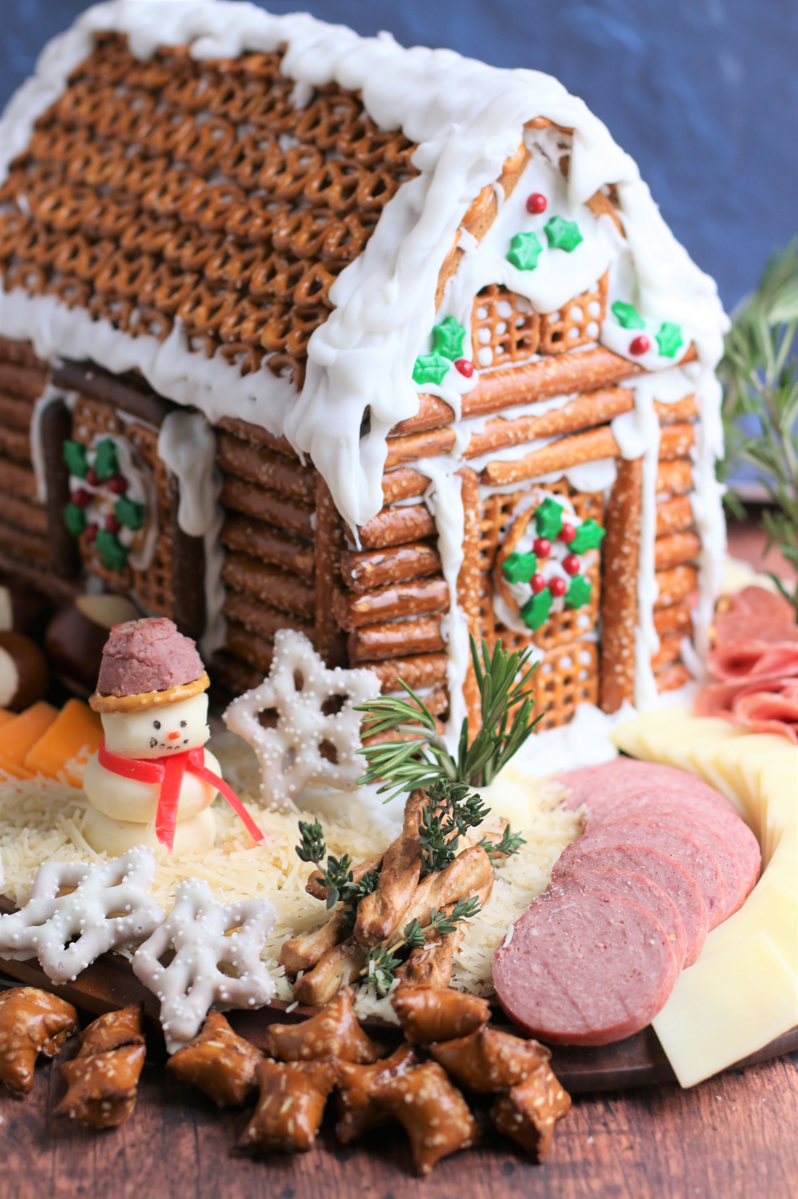

What do you get when you combine a family gingerbread house contest and a winter charcuterie board? This adorable Charcuterie Chalet is the most creative fun I’ve had in a long time! Starting with a gingerbread house and LOTS of pretzels, and all dressed up with savory cheese, meats, fruits, nuts, and parmesan snow, there’s nothing more festive for easy and fun entertaining – and everyone loves this winter Charcuterie Chalet themed board!

INGREDIENTS:
The secret of a great charcuterie board is to find fresh flavors and textures that work for you and your friends. Mix and match your favorite cheeses, meats, fruits, nuts and condiments for something wonderful and unique every time! Remember that this is a concept, rather than a recipe. Savory or sweet, I’m already thinking of ways to change this up for my next Charcuterie Chalet!

FOR MY CHARCUTERIE CHALET I USED:
- Gingerbread Chalet
- Prosciutto Panino (thin sliced mozzarella cheese with prosciutto)
- Smoked Summer Sausage
- Peppered Salami (sliced thin)
- White Chocolate Covered Snowflake Pretzels
- Cheddar Cheese
- Swiss Cheese
- Creamy Havarti Cheese
- Cranberry White Cheddar Cheese
- Fresh Pretzel Bites
- Fresh Parmesan Cheese (shredded for snow)
- Peanut Butter filled Pretzels
- Butter Pretzel Twists
- Laughing Cow Mini Babybel Cheese (Original, Gouda & Light varieties)
- Laughing Cow Soft Cheese Wedges (Swiss, Garlic & Herb, Spicy Jack)
- Butter Pretzel Rounds
- Fresh Rosemary
- Fresh Thyme
- Dark Chocolate & Seasonal Candies
- Glazed Pecans & Seasoned Almonds
- Edible Ink Markers

FAVORITE WINES: Pick a few of your favorites and you’ve got an instant party! You can’t go wrong with a red and white, something dry and something sweet:
- A good Pinot Noir
- Cabernet Sauvignon
- Moscato
- Zinfandel
- Merlot
- Chardonnay or Sauvignon Blanc
- For something special, serve with Winter Sangria, Hot Apple Cider or Spiced Wine!

HOW I MADE THIS:
- BUILD YOUR GINGERBREAD CHALET STRUCTURE: Make it easy on yourself and find a pre-built gingerbread kit to start with. Big or small, mansion or village, you can find the gingerbread structure you like best for a quick start. Gather your favorite pretzels – pretzel logs, butter twists, mini-twists, pumpernickel twists, pretzel snaps, pretzel sticks, etc. I used the royal icing that came with my gingerbread house kit as the glue, but if you want to create a structure that will hold up to several parties, you can use a hot glue gun as well – you just won’t be able to eat it!
Start by creating the log exterior, building up from the bottom. Use a serrated knife to carefully cut logs to size. Pipe royal icing (or hot glue) onto structure and work one layer at a time. Add pretzel windows and doors to each finished wall. The roof comes next – I used mini pretzel twists for mine, but you could also use shredded wheat cereal, triscuit crackers, rustic flatbread or crackers to create a stacked rooftop – again, start from the bottom of the roof and work your way to the peak.
Once everything has dried and is stuck well in place, you can drizzle more royal icing for snow on the roof cap and gable ends. Add decorative candies to the roof, windows and doors if you want – make it your own creation! Because I had a savory Gingerbread Chalet as my theme, I included minimal sweet touches – but you could totally use sprinkles, gum drops, peppermint candies or other sweet treats.
- START WITH A STURDY BASE: Choose a nice solid cutting board, wooden serving tray or large Lazy Susan to create your base. I used a Lazy Susan for my base, which made it easier to create, decorate and enjoy! You can always use a massive serving board or add additional platters if you are preparing this for a crowd.
- Place your assembled Gingerbread Chalet on your serving board.
- DECIDE ON THEME: I made my Gingerbread Chalet all savory, but you could do a sweet version, or a combination of sweet and savory items. Think about the elements you want to have on your chalet – landscaping, trimmings and characters. This will help you decide on the colors, textures and shapes you will want to look for in your ingredients.
- ASSEMBLE: Starting with cheese and meats, assemble and layer around the pretzel house, building a walkway, and layers of different ingredients in fun patterns. Spreadable cream cheese makes a wonderful glue.
- For this particular charcuterie board, I used pre-sliced meats and sliced up the cheeses for easy serving.
- LANDSCAPING: Garnish with lots of fresh green and reds - fresh rosemary and thyme, whole cranberries, ripe pomegranates or pomegranate arils. Pretzel sticks were stacked to create fences. I used Mini Babybel wheels and wedges, cut into various sizes so that there were flat bottoms to anchor, and inserted fresh rosemary to create bushes and trees. Pieces of fresh thyme were added to create detail. Sugared Cranberries & Rosemary also add a beautiful snowy quality! You could also create a small pond or skating rink.
- CHARACTERS: For my winter-themed board, the perfect garnish is a snowman! I created this by peeling the wax from 3 Mini Babybel cheeses; carving one disk smaller for the head, and then stacking them up to create a snowman shape. I used strips of the leftover red wax to create a scarf, and used a food-safe edible ink marker to create the face and buttons. A small orange sprinkle made the perfect carrot nose! A round pretzel topped with a rounded piece of sausage created the perfect top hat for my snowman! You can also create a miniature Santa with Mini Babybel cheese, or make tiny penguins using black olives.
- SNOW TIME: Sprinkle freshly-shredded parmesan cheese all around for a “snowy” effect and lots of wintery sparkle!
- Add appetizer plates and napkins next to the board for easy serving.
- Start with small amounts of each item – you can always refresh your platter as time goes by!
YIELD: 2 to 20 - serves a crowd!

© SnowflakesandCoffeecakes. All images, attachments & content are copyright protected. All rights reserved. Please do not use my images without prior permission. If you want to republish this recipe, please re-write the recipe in your own words, or link back to www.snowflakesandcoffeecakes.com for the recipe.

