BROWNIE SUNDAE COOKIES
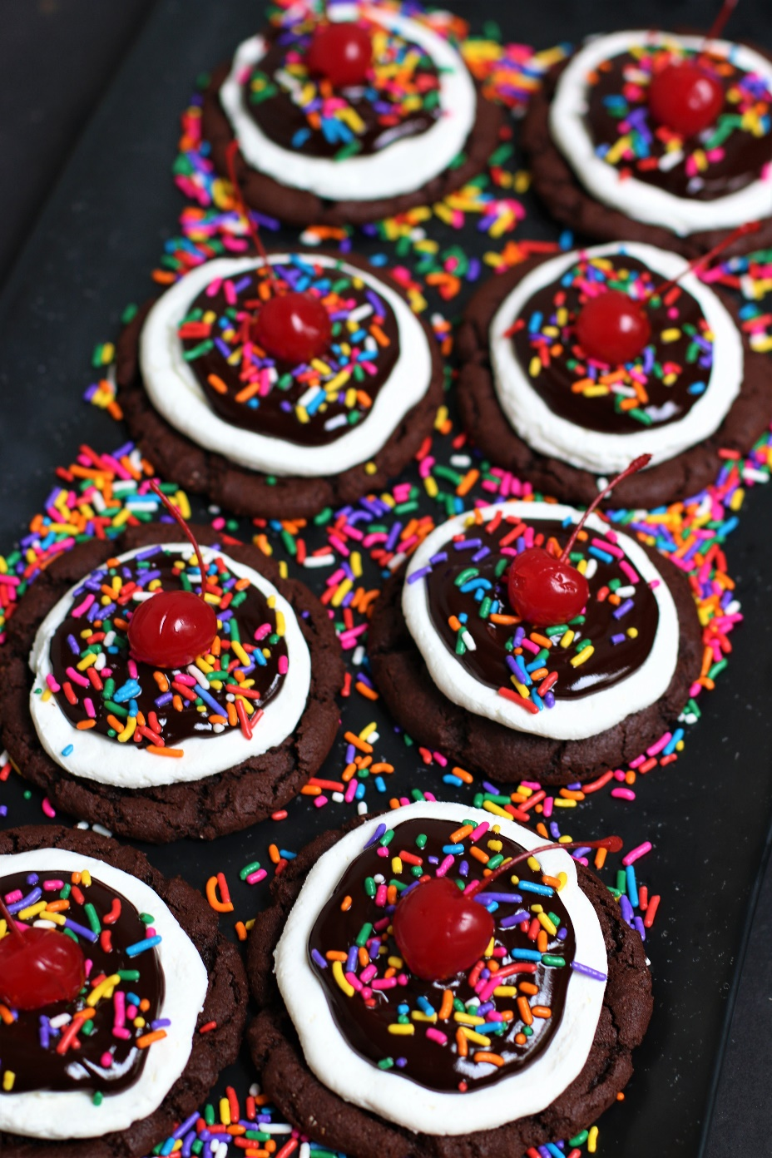

Get ready to indulge your senses with my Crumbl-inspired Brownie Sundae Cookies! One bite and you'll experience an irresistible rich brownie cookie paired with fluffy vanilla mousse, a swirl of gooey hot fudge, colorful rainbow sprinkles and crowned with a delightful maraschino cherry on top - all the classic flavors of an old-fashionied ice cream sundae! These decadent brownie cookies are soft and chewy, with a slightly crispy texture on the outside - and the silky Vanilla Mousse Frosting is just like your favorite rich and creamy vanilla ice cream! I've never had a better chocolate brownie cookie in my life! These cookies are not only visually stunning, but also incredibly delicious, making them the ideal treat for any special occasion. Whether you're looking to impress guests or simply treat yourself to a sweet indulgence, these cookies will never disappoint! This is my mouthwatering Crumbl copycat recipe that family and friends have declared "BETTER THAN CRUMBL!" So fast and easy to make, with a no-chill dough, it’s easy to see why these are always a favorite for special occasions and everyday treats!
INGREDIENTS:
CHOCOLATE BROWNIE COOKIE BASE:
1-1/2 cups (3 sticks) unsalted butter (softened)
3 large eggs (room temperature)
3-3/4 cups (450g) all-purpose flour
1 cup (100g) Dutch processed cocoa powder
2 tablespoons (15g) cornstarch
1 tablespoon (5g) milk powder
2 teaspoons baking soda
1 teaspoon salt
1-1/2 cups (319g) brown sugar (light or dark)
1/2 cup (100g) granulated sugar
1 teaspoon espresso powder
2 tablespoons corn syrup
1 tablespoon pure vanilla extract
1-1/2 cups semi sweet chocolate chips

VANILLA MOUSSE FROSTING:
6 oz. (170g) cream cheese (room temperature)
2 ½ cups heavy whipping cream (icy cold)
6 Tablespoons instant vanilla pudding mix
1 cup (120g) powdered sugar
1 teaspoon pure vanilla extract

HOT FUDGE TOPPING:
¼ cup heavy cream
1 cup (170g) Ghirardelli semi-sweet chocolate chips
1 teaspoon Karo syrup
Rainbow sprinkles
30 maraschino cherries with stems

HOW I MAKE THESE:
- Set eggs and butter out to come to room temperature (this helps them incorporate into the cookie dough better).
- Preheat oven to 350 degrees. Line baking sheets with parchment paper; set aside.
- PREPARE BROWNIE COOKIE BASE: In a medium bowl, whisk together the flour, cocoa powder, cornstarch, milk powder, baking powder and salt until well combined; set aside.
- In a large bowl using a hand-held mixer or stand mixer fitted with a paddle attachment, beat the butter, both sugars and espresso powder on medium speed until completely creamy and fluffy (about 3-4 minutes).
- Scrape down the sides and add in the eggs one at a time, beating well between until each is fully mixed in.
- Add corn syrup and vanilla extract; beat until well blended.
- Scrape down the sides and add in the flour mixture, ½ at a time, mixing just until blended; add remaining flour mixture and again mix just until blended.
- Fold in the chocolate chips and stir until evenly mixed. This cookie dough will be really soft and creamy!
- Using a large cookie scoop (3 Tablespoon size), scoop out cookie dough and roll into a ball with your hands. Repeat with remaining dough.
- Place six cookie dough balls on each baking sheet, leaving room between each cookie as the cookies will spread when they bake.
- Flatten the cookie dough balls by pressing gently with your hand to about ¾-inch thickness.
- Bake for 12-14 minutes or until the centers of the cookies have puffed up and are no longer glossy. Every oven is a little bit different, so watch your first batch when baking and time accordingly. DO NOT OVERBAKE, as these will lose their softness.
- Remove from oven and allow cookies to cool on the baking sheets.
- PREPARE VANILLA MOUSSE FROSTING: In the bowl of a stand mixer fitted with a paddle attachment, add room temp cream cheese, beating until light and fluffy.
- Add vanilla pudding mix and powdered sugar and slowly mix until well blended. Add vanilla extract and ICY COLD half & heavy cream and beat on medium until light, fluffy and well combined, scraping down the sides of the bowl as necessary.
- Add additional heavy cream, 1 tablespoon at a time, until frosting is piping consistency. If your frosting is too thin, add a little bit of powdered sugar and beat until light and fluffy.
- FROST & DECORATE: Spoon frosting into a large piping bag fitted with a large round tip.
- Once cookies have reached room temperature, pipe the frosting onto cookies, starting in the center of the cooking and piping in a circular motion until the cookie is covered evenly. Chill cookies.
- PREPARE HOT FUDGE GANACHE: In a microwave-safe bowl, add the chocolate chips and the heavy cream and microwave in 30-second intervals. Stir in between and repeat the process until the mixture is fully melted and smooth. Add the Karo syrup and gently whisk or stir the mixture until smooth.
- FROST & DECORATE: Spoon 2 tablespoons of the Hot Fudge Ganache over each cookie, giving the top a gentle swirl with the back of your spoon for a nice, smooth finished look.
- Immediately sprinkle with rainbow sprinkles and top each cookie with a whole maraschino cherry (with stem).
- Once the cookies have been frosted and decorated, chill in the fridge until ready to serve. These cookies are best served chilled.
YIELD: Makes 30 (four-inch) cookies
RECIPE VARIATIONS:
- STRAWBERRY BROWNIE SUNDAE COOKIES: Replace the Hot Fudge Topping with Strawberry Topping, and top with a fresh strawberry (rather than maraschino cherry).
- BUTTERSCOTCH BROWNIE SUNDAE COOKIES: Replace the Hot Fudge Topping with Butterscotch Ice Cream Topping.
- RASPBERRY BROWNIE SUNDAE COOKIES: Replace the Hot Fudge Topping with Fresh Raspberry Sauce (outlined in my Raspberry Cheesecake Cookie recipe).
- MARSHMALLOW HOT FUDGE BROWNIE SUNDAE COOKIES: Add a dollop of Marshmallow topping on top of the Vanilla Mousse Frosting before drizzling with the Hot Fudge Topping.
- CAN I MAKE GLUTEN-FREE BROWNIE SUNDAE COOKIES? You can easily make this recipe gluten-free by substituting your favorite 1:1 gluten free flour for the all-purpose flour - I use and recommend King Arthur, Measure for Measure Flour and Bob's Red Mill Gluten Free 1-to-1 Baking Flour. Most instant pudding mix brands and flavors are also gluten free – but double check the brand you use!
RECIPE NOTES:
WEIGH INGREDIENTS CAREFULLY FOR BEST RESULTS: If I can only share one baking secret with you, always use a DIGITAL KITCHEN SCALE. You can use measuring cups and spoons for most recipes, but using a digital scale makes for the more consistent and efficient baking. Take this from someone that bakes A LOT!
VANILLA PUDDING POWDER: Make sure to use instant vanilla pudding powder – this will help stabilize the Vanilla Mousse Topping and add vanilla flavor.
TO KEEP THESE COOKIES SOFT: These cookies will stay soft and fresh for up to 5 days in an air-tight container kept in the refrigerator.
MAKE AHEAD TIP: You can bake the cookies and freeze UNFROSTED in an airtight container for up to 2 months – simply defrost and then frost and decorate before you plan on serving.
HOW TO THAW FROSTED COOKIES: To keep your cookies from getting soggy and frosting from losing its shape and texture, remove from the freezer and place the unopened container in the refrigerator overnight to thaw. Cookies that are not frosted can also thaw overnight UNOPENED on your kitchen countertop.
FOR PARTIES: Because of the chilled mousse frosting, hot fudge topping and whole cherry, this is one of the few cookies that I recommend NOT be bagged individually for parties. If you need to package separately, I recommend using 4”-inch clear cookie boxes.

Original recipe created by Snowflakes & Coffeecakes; published July 2023.
© SnowflakesandCoffeecakes. All images, attachments & content are copyright protected. All rights reserved. Please do not use my images without prior permission. If you want to republish this recipe, please re-write the recipe in your own words, or link back to www.snowflakesandcoffeecakes.com for the recipe.

Tried it and loved it? Snap a picture and share it with me on Instagram @SnowflakesandCoffeecakes and by using the hashtag #SnowflakesandCoffeecakes.

