crumbl butterfinger cookies
(COPYCAT RECIPE)
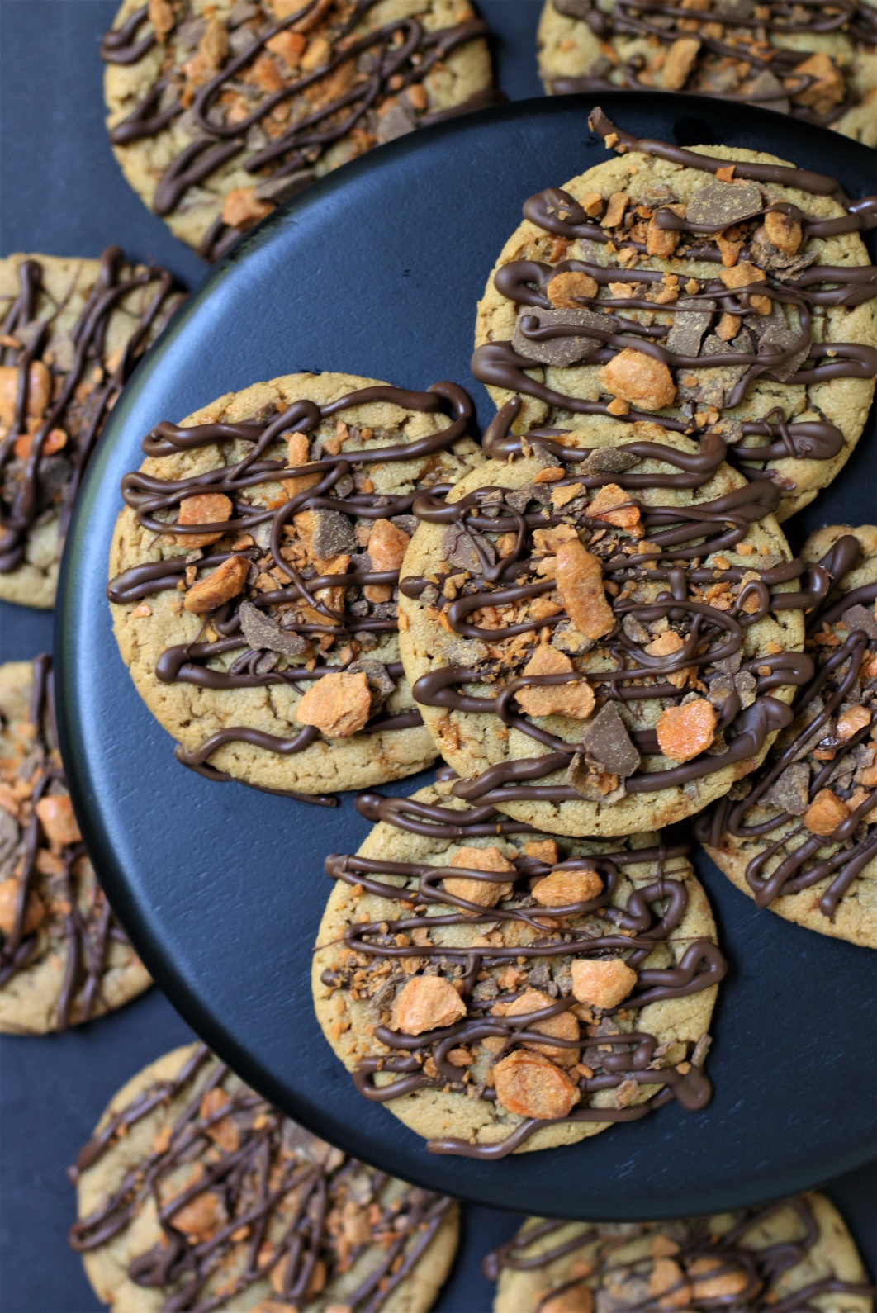

If you love peanut butter cookies, you are going to love this copycat recipe for Crumbl Butterfinger Cookies – biting into one of these is chocolate and peanut butter bliss! Start with a super soft and chewy peanut butter cookie, with a silky milk chocolate drizzle and overloaded with Butterfinger candy pieces inside and out…could you really ask for anything more? So fast and easy to make, with a no-chill dough, it’s easy to see why these are always a favorite at our house! Warm from the oven, these Butterfinger Bliss Cookies are an indulgent treat anytime. And when it comes to cookies, go big or go home!

INGREDIENTS:
PEANUT BUTTER COOKIE BASE:
1 cup (2 sticks) unsalted butter (softened)
2 large eggs (room temperature)
2-1/2 cups (300g) all-purpose flour
2 tablespoons cornstarch
1 tablespoon nonfat milk powder
1 teaspoon baking soda
½ teaspoon salt
1 cup (213g) packed light brown sugar
2/3 cup (140g) granulated sugar
1 cup (240g) creamy peanut butter
1 tablespoon pure vanilla extract
1 cup Butterfinger Bits (or roughly chopped Butterfinger candy bar pieces)

COOKIE FINISHING:
1 cup (6 oz. or 170g) Ghirardelli milk chocolate chips
½ cup Butterfinger Bits

HOW I MAKE THESE:
- Set eggs and butter out to come to room temperature (this helps them incorporate into the cookie dough better).
- Preheat oven to 350 degrees. Line baking sheets with parchment paper; set aside.
- PREPARE COOKIES: In a medium bowl, whisk together the flour, cornstarch, nonfat milk powder, baking soda and salt; set aside.
- In a large bowl using a hand-held mixer or stand mixer fitted with a paddle attachment, beat the butter, brown sugar and granulated sugar on medium speed until completely creamy and fluffy (about 3 minutes).
- Scrape down the sides and add peanut butter and pure vanilla extract; beat until well combined.
- Add in the eggs one at a time, beating well between until each is fully mixed in.
- Scrape down the sides and add in the flour mixture, ½ at a time, mixing just until blended; add remaining flour mixture and again mix just until blended.
- Gently fold in 1 cup of the chopped Butterfinger pieces with a spatula. This cookie dough will be really soft and creamy!
- Using a large cookie scoop (3 Tablespoon size), scoop out cookie dough and roll into a ball with your hands. Repeat with remaining dough.
- Place six cookie dough balls on each baking sheet, leaving room between each cookie as the cookies will spread when they bake.
- Bake cookies one pan at a time for about 13-14 minutes or until the cookies are very lightly crackled on top and the edges are turning golden. Every oven is a little bit different, so watch your first batch when baking and time accordingly. DO NOT OVERBAKE, as these will lose their softness.
- Remove from oven and allow cookies to cool on the baking sheets for 10 minutes and then transfer to a cooling rack to cool completely. Cookies will be puffy and then flatten as they cool. Once the cookies are cool/slightly warm, it’s time to move on to drizzling with melted chocolate!
- PREPARE CHOCOLATE DRIZZLE: In a small microwave-safe bowl, melt the chocolate chips in 30 second intervals at 50% power, stirring between each interval.
- DRIZZLE & DECORATE: When chocolate is melted and smooth, pour into a piping bag or small disposable sandwich bag and cut a tiny hole off the tip. Drizzle melted chocolate over each cookie, and then immediately sprinkle with additional Butterfinger bits.
- These cookies are best served warm or at room temperature.
YIELD: Makes 24 (four-inch) cookies
RECIPE NOTES:
FOR CRUMBL-SIZE COOKIES: Use a 1/3 cup scoop and adjust baking time to about 14-16 minutes.
TO KEEP THESE COOKIES SOFT: These cookies will stay soft and fresh in an air-tight container for 3-4 days at room temperature, or refrigerated for up to 7 days. To store the cookies longer, pop them in the freezer (use a freezer safe container or zip-top bag) and keep for 1-2 months.
MAKE AHEAD TIP: Baked and decorated cookies freeze well for up to 2 months. You can also bake the cookies and freeze UNDECORATED for up to 2 months – simply defrost and then drizzle and sprinkle with Butterfinger pieces before you plan on serving.
BEFORE FREEZING: With drizzled or decorated cookies, it’s important to freeze the cookie prior to placing them into a container so that the drizzle remains intact. Place all frosted cookies on a parchment paper lined baking sheet and pop it in the freezer. Once the icing is set and hard (usually an hour) or the cookies are frozen solid, the cookies can be frozen in containers with parchment paper between layers.
HOW TO THAW DECORATED COOKIES: To keep your cookies from getting soggy and the chocolate drizzle from losing its color, texture and shine, remove from the freezer and place the unopened container in the refrigerator overnight to thaw. Cookies that are not drizzled and decorated can thaw overnight UNOPENED on your kitchen countertop.
FOR PARTIES: I package cookies individually in self-sealing clear cellophane cello bags (Pack It Chic are my favorite brand). Make sure drizzle is completely set after decorating before packaging. To make ahead, place individually wrapped and sealed cookies in a larger airtight container and refrigerate or freeze. Thaw frozen cookies unopened in the refrigerator - you are trying to minimize moisture during defrosting, which can cause your chocolate drizzle to lose color, texture and shine.
CRUMBL BUTTERFINGER COOKIE SUCCESS TIPS:
- WEIGH INGREDIENTS CAREFULLY FOR BEST RESULTS: If I can only share one baking secret with you, always use a DIGITAL KITCHEN SCALE. You can use measuring cups and spoons for most recipes, but using a digital scale makes for the more consistent and efficient baking. Take this from someone that bakes A LOT!
- Not as much flour as you’d expect. You may look at this recipe and wonder why there’s so little flour, but peanut butter and other nut butters act as a binder and can actually replace some of the flour in recipes, including these Crumbl Butterfinger Cookies. Using more flour will dry out the cookies, so stick with the recipe as written!
- Use a combination of brown sugar and granulated sugar. Similar to chocolate chip cookies, it’s ideal to use more brown sugar than white granulated sugar in this cookie dough. Brown sugar lends a softer, moister and thicker cookie, while white granulated sugar causes cookies to spread.
- Use creamy peanut butter instead of crunchy. Creamy peanut butter is ideal for this recipe because crunchy peanut butter is typically a bit thicker and creates an overly crumbly cookie. For a soft cookie with the best texture, use creamy peanut butter!
- Can I use natural peanut butter in these cookies? Processed peanut butters (such as Skippy or Jif) truly taste perfect with great texture – they spread less and aren’t as crumbly. Natural peanut butters (processed with only peanuts and salt) spread a bit more and are somewhat sandier and crumblier. Feel free to use whichever you prefer – both have fantastic peanut butter flavor! If using natural peanut butter, make sure it's at room temperature, stirred well, and expect a slightly crumblier cookie.
- Can I use almond butter in these cookies? Yes, but expect a crumblier cookie.
- How many Butterfinger Bars will I need?
Butterfinger Bits come in an 8 oz. bag, which can be divided 1 cup for the cookie base, and ½ cup for sprinkling on top. I prefer to use these, as they are just more convenient!
If you want to use a bag of Butterfinger Fun Size Bars, at least for now they come in 10.2 ounce bags (you’ll have a few leftover).
- Plan on 1 cup of chopped Butterfinger candy pieces for inside the cookies. You’ll need about 8 fun size bars or 6.1 ounces for this.
- Plan on 1/2 cup of chopped Butterfinger candy pieces for sprinkling on top of the cookies. This is about 4 fun size bars or 3 ounces.
- Do I have to use Milk Chocolate Chips? For best results, use good quality chocolate chips or bars (chopped into small pieces). You can substitute semi-sweet or dark chocolate chips if you prefer – but again, make sure you are using a quality chocolate.
Original recipe created by Snowflakes & Coffeecakes; published June 2022.
© SnowflakesandCoffeecakes. All images, attachments & content are copyright protected. All rights reserved. Please do not use my images without prior permission. If you want to republish this recipe, please re-write the recipe in your own words, or link back to www.snowflakesandcoffeecakes.com for the recipe.

Tried it and loved it? Snap a picture and share it with me on Instagram @SnowflakesandCoffeecakes and by using the hashtag #SnowflakesandCoffeecakes.

