crumbl sugar cookies
(COPYCAT RECIPE)
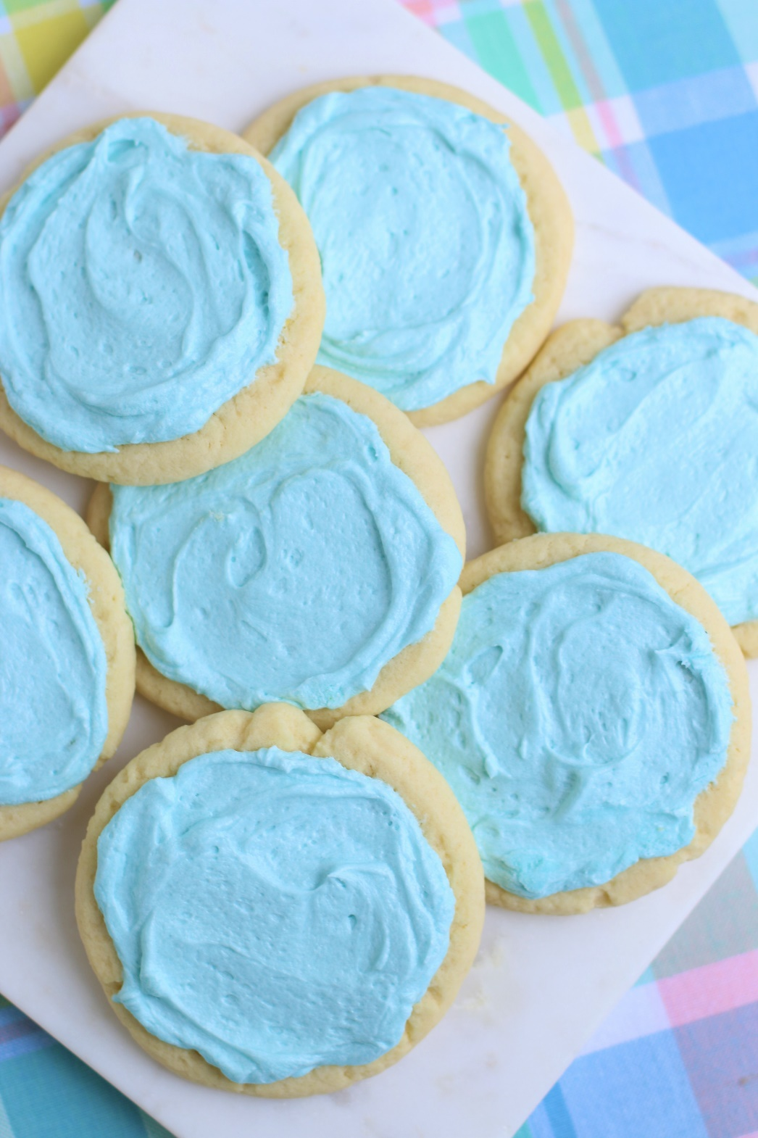

You are going to love this copycat recipe for Crumbl Sugar Cookies! So fast and easy to make, with a no-chill dough, it’s easy to see why these are always a favorite at our house! Super soft, chewy and buttery, topped with a perfect Sweet Almond Buttercream Frosting, and the same GIANT size to share or tackle on your own! I’m famous for my decorated sugar cookies, but sometimes you just want a cookie that is fast, yummy, and warm from the oven!
INGREDIENTS:
SUGAR COOKIES:
1 cup salted butter
1 cup (200g) granulated sugar
2 large eggs (room temperature)
2 teaspoons pure vanilla extract
½ teaspoon pure almond extract
3 cups (375g) all purpose flour
2 teaspoons baking powder

SWEET ALMOND BUTTERCREAM FROSTING:
1/2 cup salted butter softened
3 cups (360g) powdered sugar
1 teaspoon pure almond extract
2-4 tablespoons milk or half & half
AmeriColor Soft Gel Food Coloring (strongly recommended – neon pink is the traditional color)

HOW I MAKE THESE:
- Set eggs out to come to room temperature (this helps them incorporate into the cookie dough better).
- Preheat oven to 350 degrees. Line three baking sheets with parchment paper; set aside.
- PREPARE COOKIES: In a medium bowl, whisk together the flour and baking powder; set aside.
- In a large bowl using a hand-held mixer or stand mixer fitted with a paddle attachment, beat the butter and sugar on medium speed until completely creamy and fluffy (about 3 minutes).
- Scrape down the sides and add in the eggs one at a time, beating well between each is fully mixed in.
- Add vanilla extract and almond extract; beat until mixed.
- Scrape down the sides and add in the flour mixture, ½ at a time, mixing just until blended; add remaining flour mixture and again mix just until blended. This cookie dough will be really soft and creamy!
- Using a large cookie scoop (3 Tablespoon size), scoop out cookie dough and roll into a ball with your hands. Repeat with remaining dough.
- Place six cookie dough balls on each baking sheet, leaving room between each cookie as the cookies will spread when they bake.
- Flatten the cookie dough by gently pressing the bottom of a drinking glass or measuring cup into the center of each, and press down gently to create a small indentation. To keep your glass from sticking to the cookie dough, it works best to dip the bottom in flour before pressing each cookie. Any flour left behind will “melt” into the cookie as it bakes – not to worry!
- Bake for 9-11 minutes or until the centers of the cookies have puffed up and are no longer glossy. Every oven is a little bit different, so watch your first batch when baking and time accordingly. DO NOT OVERBAKE, as these will lose their softness.
- Remove from oven and allow cookies to cool on the baking sheets.
- PREPARE SWEET ALMOND BUTTERCREAM FROSTING: In the bowl of a stand mixer fitted with a paddle attachment, add softened butter, powdered sugar, almond extract and 1 tablespoon of milk or half & half.
- Beat on medium speed until light and fluffy; add additional milk or half & half as necessary until you the frosting is spreading consistency. If your frosting is too thin, add a little bit of powdered sugar and beat until light and fluffy.
- Add gel food coloring, if desired, and continue beating until well blended, scraping down the sides of the bowl as necessary.
- FROST & DECORATE: Spread the frosting on the cookies while they are still slightly warm, which will melt the frosting slightly and give it a nice, smooth finished look.
- Once the cookies have completely cooled, chill in the fridge until ready to serve. Allow decorated cookies to set and dry completely before storing – keep parchment paper between each layer or place cookies in individual self-sealing bags for easy freezing and serving.
- These cookies should be served chilled.
YIELD: Makes about 18 (four-inch) cookies
RECIPE NOTES: These cookies will stay fresh in an air-tight container in the refrigerator for up to 1 week.
MAKE AHEAD TIP: Baked and frosted cookies freeze well for up to 1 month. Thaw overnight UNOPENED on your kitchen countertop before decorating.
FOR PARTIES: I package cookies individually in self-sealing clear cellophane cello bags (Pack It Chic are my favorite brand). Make sure cookies are completely dry after decorating before packaging. To make ahead, place individually wrapped and sealed cookies in a larger airtight container and refrigerate or freeze. Thaw frozen cookies in the refrigerator or on your countertop before serving - you are trying to minimize moisture during defrosting, which can cause your frosting to run or bleed.
TO KEEP THESE COOKIES SOFT: These cookies will stay soft and fresh in an air-tight container refrigerated for up to one week.
NUTRITION:
Calories: 513kcal | Carbohydrates: 71g | Protein: 4g | Fat: 24g | SaturatedFat: 15g |
Cholesterol: 88mg | Sodium: 216mg | Potassium: 132mg | Fiber: 1g | Sugar: 46g |
Vitamin A: 749IU | Calcium: 53mg | Iron: 2mg

Original recipe created by Snowflakes & Coffeecakes; published April 2022.
© SnowflakesandCoffeecakes. All images, attachments & content are copyright protected. All rights reserved. Please do not use my images without prior permission. If you want to republish this recipe, please re-write the recipe in your own words, or link back to www.snowflakesandcoffeecakes.com for the recipe.
Tried it and loved it? Snap a picture and share it with me on Instagram @SnowflakesandCoffeecakes and by using the hashtag #SnowflakesandCoffeecakes.

