root beer pulled pork sandwiches
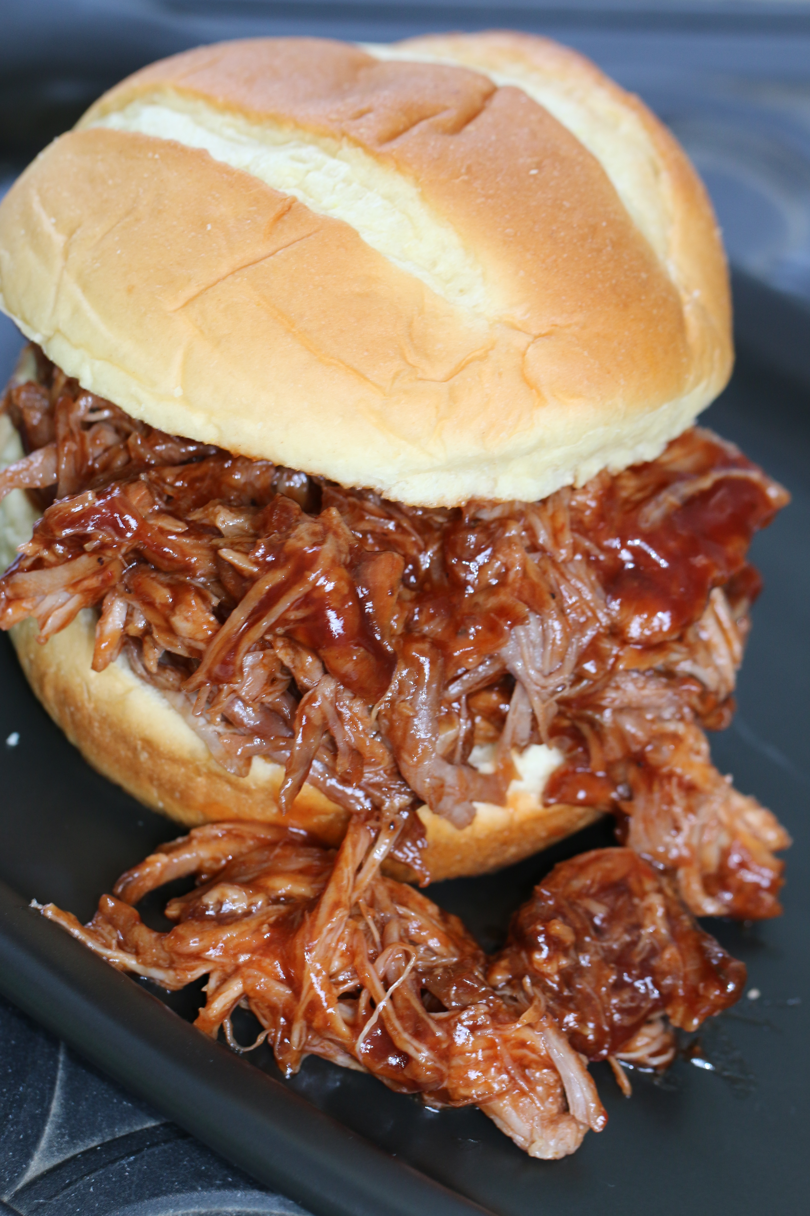

This is a wonderful and simple recipe to make root beer pulled pork in your slow cooker. This sandwich is packed with sweet onion, minced garlic and your favorite barbeque sauce.
The kids tell me that it is the best pulled pork they have ever had – even better than what you can find at the rib burn-offs around town. I just know it is simple easy to make and a real crowd pleaser!

INGREDIENTS:

3 to 4 pounds of pork shoulder
1 large sweet onion, cut into large chunks
1 cup brown sugar
1 tablespoons minced garlic
4 tablespoons barbeque rub
2 cans Root Beer (I use A&W)
18 ounce bottle Barbeque Sauce (or more)
Sandwich Buns

HOW I MAKE THIS:
- Place the pork tenderloin in slow cooker, sprinkle with brown sugar and garlic. Add onion chunks. Pour root beer over the meat.
- Cover and cook on high heat for 1 hour. Reduce heat to low and cook for an additional two hours.
- Uncover and turn pork over, sprinkle with barbeque rub and add additional root beer if needed. Cook for an additional 3 hours on low heat.
- Turn slow cooker off and allow to sit for 15 minutes before removing meat to a roasting pan (this lets the juices settle and keeps your pork moist). Scoop out as many of the onion chunks as you can and save. Drain slow cooker.
- Using your hands or two regular forks, shred the meat and place back in the slow cooker, adding the saved onion chunks. Pour barbeque sauce over the pork and stir to combine.
- Heat until warm and serve immediately, or keep warm in slow cooker until ready to serve.
- Serve on sandwich buns, or for something crazy good, serve a scoop on top of homemade macaroni and cheese (“Piggy Mac”). So good!

© Snowflakes and CoffeeCakes. All images & content are copyright protected. Please do not use my images without prior permission. If you want to republish this recipe, please re-write the recipe in your own words, or link back to this post for the recipe.

